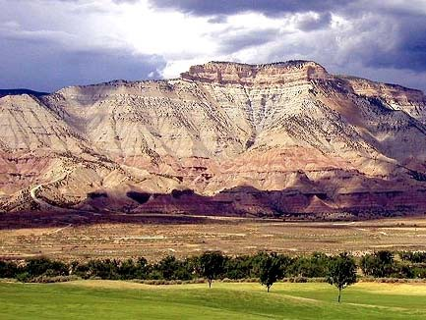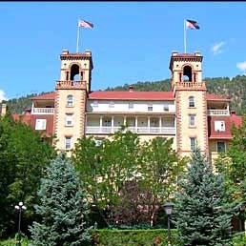

**RESOURCE GUIDE**

**A Collection of Documents, Fee Schedules, Process Flow Charts and other Useful Information related to the County’s Land Use and Development Code**

**Published April 25, 2014**

**Last Updated October 15, 201****8**

**Table of Contents**

Division 1. General Forms 1

Section 1-01. Statement of Authority 1

Section 1-02. Timeline Waiver Request 2

Section 1-03. Legal Publication 3

Section 1-04. Public Hearing NOTICE Information 4

Division 2. Fee Schedule and impact fees 5

Section 2-01. Payment of Fees 5

Section 2-02. Application Fees 6

Section 2-03. Payment Agreement Form 8

Section 2-04. CGS Submittal Form for Land-Use Reviews. 9

Section 2-05. FAQ Regarding the CGS Land Use Review Process 11

Section 2-06. Road Impact Fees and Benefit District Map. 13

Division 3. Plat Information 15

Section 3-01. Common Plat Notes 15

A. Noxious Weeds. 15

B. Open Hearth Solid-Fuel Fireplaces. 15

C. Exterior Lighting. 15

D. Right to Farm 15

E. Maintenance of Fences, Rural Living, Etc. 15

F. Mineral Rights. 15

G. Accessory Dwelling Units. 16

H. Domestic Dogs. 16

I. Wildlife-Friendly Fencing. 16

J. Septic Systems. 16

K. Foundations. 16

L. Irrigation Ditches 16

Section 3-02. Plat certificates 17

A. Minor Subdivision 17

B. Major Subdivision 21

C. Conservation Subdivision 24

D. Amended Final Plat 27

E. Rural Land Development Exemption 30

F. Public/County Road Split Exemption 33

G. Common Interest Community Subdivision 36

H. Other Plat Certificates To Be Used, As Necessary 39

Section 3-03. Avigation EASEMENT Sample 41

Division 4. Financial Documents 43

Section 4-01. Irrevocable Letter of Credit 43

Section 4-02. Partial Release of Letter of Credit 45

Section 4-03. Request for Final Release of Letter of Credit. 46

Section 4-04. Treasurer’s Deposit Agreement 47

Section 4-05. Treasurer’s Revegetation Deposit Agreement 48

Section 4-06. Revegetation Acknowledgement of satisfaction 53

Division 5. Subdivision information. 54

Section 5-01. Subdivision Improvements Agreement 54

Section 5-02. Rural Land Development Exemption Example 65

Section 5-03. Conservation Subdivision Primer 70

Division 6. Flow Charts 78

A. Section 4-103 Administrative 79

B. Section 4-104 Limited Impact 80

C. Section 4-105 Major Impact 81

D. Section 4-106 Amendment to an Approved Land Use Change Permit 82

E. Section 4-107 Minor Temporary Employee Housing Facility 83

F. Section 4-108 Vacation of a County Road or Public Right-of-Way 84

G. Section 4-109 Development in 100-year Floodplain 85

H. Section 4-110 Development in 100-year Floodplain Variance 86

I. Section 4-111 Location and Extent 87

J. Section 4-112 Call-Up to the BOCC 88

K. Section 4-113 Rezoning 89

L. Section 4-114 Code Text Amendment 90

M. Section 4-115 Variance 91

N. Section 4-116 Administrative Interpretation 92

O. Section 4-117 Administrative Interpretation Appeal 93

P. Section 4-119 Accommodation Pursuant to Federal Fair Housing Act 94

Q. Section 5-202 Public or County Road Split Exemption 95

R. Section 5-203 Rural Land Development Exemption 96

S. Section 5-204 Basic Correction Exemption 97

T. Section 5-301 Minor Subdivision 98

U. Section 5-302 Major Subdivision 99

V. Section 5-303 Conservation Subdivision 100

W. Section 5-304 Amendment to an Approved Preliminary Plan 101

X. Section 5-305 Amended Final Plat 102

Y. Section 5-306 Common Interest Community Subdivision 103

Z. Section 6-202 Planned Unit Development 104

AA. Section 6-203 Amendment to an Approved PUD 105

BB. Section 9-103 Pipeline 106

CC. Section 11-201 Sign Permit 107

1. General Forms
2. Statement of Authority

Pursuant to C.R.S. §38-30-172, the undersigned executes this Statement of Authority on behalf of ____________________________________, a _____________________________ (corporation, limited liability company, general partnership, registered limited liability partnership, registered limited liability limited partnership, limited partnership association, government agency, trust or other), an entity other than an individual, capable of holding title to real property (the “Entity”), and states as follows:

The name of the Entity is ______________________________________________________________,

and is formed under the laws of _________________________________________________________.

The mailing address for the Entity is ______________________________________________________

___________________________________________________________________________________.

The name and/or position of the person authorized to execute instruments conveying, encumbering, or otherwise affecting title to real property on behalf of the Entity is ____________________________

___________________________________________________________________________________.

The limitations upon the authority of the person named above or holding the position described above to bind the Entity are as follows (if no limitations, insert “None”): _____________________________

___________________________________________________________________________________.

Other matters concerning the manner in which the Entity deals with any interest in real property are (if no other matter, leave this section blank): _________________________________________________

___________________________________________________________________________________.

EXECUTED this ______ day of _________________________, 20______.

Signature: ______________________________________

Name (printed): __________________________________

Title (if any): _____________________________________

STATE OF __________________)

)SS.

COUNTY OF __________________)

The foregoing instrument was acknowledged before me this _____ day of ________________, 20____ by ___________________________________, on behalf of __________________________________, a ____________________________________.

Witness my hand and official seal.

My commission expires: _______________ _____________________

(Date) (Notary Public)

[SEAL]

1. Timeline Waiver Request

__________________

Date

I ______________ (print name) hereby waive any applicable timelines specified in the Garfield County Land Use and Development Code, as amended and in the Colorado Revised Statutes for scheduling and/or conducting a public hearing before the Garfield County Planning Commission and/or the Board of County Commissioners for ______________________________________________________ (project name and number).

Sincerely,

________________________________

Authorized Applicant or Property Owner

1. Legal Publication

All legal notices are required to follow the provisions regarding legal notice publication in §24- 70-102 C.R.S., et. seq. which is stated here:

*Every newspaper printed and published daily, or daily except Sundays and legal holidays, or on each of any five days in every week excepting legal holidays and including or excluding Sundays shall be considered and held to be a daily newspaper; every newspaper printed and published at regular intervals three times each week shall be considered and held to be a tri-weekly newspaper; every newspaper printed and published at regular intervals twice each week shall be considered and held to be a semiweekly newspaper; and every newspaper printed and published at regular intervals once each week shall be considered and held to be a weekly newspaper. No publication, no matter how frequently published shall be considered a legal publication unless it has been admitted to the United States mails with periodicals mailing privileges.*

At present, the Rifle Citizen Telegram meets this standard and is considered a paper of “general circulation."

1. Public Hearing NOTICE Information

**PUBLIC HEARING NOTICE INFORMATION**

Please check the appropriate boxes below based upon the notice that was conducted for your public hearing. In addition, please initial on the blank line next to the statements if they accurately reflect the described action.

* **My application required written/mailed notice to adjacent property owners and mineral owners.**

**____** Mailed notice was completed on the ______ day of ______________, 20____.

____ All owners of record within a 200 foot radius of the subject parcel were identified as shown in the Clerk and Recorder’s office at least 15 calendar days prior to sending notice.

**____** All owners of mineral interest in the subject property were identified through records in the Clerk and Recorder or Assessor, or through other means [list] __________________ _______________________________________________________________________.

* Please attach proof of certified, return receipt requested mailed notice.
* **My application required Published notice.**

**____** Notice was published on the ______ day of ______________, 20___.

* Please attach proof of publication in the Rifle Citizen Telegram.
* **My application required Posting of Notice.**

**____** Notice was posted on the ______ day of ______________, 20____.

**____** Notice was posted so that at least one sign faced each adjacent road right of way generally used by the public.

**I testify that the above information is true and accurate.**

Name: _____________________________________________

Signature: __________________________________________

Date: _____________________________________________

1. Fee Schedule and impact fees
2. Payment of Fees

Garfield County, pursuant to Board of County Commissioners (“Board”) Resolution No. 98-09 and 2014-60, has established a fee structure (“Base Fee”) for the processing of each type of subdivision and land use applications.

The Base Fee is an estimate of the average number of hours of staff time devoted to an application, multiplied by an hourly rate for the personnel involved. The Board recognized that the subdivision and land use application processing time will vary and that an applicant should pay for the total cost of the review which may require additional billing. Hourly rates based on the hourly salary, and fringe benefits costs of the respective positions combined with an hourly overhead cost for the office will be used to establish the actual cost of County staff time devoted to the review of a particular project.

Actual staff time spent will be charged against the Base Fee. After the Base Fee has been expended, the applicant will be billed based on actual staff hours accrued. Any billing shall be paid in full prior to final consideration of any land use permit, zoning amendment or subdivision plan. If an applicant has previously failed to pay application fees as required, no new or additional applications will be accepted for processing until the outstanding fees are paid.

Checks, including the appropriate Base Fee set forth below, must be submitted with each land use application, and made payable to the Garfield County Treasurer. Applications will not be accepted without the required application fee. Base Fees are non-refundable in full, unless a written request for withdraw from the applicant is submitted prior the initial review of the application materials.

Applications must include a Payment Agreement Form (“Agreement”) set forth below. The Agreement establishes the applicant as being responsible for payment of all costs associated with processing the application. The Agreement must be signed by the party responsible for payment and submitted with the application in order for it to be accepted.

The following Base Fees shall be received by the County at the time of submittal of any procedural application to which such fees relate. Such Base Fees shall be in addition to and exclusive of any cost for publication or cost of consulting service determined necessary by the Board for the consideration of any application or additional County staff time or expense not covered by the Base Fee, which have not otherwise been paid by the applicant to the County prior to final action upon the application tendered to the County.

1. Application Fees



**EXHIBIT A to Resolution 2014-60 - PLANNING REVIEW PROCESS FEE SCHEDULE**

|  |  |  |
| --- | --- | --- |
| **Section** | **Review Process** | **Base Fee** |
| **Land Use Change Permits** | |  |
| 4-103 | Administrative Review | $250 |
| 4-105 | Limited Impact | $400 |
| 4-106 | Major Impact | $525 |
| 4-107 | Minor Temporary Employee Housing | $250 |
| 4-107 | Amendment to an approved LUCP | $300 |
| 4-108 | Vacation of a County Road or Public ROW | $400 |
| 4-109 | Development in 100-year Floodplain | $400 |
| 4-110 | Development in 100-year Floodplain Variance | $250 |
| 4-111 | Location and Extent | Staff Hourly Rate |
| 4-112 | Call-up to the BOCC | Staff Hourly Rate |
| 4-113 | Rezoning | $450 |
| 4-114 | Code Text Amendment | $300 |
| 4-115 | Variance | $250 |
| 4-116 | Administrative Interpretation | $250 |
| 4-117 | Administrative Interpretation Appeal | $250 |
| 4-118 | Waiver of Standards | *Part of Application |
| 4-119 | Accommodation Pursuant to the FFHA | $250 |
| 6-202 | PUD Zoning | $500 |
| 6-203 | PUD Zoning Amendment | $300 |
| 7-707 | Small Temporary Employee Housing | $50 |
| 9-101 | Pipeline Plan | $400 |
| 14-302 | 1041: Areas & Activities of State Interest: Minor Permit | $1,000 |
| 14-303 | 1041: Areas & Activities of State Interest: Major Permit | $2,500 |
|  | Takings Determination | Staff Hourly Rate |
| Chapter 4 | Comprehensive Plan Amendment | $450 |
| Divisions of Land | |  |
| 5-202 | Public/County Road Split Exemption | $300 |
| 5-203 | Rural Land Development Option Exemption | $400 |
| 5-204 | Basic Correction Exemption | $300 |
| 5-301 | Minor Subdivision | $400 |
| 5-302.B | Sketch Plan (Major or Conservation) | $325 |
| 5-302.C | Preliminary Plan (Major or Conservation) | $675 |
| 5-302.D | Final Plan/Plat (Major or Conservation) | $200 |
| 5-304 | Preliminary Plan Amendment | $325 |
| 5-305 | Final Plat Amendment | $100 |
| 5-306 | Common Interest Community Subdivision | $400 |
| 5-307 | Vacating a plat | $250 |
| Staff Hourly Rate | |  |
| Director/Manager | | $50.50 |
| Senior Planner | | $40.50 |
| Administrative Assistant | | $30.00 |
| Other Fees (Application agency review fees and outside consultant review fees, as authorized pursuant to the Regulations, such as the Colorado Geologic Survey) | | TBD |

The following guidelines shall be used for the administration of the fee structure set forth above:

1. All applications shall be submitted with a signed Agreement for Payment form set forth below.
2. County staff shall keep accurate record of actual time required for the processing of each land use application, zoning amendment, or subdivision application. Any additional billing will occur commensurate with the additional costs incurred by the County as a result of having to take more time that that covered by the base fee.
3. Any billings shall be paid prior to final consideration of any land use permit, zoning amendment, or subdivision plan. All additional costs shall be paid to the execution of the written resolution confirming action on the application.
4. Final Plats, Amended or Corrected Plats, Exemption Plats or Permits will not be recorded or issued until all fees have been paid.
5. In the event that the Board determines that special expertise is needed to assist them in the review of a land use permit, zoning amendment, or subdivision application, such costs will be borne by the applicant and paid prior to the final consideration of the application. All additional costs shall be paid prior to the execution of the written resolution confirming action on the application.
6. If an application involves multiple reviews, the Applicant shall be charged the highest Base Fee listed above.
7. Types of “Procedures" not listed in the above chart will be charged at an hourly rate based on the pertinent planning staff rate listed above.
8. The Planning Director shall establish appropriate guidelines for the collection of Additional Billings as required.
9. Payment Agreement Form

**Payment Agreement Form**

GARFIELD COUNTY (hereinafter COUNTY) and Property Owner (hereinafter OWNER) agree as follows:

1. OWNER has submitted to COUNTY an application for (hereinafter, THE PROJECT).

2. OWNER understands and agrees that Garfield County Resolution No. 98-09, as amended, establishes a fee schedule for each type of subdivision or land use review applications, and the guidelines for the administration of the fee structure.

3. OWNER and COUNTY agree that because of the size, nature or scope of the proposed project, it is not possible at this time to ascertain the full extent of the costs involved in processing the application. OWNER agrees to make payment of the Base Fee, established for the PROJECT, and to thereafter permit additional costs to be billed to OWNER. OWNER agrees to make additional payments upon notification by the COUNTY when they are necessary as costs are incurred.

4. The Base Fee shall be in addition to and exclusive of any cost for publication or cost of consulting service determined necessary by the Board of County Commissioners for the consideration of an application or additional COUNTY staff time or expense not covered by the Base Fee. If actual recorded costs exceed the initial Base Fee, OWNER shall pay additional billings to COUNTY to reimburse the COUNTY for the processing of the PROJECT mentioned above. OWNER acknowledges that all billing shall be paid prior to the final consideration by the COUNTY of any land use permit, zoning amendment, or subdivision plan.  
________________________________________________________________________

**PROPERTY OWNER (OR AUTHORIZED REPRESENTATIVE)**

I hereby agree to pay all fees related to this application.

**Print Name**

**Mailing Address:**

**E-Mail Address:**

**Phone Number:**

_____________________________

**Signature Date**

1. CGS Submittal Form for Land-Use Reviews.

**COLORADO GEOLOGICAL SURVEY SUBMITTAL FORM FOR LAND-USE REVIEWS**

**County**

**Date**

**Project Name**

**APPLICANT**

**(or Applicant’s Authorized Representative responsible for paying CGS-review fee)**

**Name**

**Address**

**Ph. No. _Fax No.**

**/4, /2, or /4 /4**

**Section(s)**

**Township_**

**Range**

**Dec Lat**

**Dec Long**

***Reviews for Counties***

**FEE SCHEDULE (effective June 1, 2009)**

Small Subdivision (> 3 dwellings and < 100 acres) . . . . . . . . . . . . . . . . . . . . . . . . . . . . . . . . . . . . . $950

Large Subdivision (> 100 acres and < 500 acres) . . . . . . . . . . . . . . . . . . . . . . . . . . . .. . . . . . . . $1,550

Very Large Subdivision (500 acres or more) . . . . . . . . . . . . . . . . . . . . . . . . . . . . . . . . .. . . . . . . . . . . . $2,500

Very small **residential** subdivisions (1-3 **dwellings** and < 100 acres) . . . . . . . . . . . . . . . .$600

***Reviews for Municipalities*** . . . . . . . . . . . . . . . . . . . . . . . . . . . . . . . . . . . . .*At hourly rate of reviewer* ***Special Reviews*** . . . . . . . . . . . . . . . . . . . . . . . . . . . . . . . . . . . . . . . . . . . . . . . . . . . .*At hourly rate of reviewer* School Site Reviews . . . . . . . . . . . . . . . . . . . . . . . . $855

**CGS LAND USE REVIEWS**

Geological studies are required by Colorado counties for all subdivisions of unincorporated land into parcels of less than 35 acres, under State statute C.R.S. 30-28-136 (1) (i) (Senate Bill 35, 1972). Some Colorado municipalities require geological studies for sub- division of incorporated land. In addition, local governments are empowered to regulate development activities in hazardous or mineral-resource areas under C.R.S. 24-65.1-101 et seq. (House Bill 1041, 1974) and C.R.S. 34-1-301 et seq. (House Bill 1529, 1973), respectively.

Local-government agencies submit proposed subdivision applications and supporting technical reports to the Colorado Geological Survey ”...for evaluation of those geologic factors which would have significant impact on the proposed use of the land,“ in accordance with State statutes. The CGS reviews the submitted documents and serves as a technical advisor to local-government planning agencies during the planning process. Since 1984, the CGS has been required by law to cover the full direct cost of performing such reviews.

The adequate knowledge of a site’s geology is essential for any development project. It is needed at the start of the project in order to plan, design, and construct a safe development. Proper planning for geological conditions can help developers and future owners/users reduce unnecessary maintenance and/or repair costs

1. FAQ Regarding the CGS Land Use Review Process
2. ***Why am I required to have a CGS review when I already hired and paid for my own consultant?***

In 1972, Senate Bill 35 was passed stating that any person or entity subdividing a property into parcels of 35 acres or less on unincorporated land must submit geologic or geotechnical reports to the County as part of the preliminary plat application process. Municipalities or public agencies may request that CGS review a site, although these reviews are not governed by the statute.

1. ***Why is a CGS review necessary when I already hired my own geologist?***

The CGS review is an independent third-party review that is done for the County, similar to the service a building inspector provides for construction review. The purpose of the CGS review is to ensure that all geologic concerns have been adequately identified and addressed in the geologic reports and that the proposed development is feasible.

1. ***Why does CGS charge for land use reviews? Doesn’t taxpayer money pay for this service?***

CGS land use reviews are not subsidized through the general fund, although some other review agencies are supported by taxpayer money. In 1984 the state legislature decided that CGS reviews should be paid for with fees paid by the applicant of the proposed development so that taxpayers are not viewed as subsidizing development.

1. ***Did the CGS geologist make a field visit to the site?***

A CGS geologist visits each site being reviewed. If the review is a re-submittal for a site that has been visited previously, a second site visit may not be necessary. If significant changes have occurred since the initial review, the site may be visited again.

1. ***Why is the CGS review letter so short and simple? What is my fee paying for?***

The CGS letter is a review of the geologic material submitted and reflects the level of detail contained in those documents. CGS does not offer designs, but rather ensures that the work that has been done is meaningful and adequate for the site conditions and proposed development. A site review that adequately addresses all the geologic conditions present at the site may be a short confirmation letter. If more work needs to be done or if difficult site conditions are present, the letter may be longer.

1. ***What type of information do I need to submit to CGS for a land use review?***

The more geologic information that is submitted to CGS, the easier it is for CGS to evaluate the property. The required documents may vary based on county requirements and the potential problems that may impact the proposed development. A topographic map is essential. Also, information regarding slope, surficial materials, subsurface materials and bedrock, presence of groundwater and depth, and specific geologic hazards should be included, where applicable. Grading plans, drainage plans, and geotechnical testing results are also very helpful for the review. The presence of geologic hazards should be evaluated with respect to the development plan. Also, the effect of development on geologic conditions should be discussed. The evaluation should include alternatives such as avoidance and mitigation techniques.

1. ***The subdivision down the road was approved, why wasn’t mine?***

There could be several reasons: geologic conditions can change over short distances; subdivisions made prior to 1972 were not required to undergo a CGS review and may have not been evaluated for geologic suitability at all; the area down the road may be incorporated as part of a municipality, which exempts it from the CGS review process. Another consideration is that geologic reviews are continually evolving and site conditions that have been judged acceptable in the past may no longer be considered as such, based on the current understanding of the geologic processes and adverse impacts associated with them.

1. ***Why are CGS reviews required even on low-density properties?***

Senate Bill 35 pertains to subdivisions of less than 35 acres. Geologic hazards can occur on large-scales or small-scales; relying on low-density subdivision cannot mitigate all geologic hazards. For instance, entire hillsides might be prone to rockfall or landslide hazards. Large tracts of land may be subject to groundwater problems.

1. ***Why can’t I just use the soil conservation maps for a geologic report?***

The USDA soil conservation maps are a good start for geologic investigations, but do not contain sufficient detail on the possible geologic problems that may occur at any site

1. ***Aren’t some of your review comments beyond the scope of geologic hazards on my site?***

Technically other agencies have regulatory authority regarding issues such as flood plains, groundwater availability and wildfire, but these issues are also important factors in the overall geologic context of the site and may affect geologic hazards on the site. The mention of a condition in the CGS review letter is not intended to influence the statutory authority of any other agency, but rather to ensure that all parties are aware of a potentially problematic geologic condition. For instance, mention of a situation involving a major drainage is a flag that the U.S. Army Corps of Engineers or the Colorado Water Conservation Board should be reviewing development plans.

1. ***When I bought this property, no one told me about any geologic hazards on the site; can I go back to the previous owners somehow?***

CGS can not give legal advice. If the seller was aware of adverse conditions with respect to the proposed use, this should have been disclosed. A legal opinion should be sought

1. ***Can I get a waiver from having the CGS do a review?***

The discretion to grant waivers is vested by law with the counties. Once an application for review is submitted to CGS, we are under a statutory responsibility to respond.

1. ***I am willing to accept the risk associated with my property —why is it anyone’s business what I do with my own land?***

The presumption associated with a subdivision is that portions of the property will be sold to others. This then assigns any risk to future buyers, and the county is required to protect their interests. Senate Bill 35 addresses a wide variety of land use issues as well as geologic suitability in an attempt to provide information so that the overall appropriateness of the subdivision proposal can be evaluated

1. Road Impact Fees and Benefit District Map.

|  |  |  |  |
| --- | --- | --- | --- |
| **Table 7-405: Road Impact Fees (from LUDC)** | | | |
| **Development Type** | **Square Feet** | **Fee** | |
| **East Benefit Area** | **South and North Benefit Areas** |
| **Residential (Per Dwelling by Square Feet of Finished Floor Areas** | | | |
| Residential | 900 or Less | $726 | $486 |
|  | 901 to 1,400 | $1,474 | $986 |
|  | 1,400 to 1,900 | $1,988 | $1,332 |
|  | 1,901 to 2,400 | $2,385 | $1,598 |
|  | 2,401 and greater | $2,703 | $1,811 |
| **Non-residential (Per 1,000 square feet of Floor Area)** | | | |
| Industrial | Per 1,000 sq.ft | $564 | $379 |
| Commercial | Per 1,000 sq.ft | $3,766 | $2,523 |
| Institutional | Per 1,000 sq.ft | $1,505 | $1,008 |
| Office & Other Services | Per 1,000 sq.ft | $1,630 | $1,092 |

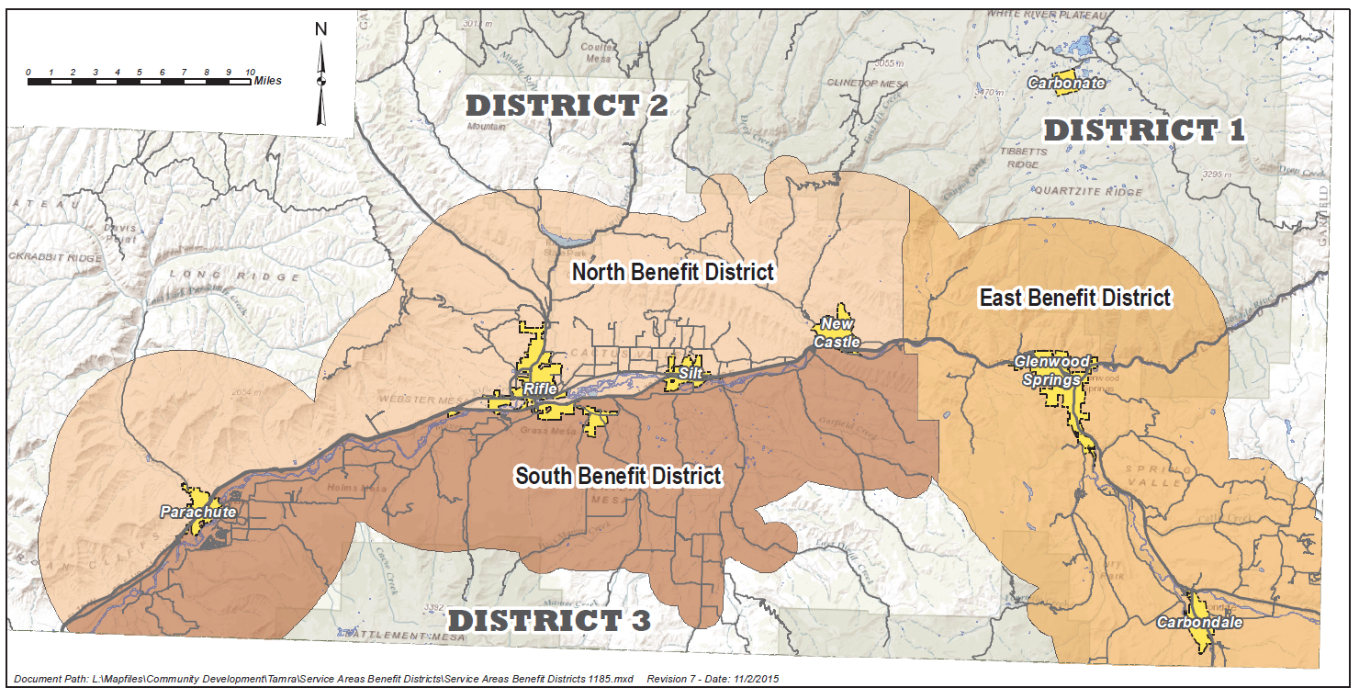

1. Plat Information
2. Common Plat Notes

These notes may be required dependent upon the site. The Applicant shall comply with the final plat requirements in addition to those requirements contained within the Land Use and Development Code. The Final Plat may be required to contain the following notes:

* + - 1. Noxious Weeds.

Control of noxious weeds is the responsibility of the property owner.

* + - 1. Open Hearth Solid-Fuel Fireplaces.

No open hearth solid-fuel fireplaces will be allowed anywhere within the subdivision. One new solid-fuel burning stove as defined by C.R.S. 25-7-401, et.seq., and the regulations promulgated thereunder, will be allowed in any dwelling unit. All dwelling units will be allowed an unrestricted number of natural gas burning stoves and appliances.

* + - 1. Exterior Lighting.

All exterior lighting shall be the minimum amount necessary and that all exterior lighting shall be directed inward and downward, towards the interior of the subdivision, except that provisions may be made to allow for safety lighting that goes beyond the property boundaries.

* + - 1. Right to Farm

Colorado is a “RIGHT-TO-FARM” state pursuant to C.R.S. 35-3-11, Et. Seq. Landowners, residents and visitors must be prepared to accept the activities, sights, sounds and smells of Garfield County’s agricultural operations as a normal and necessary aspect of living in a county with a strong rural character and a healthy ranching sector. Those with an urban sensitivity may perceive such activities, sights, sound, and smells only as inconvenience, eyesore, noise and odor. However, state law and county policy provide that ranching, farming and other agricultural activities and operations within Garfield County shall not be considered to be nuisances so long as operated in conformance with the law and in a non-negligent manner. Therefore, all must be prepared to encounter noises, odor, lights, mud, dust, smoke, chemicals, machinery on public roads, livestock on public roads, storage and disposal of manure, and the application by spraying or otherwise of chemical fertilizers, soil amendment, herbicide, and pesticides, any one or more of which may naturally occur as part of legal and non-negligent agricultural operations.

* + - 1. Maintenance of Fences, Rural Living, Etc.

All owners of land, whether ranch or residence, have obligations under state law and county regulations with regard to the maintenance of fences and irrigation ditches, controlling weeds, keeping livestock and pets under control, using property in accordance with zoning, and other aspects of using and maintaining property. Residents and landowners are encouraged to learn about these rights and responsibilities an act as good neighbors and citizens of the county. A good introductory source for such information is “A Guide to Rural Living & Small Scale Agriculture” put out by the Colorado State University Extension Office in Garfield County.

* + - 1. Mineral Rights.

The mineral rights associated with this property may not be transferred with the surface estate therefore allowing the potential for natural resource extraction on the property by the mineral estate owner(s) or lessee(s).

* + - 1. Accessory Dwelling Units.

Accessory dwelling units are not permitted in conformance with the comprehensive plan density standards.

* + - 1. Domestic Dogs.

Dogs kept on the property shall be in a fenced yard or on a leash to prevent harassment of wildlife.

* + - 1. Wildlife-Friendly Fencing.

Fencing on the property shall comply with the Colorado Parks and Wildlife specifications for wildlife-friendly fencing.

* + - 1. Septic Systems.

Engineer-designed septic systems are required within this subdivision.

* + - 1. Foundations.

Engineer-designed foundations are required within this subdivision.

* + - 1. Irrigation Ditches

Ditch Owner(s) Rights: Colorado State Statutes 37-86-102 provides that any person owning a water right or conditional water right shall be entitled to a right-of-way through the lands which lie between the point of diversion and point of use or proposed use for the purpose of transporting water for beneficial use in accordance with said water right or conditional water right.  Any impact, change or crossing of a ditch shall require approval from the ditch owner.

1. Plat certificates
   * + 1. Minor Subdivision

**County Commissioners’ Certificate**

Based upon the review and recommendation of Garfield County Director of Community Development, the Board of County Commissioners of Garfield County, Colorado, hereby approves this Subdivision Plat this ___ day of _______________, A.D., 20__, for filing with the Clerk and Recorder of Garfield County and for conveyance to the County of the public dedications shown hereon, subject to the provisions that approval in no way obligates Garfield County for the financing or construction of improvements on lands, public roads, highways or easements dedicated to the public, except as specifically agreed to by the Board of County Commissioners by subsequent resolution. This approval shall in no way obligate Garfield County for the construction, repair or maintenance of public roads, highways or any other public dedications shown hereon.

Chairman, Board of County Commissioners

Garfield County, Colorado

Witness my hand and seal of the County of Garfield.

ATTEST:

County Clerk

**Certificate of Dedication and Ownership**

The undersigned , being sole Owner(s) in fee simple of all that real property situated in Garfield County, described as follows:

containing _____ acres, more or less, has [have] caused the described real property to be surveyed, laid out, platted and subdivided into lots and blocks as shown on this Plat under the name and style of , a subdivision in the County of Garfield. The Owner(s) do(es) hereby dedicate and set apart all of the streets and roads as shown on the accompanying Plat to the use of the public forever, and hereby dedicate(s) to the Public Utilities those portions of said real property which are labeled as utility easements on the accompanying Plat as perpetual easements for the installation and maintenance of utilities, irrigation and drainage facilities including, but not limited to, electric lines, gas lines and telephone lines, together with the right to trim interfering trees and brush, with perpetual right of ingress and egress for installation and maintenance of such lines. Such easement and rights shall be utilized in a reasonable and prudent manner. All expense for street paving or improvements shall be furnished by the seller or purchaser, not by the County of Garfield.

EXECUTED this ____ day of _______________, A.D., 20__.

Owner

Address:

STATE OF COLORADO )

: ss

COUNTY OF GARFIELD )

The foregoing Certificate of Dedication and Ownership was acknowledged before me this ____ day of _______________, A.D., 20__, by .

My commission expires: .

Witness my hand and official seal.

(SEAL)

Notary Public

**Surveyor’s Certificate**

I, , do hereby certify that I am a Professional Land Surveyor licensed under the laws of the State of Colorado, that this Plat is a true, correct and complete Plat of , as laid out, platted, dedicated and shown hereon, that such Plat was made from an accurate survey of said property by me, or under my supervision, and correctly shows the location and dimensions of the lots, easements and streets of as the same are staked upon the ground in compliance with applicable regulations governing the subdivision of land.

In witness whereof, I have set my hand and seal this ____ day of , A.D., 20__.

Professional Land Surveyor

**Clerk and Recorder's Certificate**

This Plat was filed for record in the Office of the Clerk and Recorder of Garfield County, Colorado, at ____ o’clock _____, on this ____ day of , 20__, and is duly recorded as Reception No. .

Clerk and Recorder

By

Deputy

**County Surveyor's Certificate**

Approved for content and form only and not the accuracy of surveys, calculations or drafting, pursuant to C.R.S. § 38-51-101 and 102, *et seq.*

DATED this _____ day of , A.D., 20__.

Garfield County Surveyor

**Title Certificate**

I, , an attorney licensed to practice law in the State of Colorado, or agent authorized by a title insurance company, do hereby certify that I have examined the Title to all lands shown upon this Plat and that Title to such lands is vested in , free and clear of all liens and encumbrances (including mortgages, deeds of trust, judgments, easements, contracts and agreements of record affecting the real property in this Plat), except as follows: .

DATED this _____ day of , A.D., 20__.

TITLE COMPANY:

Agent

OR

Attorney

Colorado Attorney Registration No. ______

**Certificate of Taxes Paid**

I, the undersigned, do hereby certify that the entire amount of taxes and assessments due and payable as of , upon all parcels of real estate described on this Plat are paid in full.

DATED this _____ day of , A.D., 20__.

Treasurer of Garfield County

* + - 1. Major Subdivision

**County Commissioners’ Certificate**

This Plat is approved by the Board of County Commissioners of Garfield County, Colorado, this ____ day of _______________, A.D., 20__, for filing with the Clerk and Recorder of Garfield County and for conveyance to the County of the public dedications shown hereon, subject to the provision that approval in no way obligates Garfield County for the financing or construction of improvements on lands, public roads, highways or easements dedicated to the public, except as specifically agreed to by the Board of County Commissioners by subsequent resolution. This approval shall in no way obligate Garfield County for the construction, repair or maintenance of public roads, highways or any other public dedications shown hereon.

Chairman, Board of County Commissioners

Garfield County, Colorado

Witness my hand and seal of the County of Garfield.

ATTEST:

County Clerk

**Certificate of Dedication and Ownership**

The undersigned , being sole Owner(s) in fee simple of all that real property situated in Garfield County, described as follows:

containing _____ acres, more or less, has [have] caused the described real property to be surveyed, laid out, platted and subdivided into lots and blocks as shown on this Plat under the name and style of , a subdivision in the County of Garfield. The Owner(s) do(es) hereby dedicate and set apart all of the streets and roads as shown on the accompanying Plat to the use of the public forever, and hereby dedicate(s) to the Public Utilities those portions of said real property which are labeled as utility easements on the accompanying Plat as perpetual easements for the installation and maintenance of utilities, irrigation and drainage facilities including, but not limited to, electric lines, gas lines and telephone lines, together with the right to trim interfering trees and brush, with perpetual right of ingress and egress for installation and maintenance of such lines. Such easement and rights shall be utilized in a reasonable and prudent manner. All expense for street paving or improvements shall be furnished by the seller or purchaser, not by the County of Garfield.

EXECUTED this ____ day of _______________, A.D., 20__.

Owner

Address:

STATE OF COLORADO )

: ss

COUNTY OF GARFIELD )

The foregoing Certificate of Dedication and Ownership was acknowledged before me this ____ day of _______________, A.D., 20__, by .

My commission expires: .

Witness my hand and official seal.

(SEAL)

Notary Public

**Surveyor’s Certificate**

I, , do hereby certify that I am a Professional Land Surveyor licensed under the laws of the State of Colorado, that this Plat is a true, correct and complete Plat of , as laid out, platted, dedicated and shown hereon, that such Plat was made from an accurate survey of said property by me, or under my supervision, and correctly shows the location and dimensions of the lots, easements and streets of as the same are staked upon the ground in compliance with applicable regulations governing the subdivision of land.

In witness whereof, I have set my hand and seal this ____ day of , A.D., 20__.

Professional Land Surveyor

**Clerk and Recorder's Certificate**

This Plat was filed for record in the Office of the Clerk and Recorder of Garfield County, Colorado, at ____ o’clock _____, on this ____ day of , 20__, and is duly recorded as Reception No. .

Clerk and Recorder

By

Deputy

**County Surveyor's Certificate**

Approved for content and form only and not the accuracy of surveys, calculations or drafting, pursuant to C.R.S. § 38-51-101 and 102, *et seq.*

DATED this _____ day of , A.D., 20__.

Garfield County Surveyor

**Title Certificate**

I, , an attorney licensed to practice law in the State of Colorado, or agent authorized by a title insurance company, do hereby certify that I have examined the Title to all lands shown upon this Plat and that Title to such lands is vested in , free and clear of all liens and encumbrances (including mortgages, deeds of trust, judgments, easements, contracts and agreements of record affecting the real property in this Plat), except as follows: .

DATED this _____ day of , A.D., 20__.

TITLE COMPANY:

Agent

OR

Attorney

Colorado Attorney Registration No. ______

**Certificate of Taxes Paid**

I, the undersigned, do hereby certify that the entire amount of taxes and assessments due and payable as of , upon all parcels of real estate described on this Plat are paid in full.

DATED this _____ day of , A.D., 20__.

Treasurer of Garfield County

* + - 1. Conservation Subdivision

**County Commissioners’ Certificate**

This Plat is approved by the Board of County Commissioners of Garfield County, Colorado, this ____ day of _______________, A.D., 20__, for filing with the Clerk and Recorder of Garfield County and for conveyance to the County of the public dedications shown hereon, subject to the provision that approval in no way obligates Garfield County for the financing or construction of improvements on lands, public roads, highways or easements dedicated to the public, except as specifically agreed to by the Board of County Commissioners by subsequent resolution. This approval shall in no way obligate Garfield County for the construction, repair or maintenance of public roads, highways or any other public dedications shown hereon.

Chairman, Board of County Commissioners

Garfield County, Colorado

Witness my hand and seal of the County of Garfield.

ATTEST:

County Clerk

**Certificate of Dedication and Ownership**

The undersigned , being sole Owner(s) in fee simple of all that real property situated in Garfield County, described as follows:

containing _____ acres, more or less, has [have] caused the described real property to be surveyed, laid out, platted and subdivided into lots and blocks as shown on this Plat under the name and style of , a subdivision in the County of Garfield. The Owner(s) do(es) hereby dedicate and set apart all of the streets and roads as shown on the accompanying Plat to the use of the public forever, and hereby dedicate(s) to the Public Utilities those portions of said real property which are labeled as utility easements on the accompanying Plat as perpetual easements for the installation and maintenance of utilities, irrigation and drainage facilities including, but not limited to, electric lines, gas lines and telephone lines, together with the right to trim interfering trees and brush, with perpetual right of ingress and egress for installation and maintenance of such lines. Such easement and rights shall be utilized in a reasonable and prudent manner. All expense for street paving or improvements shall be furnished by the seller or purchaser, not by the County of Garfield.

EXECUTED this ____ day of _______________, A.D., 20__.

Owner

Address:

STATE OF COLORADO )

: ss

COUNTY OF GARFIELD )

The foregoing Certificate of Dedication and Ownership was acknowledged before me this ____ day of _______________, A.D., 20__, by .

My commission expires: .

Witness my hand and official seal.

(SEAL)

Notary Public

**Surveyor’s Certificate**

I, , do hereby certify that I am a Professional Land Surveyor licensed under the laws of the State of Colorado, that this Plat is a true, correct and complete Plat of , as laid out, platted, dedicated and shown hereon, that such Plat was made from an accurate survey of said property by me, or under my supervision, and correctly shows the location and dimensions of the lots, easements and streets of as the same are staked upon the ground in compliance with applicable regulations governing the subdivision of land.

In witness whereof, I have set my hand and seal this ____ day of , A.D., 20__.

Professional Land Surveyor

**Clerk and Recorder's Certificate**

This Plat was filed for record in the Office of the Clerk and Recorder of Garfield County, Colorado, at ____ o’clock _____, on this ____ day of , 20__, and is duly recorded as Reception No. .

Clerk and Recorder

By

Deputy

**County Surveyor's Certificate**

Approved for content and form only and not the accuracy of surveys, calculations or drafting, pursuant to C.R.S. § 38-51-101 and 102, *et seq.*

DATED this _____ day of , A.D., 20__.

Garfield County Surveyor

**Title Certificate**

I, , an attorney licensed to practice law in the State of Colorado, or agent authorized by a title insurance company, do hereby certify that I have examined the Title to all lands shown upon this Plat and that Title to such lands is vested in , free and clear of all liens and encumbrances (including mortgages, deeds of trust, judgments, easements, contracts and agreements of record affecting the real property in this Plat), except as follows: .

DATED this _____ day of , A.D., 20__.

TITLE COMPANY:

Agent

OR

Attorney

Colorado Attorney Registration No. ______

**Certificate of Taxes Paid**

I, the undersigned, do hereby certify that the entire amount of taxes and assessments due and payable as of , upon all parcels of real estate described on this Plat are paid in full.

DATED this _____ day of , A.D., 20__.

Treasurer of Garfield County

* + - 1. Amended Final Plat

**County Commissioner’s Certificate**

Based upon the review and recommendation of Garfield County Director of Community Development, the Board of County Commissioners of Garfield County, Colorado, hereby approves this Amended [Exemption] Plat this ___ day of _______________, A.D., 20__, for filing with the Clerk and Recorder of Garfield County and for conveyance to the County of the public dedications shown hereon, subject to the provisions that approval in no way obligates Garfield County for the financing or construction of improvements on lands, public roads, highways or easements dedicated to the public, except as specifically agreed to by the Board of County Commissioners by subsequent resolution. This approval shall in no way obligate Garfield County for the construction, repair or maintenance of public roads, highways or any other public dedications shown hereon.

Chairman, Board of County Commissioners

Garfield County, Colorado

Witness my hand and seal of the County of Garfield.

ATTEST:

County Clerk

**Certificate of Dedication and Ownership**

The undersigned , being sole Owner(s) in fee simple of all that real property situated in Garfield County, described as follows:

containing _____ acres, more or less, has [have] caused the described real property to be surveyed, laid out, platted and subdivided into lots and blocks as shown on this [Exemption] Plat under the name and style of , a subdivision in the County of Garfield. The Owner(s) do(es) hereby dedicate and set apart all of the streets and roads as shown on the accompanying Plat to the use of the public forever, and hereby dedicate(s) to the Public Utilities those portions of said real property which are labeled as utility easements on the accompanying Plat as perpetual easements for the installation and maintenance of utilities, irrigation and drainage facilities including, but not limited to, electric lines, gas lines and telephone lines, together with the right to trim interfering trees and brush, with perpetual right of ingress and egress for installation and maintenance of such lines. Such easement and rights shall be utilized in a reasonable and prudent manner. All expense for street paving or improvements shall be furnished by the seller or purchaser, not by the County of Garfield.

EXECUTED this ____ day of _______________, A.D., 20__.

Owner

Address:

STATE OF COLORADO )

: ss

COUNTY OF GARFIELD )

The foregoing Certificate of Dedication and Ownership was acknowledged before me this ____ day of _______________, A.D., 20__, by .

My commission expires: .

Witness my hand and official seal.

(SEAL)

Notary Public

**Surveyor’s Certificate**

I, , do hereby certify that I am a Professional Land Surveyor licensed under the laws of the State of Colorado, that this Plat is a true, correct and complete Plat of , as laid out, platted, dedicated and shown hereon, that such Plat was made from an accurate survey of said property by me, or under my supervision, and correctly shows the location and dimensions of the lots, easements and streets of as the same are staked upon the ground in compliance with applicable regulations governing the subdivision of land.

In witness whereof, I have set my hand and seal this ____ day of , A.D., 20__.

Professional Land Surveyor

**Clerk and Recorder's Certificate**

This Plat was filed for record in the Office of the Clerk and Recorder of Garfield County, Colorado, at ____ o’clock _____, on this ____ day of , 20__, and is duly recorded as Reception No. .

Clerk and Recorder

By

Deputy

**County Surveyor's Certificate**

Approved for content and form only and not the accuracy of surveys, calculations or drafting, pursuant to C.R.S. § 38-51-101 and 102, *et seq.*

DATED this _____ day of , A.D., 20__.

Garfield County Surveyor

**Title Certificate**

I, , an attorney licensed to practice law in the State of Colorado, or agent authorized by a title insurance company, do hereby certify that I have examined the Title to all lands shown upon this Plat and that Title to such lands is vested in , free and clear of all liens and encumbrances (including mortgages, deeds of trust, judgments, easements, contracts and agreements of record affecting the real property in this Plat), except as follows: .

DATED this _____ day of , A.D., 20__.

TITLE COMPANY:

Agent

OR

Attorney

Colorado Attorney Registration No. ______

**Certificate of Taxes Paid**

I, the undersigned, do hereby certify that the entire amount of taxes and assessments due and payable as of , upon all parcels of real estate described on this Plat are paid in full.

DATED this _____ day of , A.D., 20__.

Treasurer of Garfield County

* + - 1. Rural Land Development Exemption

**County Commissioners’ Certificate**

This Exemption Plat is approved by the Board of County Commissioners of Garfield County, Colorado, this ____ day of _______________, A.D., 20__, for filing with the Clerk and Recorder of Garfield County and for conveyance to the County of the public dedications shown hereon, subject to the provision that approval in no way obligates Garfield County for the financing or construction of improvements on lands, public roads, highways or easements dedicated to the public, except as specifically agreed to by the Board of County Commissioners by subsequent resolution. This approval shall in no way obligate Garfield County for the construction, repair or maintenance of public roads, highways or any other public dedications shown hereon.

Chairman, Board of County Commissioners

Garfield County, Colorado

Witness my hand and seal of the County of Garfield.

ATTEST:

County Clerk

**Certificate of Dedication and Ownership**

The undersigned, , being sole Owner(s) in fee simple of all that real property situated in Garfield County, Colorado, described as follows:

containing _____ acres, more or less, has [have] by these presents laid out and platted the same as shown on this Plat under the name and style of _______________________________, an Exemption Plat of lands in the County of Garfield. The Owner(s) do(es) hereby dedicate and set apart all of the streets and roads as shown on the accompanying Plat to the use of the public forever, and hereby dedicate(s) to the Public Utilities those portions of said real property which are labeled as utility easements on the accompanying Plat as perpetual easements for the installation and maintenance of utilities, irrigation and drainage facilities including, but not limited to, electric lines, gas lines and telephone lines, together with the right to trim interfering trees and brush, with perpetual right of ingress and egress for installation and maintenance of such lines. Such easement and rights shall be utilized in a reasonable and prudent manner. All expense for street paving or improvements shall be furnished by the seller or purchaser, not by the County of Garfield.

EXECUTED this ____ day of _______________, A.D., 20__.

Owner

Address:

STATE OF COLORADO )

: ss

COUNTY OF GARFIELD )

The foregoing Certificate of Dedication and Ownership was acknowledged before me this ____ day of _______________, A.D., 20__, by .

My commission expires: .

Witness my hand and official seal.

(SEAL)

Notary Public

**Surveyor’s Certificate**

I, , do hereby certify that I am a Professional Land Surveyor licensed under the laws of the State of Colorado, that this Plat is a true, correct and complete Plat of , as laid out, platted, dedicated and shown hereon, that such Plat was made from an accurate survey of said property by me, or under my supervision, and correctly shows the location and dimensions of the lots, easements and streets of as the same are staked upon the ground in compliance with applicable regulations governing the subdivision of land.

In witness whereof, I have set my hand and seal this ____ day of , A.D., 20__.

Professional Land Surveyor

**Clerk and Recorder's Certificate**

This Plat was filed for record in the Office of the Clerk and Recorder of Garfield County, Colorado, at ____ o’clock _____, on this ____ day of , 20__, and is duly recorded as Reception No. .

Clerk and Recorder

By

Deputy

**County Surveyor's Certificate**

Approved for content and form only and not the accuracy of surveys, calculations or drafting, pursuant to C.R.S. § 38-51-101 and 102, et seq.

DATED this _____ day of , A.D., 20__.

Garfield County Surveyor

**Title Certificate**

I, , an attorney licensed to practice law in the State of Colorado, or agent authorized by a title insurance company, do hereby certify that I have examined the Title to all lands shown upon this Plat and that Title to such lands is vested in , free and clear of all liens and encumbrances (including mortgages, deeds of trust, judgments, easements, contracts and agreements of record affecting the real property in this Plat), except as follows: .

DATED this _____ day of , A.D., 20__.

TITLE COMPANY:

Agent

OR

Attorney

Colorado Attorney Registration No. ______

**Certificate of Taxes Paid**

I, the undersigned, do hereby certify that the entire amount of taxes and assessments due and payable as of , upon all parcels of real estate described on this Plat are paid in full.

DATED this _____ day of , A.D., 20__.

Treasurer of Garfield County

* + - 1. Public/County Road Split Exemption

**County Commissioner’s Certificate**

Based upon the review and recommendation of Garfield County Director of Community Development, the Board of County Commissioners of Garfield County, Colorado, hereby approves this Exemption Plat this ___ day of _______________, A.D., 20__, for filing with the Clerk and Recorder of Garfield County and for conveyance to the County of the public dedications shown hereon, subject to the provisions that approval in no way obligates Garfield County for the financing or construction of improvements on lands, public roads, highways or easements dedicated to the public, except as specifically agreed to by the Board of County Commissioners by subsequent resolution. This approval shall in no way obligate Garfield County for the construction, repair or maintenance of public roads, highways or any other public dedications shown hereon.

Chairman, Board of County Commissioners

Garfield County, Colorado

Witness my hand and seal of the County of Garfield.

ATTEST:

County Clerk

**Certificate of Dedication and Ownership**

The undersigned, , being sole Owner(s) in fee simple of all that real property situated in Garfield County, Colorado, described as follows:

containing _____ acres, more or less, has [have] by these presents laid out and platted the same as shown on this Plat under the name and style of _______________________________, an Exemption Plat of lands in the County of Garfield. The Owner(s) do(es) hereby dedicate and set apart all of the streets and roads as shown on the accompanying Plat to the use of the public forever, and hereby dedicate(s) to the Public Utilities those portions of said real property which are labeled as utility easements on the accompanying Plat as perpetual easements for the installation and maintenance of utilities, irrigation and drainage facilities including, but not limited to, electric lines, gas lines and telephone lines, together with the right to trim interfering trees and brush, with perpetual right of ingress and egress for installation and maintenance of such lines. Such easement and rights shall be utilized in a reasonable and prudent manner. All expense for street paving or improvements shall be furnished by the seller or purchaser, not by the County of Garfield.

EXECUTED this ____ day of _______________, A.D., 20__.

Owner

Address:

STATE OF COLORADO )

: ss

COUNTY OF GARFIELD )

The foregoing Certificate of Dedication and Ownership was acknowledged before me this ____ day of _______________, A.D., 20__, by .

My commission expires: .

Witness my hand and official seal.

(SEAL)

Notary Public

**Surveyor’s Certificate**

I, , do hereby certify that I am a Professional Land Surveyor licensed under the laws of the State of Colorado, that this Plat is a true, correct and complete Plat of , as laid out, platted, dedicated and shown hereon, that such Plat was made from an accurate survey of said property by me, or under my supervision, and correctly shows the location and dimensions of the lots, easements and streets of as the same are staked upon the ground in compliance with applicable regulations governing the subdivision of land.

In witness whereof, I have set my hand and seal this ____ day of , A.D., 20__.

Professional Land Surveyor

**Clerk and Recorder's Certificate**

This Plat was filed for record in the Office of the Clerk and Recorder of Garfield County, Colorado, at ____ o’clock _____, on this ____ day of , 20__, and is duly recorded as Reception No. .

Clerk and Recorder

By

Deputy

**County Surveyor's Certificate**

Approved for content and form only and not the accuracy of surveys, calculations or drafting, pursuant to C.R.S. § 38-51-101 and 102, et seq.

DATED this _____ day of , A.D., 20__.

Garfield County Surveyor

**Title Certificate**

I, , an attorney licensed to practice law in the State of Colorado, or agent authorized by a title insurance company, do hereby certify that I have examined the Title to all lands shown upon this Plat and that Title to such lands is vested in , free and clear of all liens and encumbrances (including mortgages, deeds of trust, judgments, easements, contracts and agreements of record affecting the real property in this Plat), except as follows: .

DATED this _____ day of , A.D., 20__.

TITLE COMPANY:

Agent

OR

Attorney

Colorado Attorney Registration No. ______

**Certificate of Taxes Paid**

I, the undersigned, do hereby certify that the entire amount of taxes and assessments due and payable as of , upon all parcels of real estate described on this Plat are paid in full.

DATED this _____ day of , A.D., 20__.

Treasurer of Garfield County

* + - 1. Common Interest Community Subdivision

**County Commissioner’s Certificate**

Based upon the review and recommendation of Garfield County Director of Community Development, the Board of County Commissioners of Garfield County, Colorado, hereby approves this Plat this ___ day of _______________, A.D., 20__, for filing with the Clerk and Recorder of Garfield County and for conveyance to the County of the public dedications shown hereon, subject to the provisions that approval in no way obligates Garfield County for the financing or construction of improvements on lands, public roads, highways or easements dedicated to the public, except as specifically agreed to by the Board of County Commissioners by subsequent resolution. This approval shall in no way obligate Garfield County for the construction, repair or maintenance of public roads, highways or any other public dedications shown hereon.

Chairman, Board of County Commissioners

Garfield County, Colorado

Witness my hand and seal of the County of Garfield.

**ATTEST:**

County Clerk

**Certificate of Dedication and Ownership**

In Compliance with C.R.S. § 38-33.3-209, as amended

The undersigned, , being sole Owner(s) in fee simple of all that real property situated in Garfield County, Colorado, described as follows:

containing _____ acres, more or less, has [have] by these presents laid out, platted and subdivided the same into lots and blocks and condominium units as shown on this Plat under the name and style of , a subdivision in the County of Garfield. The Owner(s) do(es) hereby dedicate and set apart all of the streets and roads as shown on the accompanying Plat to the use of the public forever, and hereby dedicate(s) to the Public Utilities those portions of said real property which are labeled as utility easements on the accompanying Plat as perpetual easements for the installation and maintenance of utilities, irrigation and drainage facilities including, but not limited to, electric lines, gas lines and telephone lines, together with the right to trim interfering trees and brush, with perpetual right of ingress and egress for installation and maintenance of such lines. Such easement and rights shall be utilized in a reasonable and prudent manner. All expense for street paving or improvements shall be furnished by the seller or purchaser, not by the County of Garfield. Owner(s) further certify(ies) that all information required by C.R.S. § 38-33.3-209, as amended, is contained in [this Plat] [in the Declaration] [in this Plat and the Declaration].

EXECUTED this ____ day of _______________, A.D., 20__.

Owner

Address:

STATE OF COLORADO )

: ss

COUNTY OF GARFIELD )

The foregoing Certificate of Dedication and Ownership was acknowledged before me this ____ day of _______________, A.D., 20__, by .

My commission expires: .

Witness my hand and official seal.

(SEAL)

Notary Public

**Surveyor’s Certificate**

I, , do hereby certify that I am a Professional Land Surveyor licensed under the laws of the State of Colorado, that this common interest ownership map and Plat fully and accurately depict the improvements, including the condominium units and common ownership areas, and identifies location, layout, dimensions and horizontal and vertical boundaries, that such map was prepared subsequent to substantial completion of the improvements, and that such map and Plat comply with and contain all of the information required by C.R.S. § 38-33.3-209, as amended, and all other statutes and regulations applicable to maps and Plats of condominium common interest subdivisions.

In witness whereof, I have set my hand and seal this ____ day of , A.D., 20__.

Professional Land Surveyor

**Clerk and Recorder's Certificate**

This Plat was filed for record in the Office of the Clerk and Recorder of Garfield County, Colorado, at ____ o’clock _____, on this ____ day of , 20__, and is duly recorded as Reception No. .

Clerk and Recorder

By

Deputy

**County Surveyor's Certificate**

Approved for content and form only and not the accuracy of surveys, calculations or drafting, pursuant to C.R.S. § 38-51-101 and 102, *et seq.*

DATED this _____ day of , A.D., 20__.

Garfield County Surveyor

**Title Certificate**

I, , an attorney licensed to practice law in the State of Colorado, or agent authorized by a title insurance company, do hereby certify that I have examined the Title to all lands shown upon this Plat and that Title to such lands is vested in , free and clear of all liens and encumbrances (including mortgages, deeds of trust, judgments, easements, contracts and agreements of record affecting the real property in this Plat), except as follows: .

DATED this _____ day of , A.D., 20__.

TITLE COMPANY:

Agent

OR

Attorney

Colorado Attorney Registration No. ______

**Certificate of Taxes Paid**

I, the undersigned, do hereby certify that the entire amount of taxes and assessments due and payable as of , upon all parcels of real estate described on this Plat are paid in full.

DATED this _____ day of , A.D., 20__.

Treasurer of Garfield County

* + - 1. Other Plat Certificates To Be Used, As Necessary

**Lienholder Consent, Subordination and Release as to Public Rights-of-Way**

**(No Exception Needed in Title Certificate)**

, as the Beneficiary under Deed(s) of Trust granted by the Owner(s) upon the real property platted and divided as shown upon the within [Exemption] Plat, certifies that the undersigned has reviewed the [Exemption] Plat and by this certification hereby joins in and consents to said Subdivision [Exemption] Plat and to the recording thereof. Beneficiary agrees that any foreclosure of said Deed(s) of Trust shall not adversely affect the existence and continued validity of the [Exemption] Plat, which shall run with the land and remain in full force and effect as if this [Exemption] Plat had been delivered and recorded prior to the recording of said Deed(s) of Trust. Without limiting the generality of the foregoing, the public right(s)-of-way depicted on the [Exemption] Plat are dedicated by the Owner(s) hereon, free and clear of any interest in the Beneficiary. Notwithstanding such consent and subordination and release as to public rights-of-way, said real property, other than the public right(s)-of-way dedicated hereon, shall continue to be encumbered by the Deed(s) of Trust unless released in accordance with law.

EXECUTED this ____ day of _______________, A.D., 20__.

Lienholder

STATE OF COLORADO )

: ss

COUNTY OF GARFIELD )

The foregoing Lienholder Consent, Subordination and Release as to Public Rights-of-Waywas acknowledged before me this ____ day of _________________, A.D., 20__, by .

My commission expires: .

Witness my hand and official seal.

(SEAL)

Notary Public

**Lienholder Consent and Subordination**

**(Exception Needed in Title Certificate)**

The undersigned, being the Beneficiary under a Deed of Trust granted by the Owner(s) upon the real property platted and divided as shown upon the within [Exemption] Plat, certifies that the undersigned has reviewed the [Exemption] Plat and by this certification hereby consents to said [Exemption] Plat and to the recording thereof. Beneficiary further consents to said [Exemption] Plat as stated in the certificate of dedication and ownership executed by the Owner(s) hereon, and hereby subordinates any interest that Beneficiary may have in and to the property subject to such dedication, to the entity(ies) or the general public to which such dedication is made.

EXECUTED this ____ day of _______________, A.D., 20__.

Lienholder

STATE OF COLORADO )

: ss

COUNTY OF GARFIELD )

The foregoing Lienholder Consent and Subordination was acknowledged before me this ____ day of _________________, A.D., 20__, by .

My commission expires: .

Witness my hand and official seal.

(SEAL)

Notary Public

**Easement Holder Consent**

The undersigned, holding easements upon the real property which is platted and subdivided as shown on the within Final Plat, hereby certifies that it has reviewed the within Plat and by this certification does hereby consent to said Plat and to the recording thereof, and to all dedications made by and upon said Plat as stated in the Certification of Dedication and Ownership set forth hereon, and does hereby subordinate any interest that it may have in and to the property subject to such dedications to the entity(ies) to which such dedications are made.

EXECUTED this ____ day of _______________, A.D., 20__.

Easement Holder

STATE OF COLORADO )

: ss

COUNTY OF GARFIELD )

The foregoing Easement Holder Consent was acknowledged before me this ____ day of _________________, A.D., 20__, by .

My commission expires: .

Witness my hand and official seal.

(SEAL)

Notary Public

1. Avigation EASEMENT Sample

**AVIGATION AND HAZARD EASEMENT**

WHEREAS, (full name of property owner(s)) hereinafter called the Grantors, are the owners in fee of that certain parcel of land situated in the City of ____________________, County of ____________________, State of __________________________, more particularly described as follows: (Full description of property to be covered by easement)

hereinafter called “Grantors’ property,” and outlined on the attached map (Exhibit 1);

NOW, THEREFORE, in consideration of the sum of _________________dollars ($_____________) and other good and valuable consideration, the receipt and sufficiency of which is hereby acknowledged, the Grantors, for themselves, their heirs, administrators, executors, successors, and assigns, do hereby grant, bargain, sell, and convey unto (owner and operator of airport, i.e., City of _________________) hereinafter called the Grantee, its successors and assigns, for the use and benefit of the public, as easement and right of way, appurtenant to (full name of airport) or the unobstructed passage of all aircraft, (“aircraft” being defined for the purpose of this instrument of any contrivance now known or hereafter invented, used, or designed for navigation of or flight in the air) by whomsoever owned and operated.

In the air space above Grantors’ property above an imaginary plane rising and extending in a general (i.e., Easterly) direction over Grantors’ property, said imaginary plane running from approximately (i.e., 25) feet Mean Sea level above Point A on Exhibit 1 at the rate of one foot vertically for each (i.e., 50) feet horizontally to approximately (i.e., 55) feet Mean Sea level above Point B on Exhibit 1, to an infinite height above said imaginary plane,1

(OR USE THE FOLLOWING)

in the air space above Grantors’ property above a Mean Sea level of (i.e., 150) feet, to an infinite height above said Mean Sea level of (i.e., 150) feet,1 (OR USE THE FOLLOWING)

in all air space above the surface of Grantors’ property, to an infinite height above said Grantors’ property.[1]

Together with the right to cause in all air space above the surface of Grantors’ property such noise, vibrations, fumes, dust, fuel particles, and all other effects that may be caused or may have been caused by the operation of aircraft landing at, or taking off from, or operating at or on said ____________(full name of airport).

The easement and right of way hereby granted includes the continuing right in the Grantee to prevent the erection or growth upon Grantors’ property of any building, structure, tree, or other object, extending into the air space above the aforesaid imaginary plane,

(OR USE THE FOLLOWING)

extending into the air space above the said Mean Sea level of (i.e., 150) feet,1

(OR USE THE FOLLOWING)

extending into the air space above the surface of Grantors’ property;1

and to remove from said air space, or at the sole option of the Grantee, as an alternative, to mark and light as obstructions to air navigation, any such building, structure, tree or other objects now upon, or which in the future may be upon Grantors’ property, together with the right of ingress to, egress from, and passage over Grantors’ property for the above purposes.

TO HAVE AND TO HOLD said easement and right of way, and all rights appertaining thereto unto the Grantee, its successors, and assigns, until said (full name of airport) shall be abandoned and shall cease to be used for public airport purposes.

AND for the consideration hereinabove set forth, the Grantors, for themselves, their heirs, administrators, executors, successors, and assigns, do hereby agree that for and during the life of said easement and right of way, they will not hereafter erect, permit the erection or growth of, or permit or suffer to remain upon Grantors’ property any building, structure, tree, or other object extending into the aforesaid prohibited air space, and that they shall not hereafter use or permit or suffer the use of Grantors’ property in such a manner as to create electrical interference with radio communication between any installation upon said airport and aircraft, or as to make it difficult for flyers to distinguish between airport lights and others, or as to impair visibility in the vicinity of the airport or as otherwise to endanger the landing, taking off, or maneuvering of aircraft, it being understood and agreed that the aforesaid covenants and agreements shall run with the land.

In consideration of the premises and to assure Grantee of the continued benefits accorded it under this Easement, (name of mortgagee), owner and holder of a mortgage dated ________________________ and recorded ____________________ covering the premises above described, does hereby covenant and agree that said mortgage shall be subject to and subordinate to this Easement and the recording of this Easement shall have preference and precedence and shall be superior and prior in lien to said mortgage irrespective of the date of the making or recording of said mortgage instrument.[2]

IN WITNESS WHEREOF, the Grantors have hereunto set their hands and seals this ________________day of ________________________, 20_________. Signed, sealed, and delivered in the presence of: ______________________________ __________________________(SEAL) ______________________________ __________________________(SEAL) (Notarial Acknowledgment)

1. Financial Documents
2. Irrevocable Letter of Credit

**IRREVOCABLE STANDBY LETTER OF CREDIT**

Reference #:

Amount:

Date of Issue:

Expiration Date:

BENEFICIARY: Board of County Commissioners of Garfield County (“Beneficiary” or “BOCC”)

108 8th Street, Suite 213

Glenwood Springs, CO 81601

ACCOUNT PARTY/Applicant:

_________________________________________

_________________________________________

_________________________________________

*Establishment/Face Amount/Purpose/Expiration Date/Transferability*

We hereby establish/issue/open, at the request of the Applicant/Account Party, Irrevocable Standby Letter of Credit No. ______________ in an amount not to exceed _________________ Thousand _________________ Hundred Dollars and ___________ Cents ($___________________). The purpose of this letter is to secure the Applicant/Account Party’s performance of and compliance with the agreement between Applicant/Account Party and Beneficiary, dated ______________ and titled _______________________________________ (“Subdivision Improvements Agreement”). This Letter of Credit expires at _____________________ Bank, at _____ p.m. Mountain Standard Time on ______________, 200__. This letter is not transferable.

*Partial Releases*

Partial draws are [are not] permitted. The BOCC may [may not] authorize periodic reductions in the face amount of this Letter of Credit[*If Bank requires Reduction Certificates:* and, if so authorized, the revised face amount of the Letter of Credit shall be evidenced by a separate Reduction Certificate, approved and executed by the BOCC or the BOCC’s authorized representative].

*Conditions for Payment to Beneficiary*

Drafts submitted by Beneficiary must be accompanied by the following documents:

1. Beneficiary’s signed statement executed by the Chairman of the BOCC or the BOCC’s authorized designee stating:

__________________________________________________, developer of Subdivision [PUD] is in default of its obligations set forth in that certain Subdivision Improvements Agreement between ___________________________ and the BOCC, dated ___________________, and recorded as Reception Number ___________________ in Book ______________ at Page _____________ of the Real Estate Records of the Office of the Garfield County Clerk and Recorder.

1. The original Letter of Credit, endorsed on the reverse side with the words: “Drawn by the Board of County Commissioners of Garfield County, Colorado in the amount of $______________________,” manually signed by the Chairman or the BOCC’s authorized representative.
2. Telefacsimile of the Draw Documents is acceptable to our Fax No. __________. If presentation is made by fax, prompt phone notification must be given to _________________________, _____________________ (telephone no.), or _________________________, _____________________ (telephone no.). The fax presentation shall be deemed the original presentation. In the event of a full or final drawing the original standby Letter of Credit must be returned to bank by overnight courier at the time of fax presentation.

*Cancellation*

This Letter of Credit and amendments, if any, must be returned to us for cancellation by Applicant/Account party with a statement signed by the Beneficiary stating: “This Letter of Credit is no longer required by the BOCC and is hereby returned to the issuing bank for cancellation.”

*Issuer’s Undertaking*

We hereby agree to honor each draft drawn under and in compliance with the terms of this Letter of Credit if presented, together with the documents above specified, to *(name)*__________________ Bank, (*street* *address)*____________________*(city/town)* _____________, Colorado, on or before the date of expiration identified above. This letter is issued subject to the Uniform Customs and Practices for Documentary Credit ( _________ Revision), International Chamber of Commerce Publication Number 600 and the Uniform Commercial Code at C.R.S., §4-1-101 *et seq.*, as amended.

The laws of the State of Colorado shall govern the validity, interpretation, performance and enforcement of this Letter of Credit, and mandatory exclusive venue for any judicial proceeding pertaining to this Letter of Credit shall be in a court of competent jurisdiction in Garfield County, Colorado.

_______________________________________ Bank

By _________________________________

Name _________________________________

Title _________________________________

THIS IS A FORM DOCUMENT. BANKS USE DIFFERENT FORMATS AND DIFFERENT TERMS TO IDENTIFY ISSUER, APPLICANT AND BENEFICIARY. ASK YOUR BANK TO ADDRESS THE MATTERS IDENTIFIED ABOVE: *Establishment, Face Amount, Purpose, Expiration Date, Transferability*, *Partial /Single Releases, Conditions for Payment to Beneficiary, Cancellation*,  *Issuer’s Undertaking* AND TO SPECIFY WHETHER OR NOT PARTIAL RELEASES OF THE LETTER OF CREDIT, IF ALLOWED, REQUIRE THE USE OF REDUCTION CERTIFICATES.

LETTERS OF CREDIT ARE HELD IN THE CUSTODY OF THE GARFIELD COUNTY TREASURER. ADDRESS QUESTIONS RELATED TO PARTIAL OR FULL RELEASE, HOWEVER, TO THE BUILDING AND PLANNING DEPARTMENT.

1. Partial Release of Letter of Credit

REQUEST FOR PARTIAL RELEASE OF LETTER OF CREDIT

Board of County Commissioners

Garfield County, Colorado

c/o Director of Community Development

108 8th Street, Suite 401

Glenwood Springs, CO 81601

RE: _______________Subdivision [PUD]

This request is written to formally notify the BOCC of work completed for _____________________ Subdivision [PUD]. As Owner [On behalf of the Owner], we request that the BOCC review the attached Engineer’s Certificate of Partial Completion and approve a reduction in the face amount of the Letter of Credit in the amount of

$____________________, to a reduced face amount of $_____________________.

Attached is the certified original cost estimate and work completed schedule, showing:

Engineers Cost Estimate _____________

Work Completed, less 10% _____________

Reduced Face Amount of LOC _____________

Based on periodic observation and testing, the construction has been completed, to date, in accordance with the intent of the plans and specifications that were reviewed and approved by the BOCC’s representatives and referenced in Paragraph 2 of the Subdivision Improvements Agreement between the BOCC and the Owner.

If further information is needed, please contact _________________________, at ___________.

_____________________________

Owner

or

_____________________________

Owner’s Representative/Engineer

1. Request for Final Release of Letter of Credit.

REQUEST FOR FINAL RELEASE OF LETTER OF CREDIT

Board of County Commissioners

Garfield County, Colorado

c/o Director of Building and Planning

108 8th Street, Suite 401

Glenwood Springs, CO 81601

RE: _______________[Subdivision] [PUD] [LAND USE CHANGE PERMIT]

This request is written to formally notify the BOCC of work completed for _____________________ [Subdivision] [PUD] [LAND USE CHANGE PERMIT]. As Owner [On behalf of the Owner], we request that the BOCC review the attached Engineer’s Certificate of Completion and approve a full release of the Letter of Credit in the amount of $____________________.

Attached is the certified original cost estimate and work completed schedule, showing that all improvements required by the Improvements Agreement and secured by the Letter of Credit have been completed.

Also enclosed are the following, required by the Improvements Agreement [LAND USE CHANGE PERMIT] dated _______ between Owner and the BOCC, recorded at Reception No. ____________ at the Real Estate Records of the Garfield County Clerk and Recorder (the “SIA”):

1. record drawings bearing the stamp of Owner’s Engineer certifying that all improvements have been constructed in accordance with the requirements of the IA, both in hand copy and digital format acceptable to the BOCC; and
2. copies of instruments conveying real property and other interests which Owner was obligated to convey to the homeowner’s association or other entity at the time of final Plat Approval.

If further information is needed, please contact _________________________, at ___________.

_____________________________

Owner

or

_____________________________

Owner’s Representative/Engineer

1. Treasurer’s Deposit Agreement

**ACKNOWLEDGMENT OF SATISFACTION AND DIRECTION TO TREASURER**

**TREASURER’S DEPOSIT AGREEMENT**

**Recitals**

1. ___________ , [a Colorado ________________] [an individual], entered into a 20____ Garfield County Treasurer’s Deposit Agreement with the Board of County Commissioners of Garfield County, Colorado (“BOCC”) and the Treasurer of Garfield County, Colorado (“Treasurer”) dated _________________ and recorded on __________ as Reception Number ______________ of the Real Estate Records of the Garfield County Clerk and Recorder ( “Deposit Agreement”).
2. has presented certification to the BOCC from a licensed engineer that construction of Improvements is final and/or written approval from the Garfield County Vegetation Manager that revegetation is successful related to Grading Permit number ______________.

**Acknowledgment**

NOW THEREFORE, at the request of and in consideration of the premises and the prior agreements contained in the Deposit Agreement the BOCC hereby:

1. acknowledges full satisfaction of the security requirements of the Grading Permit;
   * + - 1. authorizes disbursement of funds from the Treasurer’s Account in the amount of $ , resulting in a remaining balance of $ -0- ;
   1. authorizes and directs the Treasurer to release the funds held in the Treasurer’s Account to ________________________ an authorized representative of _______________.

BOARD OF COUNTY COMMISSIONERS

ATTEST: OF GARFIELD COUNTY, COLORADO

By: _________________________

Clerk to the Board John Martin, Chairman

Date: _________________________

1. Treasurer’s Revegetation Deposit Agreement

**GARFIELD COUNTY TREASURER’S DEPOSIT AGREEMENT**

**[INSERT NAME OF PROJECT] REVEGETATION**

**Owner: _____________________**

THIS 20____ GARFIELD COUNTY TREASURER’S DEPOSIT AGREEMENT – [INSERT NAME OF PROJECT] REVEGETATION (“Deposit Agreement”) is entered into by and between the Garfield County Board of County Commissioners (“BOCC” or “beneficiary”), the Garfield County Treasurer, Georgia Chamberlain (“Treasurer”), and [INSERT NAME OF PROPERTY OWNER] (“Owner”).

Recitals

The BOCC approved the Owner’s Application for a Grading Permit for the [INSERT NAME OF PROJECT] pursuant to Permit Number [#].

The Grading Permit requires provision of “Security for Revegetation” and Owner wishes to deposit good funds for such security.

The BOCC is willing to allow Owner’s use of a Garfield County Treasurer’s Deposit Agreement as such financial assurance.

The Treasurer is willing and able to hold such funds in accordance with the Treasurer’s statutory duties outlined in C.R.S. §§ 30-10-701, et seq. and 30-1-102, as amended.

Agreement

NOW THEREFORE, in consideration of the foregoing Recitals, the parties agree as follows:

1. [INSERT NAME OF PROJECT] Revegetation Treasurer’s Account. Owner shall deposit with the Treasurer the sum of ______________ Dollars ($___________) to secure revegetation as required in the Grading Permit. In consideration of the service fee payable to the Treasurer, identified in Paragraph 2, below, the Treasurer shall place the funds in an interest bearing account and disburse funds there from in accordance with the terms of this Deposit Agreement. Such account shall be known as the “[INSERT NAME OF PROJECT] Revegetation Treasurer’s Account” and shall be subject to the terms and conditions of this Deposit Agreement.
2. Treasurer’s Service Fee. The Treasurer’s service fee shall be, in accordance with C.R.S. § 30-1-102(1)(c), as amended, one percent (1.0%) of the deposited funds, i.e., _______________ Dollars ($________). The service fee covers administrative costs incurred by the Treasurer in distributing and accounting for the [INSERT NAME OF PROJECT] Revegetation Treasurer’s Account. Such fee shall be paid by Owner in cash or by check made payable to the Garfield County Treasurer, as identified in the “Receipt” section of this Deposit Agreement (page 5), on or before the date of execution of this Deposit Agreement. The service fee is deemed to be earned by the Treasurer upon execution of this Deposit Agreement. Interest earned on the [INSERT NAME OF PROJECT] Revegetation Treasurer’s Account shall be paid to Owner as part of the single disbursement detailed in Paragraph 3, below. The Treasurer shall thereafter provide to Owner a report of interest earned, as required by state and federal tax law. Owner shall provide a completed Form W-9 to the Treasurer at the time the deposit is made.
3. Disbursement Procedure. Disbursement from the [INSERT NAME OF PROJECT] Revegetation Treasurer’s Account shall be made by the Treasurer upon the written direction of the BOCC, as follows:
4. Request for Review and Approval. Upon complying with the two-year revegetation requirement, Owner shall obtain written approval from the Garfield County Vegetation Management Department of the required revegetation work.
5. Deficiencies. If the Garfield County Vegetation Management Department refuses approval of the success of revegetation, the Garfield County Vegetation Management Department shall provide written notice of deficiency in substantial compliance with the provisions of the Grading Permit and Owner shall correct the identified deficiencies.
6. Single Request for Disbursement. This Deposit Agreement does not provide for successive partial releases or disbursements from the [INSERT NAME OF PROJECT] Revegetation Treasurer’s Account. One (1) final disbursement shall be requested by Owner, upon completion of Revegetation. Owner specifically recognizes and agrees that partial releases are not allowed.
7. Request for Disbursement/Release. Owner shall request disbursement by means of a written “Request for Disbursement,” addressed to the BOCC and delivered to the Garfield County Building and Planning Department. The Request for Disbursement shall be accompanied by an approval statement from the Garfield County Vegetation Management Department.
8. BOCC’s Acknowledgment and Direction. Upon review of the submittals required by Paragraph 3.D., above, if the BOCC approves the statement from the Garfield County Vegetation Management Department, the BOCC shall issue its “Acknowledgment of Satisfaction and Direction to Treasurer”, in a form substantially similar to that document attached to and incorporated herein by reference as “Exhibit A”.

1. BOCC’s Completion of Revegetation. If, in the sole discretion of the BOCC, the Owner’s revegetation success is deemed unsatisfactory within the period of time defined in Paragraph 4, below, or if the BOCC determines that Owner will not or cannot complete the revegetation under the Grading Permit, the BOCC may withdraw and employ from the [INSERT NAME OF PROJECT] Revegetation Treasurer’s Account such funds as may be necessary to carry out the revegetation. If funds are inadequate, responsibility to complete remaining Revegetation shall be that of the Owner, not the BOCC. If the BOCC elects to complete the Owner’s revegetation work, expenditure on the effort shall be no more than the principal amount of the [INSERT NAME OF PROJECT] Revegetation Treasurer’s Account, plus interest, if interest is due Owner. If the cost of the revegetation to the BOCC is less than the amount available, the BOCC shall return the overage to Owner within a reasonable period of time following completion by the BOCC.
2. Term. The term of this Deposit Agreement shall begin on the date of execution, as defined below, and end on or before two years following approval of the Grading Permit. If Owner has failed to complete the Revegetation within this term, all funds held under this Agreement shall continue to be maintained by the Treasurer until needed for completion of revegetation by the BOCC under Paragraph 3.F.
3. Waiver, Consent and Indemnity. Owner consents to the disbursement procedure and other actions authorized and provided for by the terms of this Deposit Agreement. Owner waives any claim against the BOCC, the Treasurer, their officers, employees, agents, and contractors, on account of each of their good faith performance of their obligations under this Deposit Agreement. Owner shall defend, indemnify and hold harmless the BOCC, the Treasurer, their officers, employees, agents, and contractors from and against any claim made on account of this Deposit Agreement.
4. Indemnification of Treasurer. Owner and the BOCC each shall mutually defend indemnify and hold the Treasurer harmless from any claim made. Owner and the BOCC each waive any claim against the Treasurer involving this Deposit Agreement, unless such claim is premised upon the wanton and willful misconduct of the Treasurer.
5. Binding Effect. This Deposit Agreement shall be binding on the successors and assigns of all parties and shall terminate upon final disbursement of funds held by the Treasurer in the [INSERT NAME OF PROJECT] Revegetation Treasurer’s Account.
6. Immunity. Nothing contained in this Deposit Agreement constitutes a waiver of governmental immunity applicable to the BOCC under Colorado law.
7. No Agency. The making and execution of this Deposit Agreement shall not be deemed to create a partnership, joint venture, or agency or fiduciary relationship among the parties.
8. Integration. This Deposit Agreement constitutes the entire agreement among the parties pertaining to the method of deposit and disbursement of the [INSERT NAME OF PROJECT] Revegetation Treasurer’s Account. No supplement, modification or amendment of this Deposit Agreement, other than changes as to notice information, shall be binding unless executed in writing in a document of equal formality as this Deposit Agreement.
9. Notices. Any notice required or permitted by this Deposit Agreement shall be given in writing and shall be effective upon the date of delivery, or attempted delivery if delivery is refused. Delivery shall be made in person, or by certifiedreturn receipt requested U.S. Mail or receipted delivery service to:

BOCC

c/o Community Development Department

attn: Director

108 8th Street, 4th Floor

Glenwood Springs, CO 81601

Garfield County Treasurer

Georgia Chamberlain

109 8th Street, Suite 204

Glenwood Springs, CO 81601

Owner

____________________________

____________________________

____________________________

____________________________

Phone:

Changes in address, phone number and identity of contact person(s) shall be made in writing, and may be made without formal amendment of this Deposit Agreement.

WHEREFORE, the parties have caused this Deposit Agreement to be effective on the date of execution by the BOCC, as beneficiary, noted below.

BENEFICIARY:

BOARD OF COUNTY COMMISSIONERS

ATTEST: GARFIELD COUNTY, COLORADO

____________________________ By: _____________________________

Clerk to the Board John Martin, Chairman

Date: ____________________________

DEPOSIT HOLDER:

GARFIELD COUNTY TREASURER

By: _____________________

Georgia Chamberlain, Treasurer

Date: __________________

DEPOSITOR/OWNER:

_________________________

By:________________________

Date: ____________________

State of Colorado )

)ss.

County of Garfield )

Subscribed and sworn to before me this ___ day of _____________, 2012, by ______________________________________________________.

Witness my hand and official seal.

My Commission expires: ____________________________________

________________________________

Notary Public

RECEIPT

Check No. ________________; or

Cash _____________________

Form W-9: _______________

Received

By: ____________________________

Print Name: ____________________

Title: _________________________

Office of the Treasurer

Date: ___________________________

Form 1099 shall be sent to: _____________________________

_____________________________

_____________________________

1. Revegetation Acknowledgement of satisfaction

**ACKNOWLEDGMENT OF SATISFACTION AND DIRECTION TO TREASURER**

**TREASURER’S DEPOSIT AGREEMENT**

**Recitals**

1. ____________ , [a Colorado ________________] [an individual], entered into a 20_____ Garfield County Treasurer’s Deposit Agreement with the Board of County Commissioners of Garfield County, Colorado (“BOCC”) and the Treasurer of Garfield County, Colorado (“Treasurer”) dated _________________ and recorded on __________ as Reception Number ______________ of the Real Estate Records of the Garfield County Clerk and Recorder ( “Deposit Agreement”).
2. has presented certification to the BOCC from a licensed engineer that construction of Improvements is final and/or written approval from the Garfield County Vegetation Manager that revegetation is successful related to Grading Permit number ______________.

**Acknowledgment**

NOW THEREFORE, at the request of and in consideration of the premises and the prior agreements contained in the Deposit Agreement the BOCC hereby:

1. acknowledges full satisfaction of the security requirements of the Grading Permit;
2. authorizes disbursement of funds from the Treasurer’s Account in the amount of $ , resulting in a remaining balance of $ -0- ;
3. authorizes and directs the Treasurer to release the funds held in the Treasurer’s Account to ________________________ an authorized representative of _______________.

BOARD OF COUNTY COMMISSIONERS

ATTEST: OF GARFIELD COUNTY, COLORADO

By: _________________________

Clerk to the Board John Martin, Chairman

Date: _________________________

1. Subdivision information.
   * 1. Subdivision Improvements Agreement

**_______________ SUBDIVISION IMPROVEMENTS AGREEMENT**

THIS ______________SUBDIVISION IMPROVEMENTS AGREEMENT (SIA) is made and entered into this ___ day of _________________, ____, by and between ___________________________ (Owner) and the BOARD OF COUNTY COMMISSIONERS OF GARFIELD COUNTY, COLORADO, acting for the County of Garfield, State of Colorado, as a body politic and corporate, directly or through its authorized representatives and agents (BOCC).

**Recitals**

Owner is the owner and developer of the ______________Subdivision (the “Subdivision”), which property is depicted on the Final Plat of _________________ Subdivision (Final Plat or Final Plat of the Subdivision). The real property subject to this SIA is described in that Final Plat, recorded at Reception Number of the real estate records of Garfield County, Colorado and incorporated by this reference.

On _________________, 20__, the BOCC, by Resolution No. _________, recorded at Reception Number ____________of the real estate records of Garfield County, Colorado and incorporated by this reference, approved a preliminary plan for the Subdivision which, among other things, would create _____________ [single-family] [multi-family] residential lots [and __________ open space/common area parcels](Preliminary Plan Approval).

As a condition precedent to the approval of the Final Plat submitted to the BOCC as required by the laws of the State of Colorado and by the Garfield County Land Use and Development Code, as amended (LUDC), Owner wishes to enter into this SIA with the BOCC.

Owner has agreed to execute and deliver a letter of credit or other security in a form satisfactory to the BOCC to secure and guarantee Owner’s performance under this Agreement and has agreed to certain restrictions and conditions regarding the sale of properties and issuance of building permits and certificates of occupancy within the subdivision, all as more fully set forth below.

NOW, THEREFORE, in consideration of the foregoing recitals and the mutual covenants and promises contained herein, the BOCC and Owner (Parties) agree as follows:

**Agreement**

1. **FINAL PLAT APPROVAL.**  The BOCC hereby accepts and approves the Final Plat of the Subdivision, on the date set forth above, subject to the terms and conditions of this SIA, the Preliminary Plan Approval, and the requirements of the LUDC and any other governmental or quasi-governmental regulations applicable to the Subdivision (Final Plat Approval). Recording of the Final Plat in the records of the Garfield County Clerk and Recorder shall be in accordance with this SIA and at the time prescribed herein.
2. **OWNERS PERFORMANCE AS TO SUBDIVISION IMPROVEMENTS.**
3. Completion Date/Substantial Compliance. Owner [shall cause to be constructed and installed the][has constructed and installed certain and shall cause to be constructed and installed other] subdivision improvements, [including off-site improvements,] identified in the Exhibits defined in subparagraph 2.a.i., below (Subdivision Improvements) at Owner’s expense, including payment of fees required by Garfield County and/or other governmental and quasi-governmental entities with regulatory jurisdiction over the Subdivision. The Subdivision Improvements [*IF REVEGETATION REQUIRED:* except for revegetation,] shall be completed on or before the end of the first full year following execution of this SIA (Completion Date), in substantial compliance with the following:
4. Plans marked Approved for Construction for all Subdivision Improvements prepared by ________________________ and submitted to the BOCC on _______________, 20____, such plans being summarized in the list of drawings attached to and made a part of this SIA by reference as Exhibit A; the estimate of cost of completion, certified by and bearing the stamp of Owner’s professional engineer licensed in the State of Colorado (Owner’s Engineer), attached to and made a part of this SIA by reference as Exhibit B, which estimate shall include an additional 10% percent of the total for contingencies; and all other documentation required to be submitted along with the Final Plat under pertinent sections of the LUDC (Final Plat Documents).
5. All requirements of the Preliminary Plan Approval.
6. All laws, regulations, orders, resolutions and requirements of Garfield County and all special districts and any other governmental entity or quasi-governmental authority (ies) with jurisdiction.
7. The provisions of this SIA.
8. Satisfaction of Subdivision Improvements Provisions. The BOCC agrees that if all Subdivision Improvements are constructed and installed in accordance with this paragraph 2; the record drawings have been submitted upon completion of the Subdivision Improvements, as detailed in paragraph 3(c), below; and all other requirements of this SIA have been met, then the Owner shall be deemed to have satisfied all terms and conditions of the Preliminary Plan Approval, the Final Plat Documents and the LUDDC, with respect to the installation of Subdivision Improvements.
9. **SECURITY FOR SUBDIVISION IMPROVEMENTS (EXCEPT RE-VEGETATION).**
10. Subdivision Improvements Letter of Credit and Substitute Collateral. As security for Owner’s obligation to complete the Subdivision Improvements [*IF REVEGETATION REQUIRED:* other than revegetation,] Owner shall deliver to the BOCC, on or before the date of recording of the Final Plat of the Subdivision, a Letter of Credit in the form agreed to be acceptable to the BOCC, attached to and incorporated in this SIA by reference as Exhibit C (LOC) or in a form consistent with the Uniform Commercial Code, C.R.S. § 4-1-101, *et seq.* and approved by the BOCC. The LOC shall be in the amount of $( full estimate ), representing the full estimated cost of completing the Subdivision Improvements [and] [revegetation], with a sufficient contingency to cover cost changes, unforeseen costs and other variables (not less than 10% of the estimated cost and as approved by the BOCC), [minus $( cost of completed improvements ), the cost of Subdivision Improvements already completed as of the date of execution of this SIA, i.e. $( reduced amount )], as set forth and certified by Owner’s Engineer on Exhibit *B* [or *B-1*], if separate documents], to guarantee completion of the Subdivision Improvements. The LOC shall be valid for a minimum of six (6) months beyond the Completion Date for the Subdivision Improvements set forth in Paragraph 2.a., above. The BOCC, at its sole option, may permit the Owner to substitute collateral other than a Letter of Credit, in a form acceptable to the BOCC, for the purpose of securing the completion of the Subdivision Improvements subject of this Paragraph 3.a.
11. LOC Requirements and Plat Recording. The LOC required by this SIA shall be issued by a state or national banking institution acceptable to the BOCC. If the institution issuing the LOC is not licensed in the State of Colorado and transacting business within the State of Colorado, the LOC shall be confirmed within the meaning of the Uniform Commercial Code, Letters of Credit, 4-5-101, *et seq.*, C.R.S., as amended, by a bank that is licensed to do business in the State of Colorado, doing business in Colorado, and acceptable to the BOCC. The LOC shall state that presentation of drafts drawn under the LOC shall be at an office of the issuer or confirmer located in the State of Colorado. The Final Plat of the Subdivision shall not be recorded until the security, described in this paragraph 3 [*IF REVEGETATION REQUIRED:* and the security for revegetation described in paragraph 4, below] has been received and approved by the BOCC.
12. Extension of LOC Expiration Date. If the Completion Date, identified in paragraph 2.a., above, is extended by a written amendment to this SIA, the time period for the validity of the LOC shall be similarly extended by the Owner. For each six (6) month extension, at the sole option of the BOCC, the face amount of the LOC shall be subject to re-certification by Owner’s Engineer of the cost of completion and review by the BOCC.
13. Unenforceable LOC. Should the LOC expire or become void or unenforceable for any reason, including bankruptcy of the Owner or the financial institution issuing or confirming the LOC, prior to the BOCC’s approval of Owner’s Engineer’s certification of completion of the Subdivision Improvements, this SIA shall become void and of no force and effect and the Final Plat shall be vacated pursuant to the terms of this SIA.
14. Partial Releases of Security. Owner may request partial releases of the LOC, and shall do so by means of submission to the Building and Planning Department of a “Written Request for Partial Release of LOC”, in the form attached to and incorporated by this reference as Exhibit D, accompanied by the Owner’s Engineer’s stamped certificate of partial completion of improvements. The Owner’s Engineer’s seal shall certify that the Subdivision Improvements have been constructed in accordance with the requirements of this SIA, including all Final Plat Documents and the Preliminary Plan Approval. Owner may also request release for a portion of the security upon proof that 1) Owner has a valid contract with a public utility company regulated by the Colorado Public Utilities Commission obligating such company to install certain utility lines; and 2) Owner has paid to the utility company the cost of installation as required by the contract. The BOCC shall authorize successive releases of portions of the face amount of the LOC as portions of the Subdivision Improvements, dealt with in this Paragraph 3, are certified as complete to the BOCC by the Owner’s Engineer and said certification is approved by the BOCC.
15. BOCC’s Investigation. Notwithstanding the foregoing, upon submission of the Owner’s Written Request for Partial Release of LOC, along with Owner’s Engineer’s certificate of partial completion of improvements, the BOCC may review the certification and may inspect and review the Subdivision Improvements certified as complete to determine whether or not they have been constructed in compliance with relevant specifications, as follows:
16. If no letter of potential deficiency is furnished to Owner by the BOCC within fifteen (15) business days of submission of Owner’s Written Request for Partial Release of LOC, accompanied by Owner’s Engineer’s certificate of partial completion of improvements, all Subdivision Improvements certified as complete shall be deemed approved by the BOCC, and the BOCC shall authorize release of the appropriate amount of security.
17. If the BOCC chooses to inspect and determines that all or a portion of the Subdivision Improvements certified as complete are not in compliance with the relevant specifications, the BOCC shall furnish a letter of potential deficiency to the Owner, within fifteen (15) business days of submission of Owner’s Written Request for Partial Release of LOC, accompanied by Owner’s Engineer’s certificate of partial completion of improvements.
18. If a letter of potential deficiency is issued identifying a portion of the certified Subdivision Improvements as potentially deficient, then all Subdivision Improvements not identified as potentially deficient shall be deemed approved by the BOCC, and the BOCC shall authorize release of the amount of security related to the Subdivision Improvements certified as complete and not identified as potentially deficient.
19. With respect to Subdivision Improvements identified as potentially deficient in a letter of potential deficiency, the BOCC shall have thirty (30) days from the date of the letter to complete the initial investigation, begun under subparagraph 3.f.ii., above, and provide written confirmation of the deficiency(ies) to the Owner.
20. If the BOCC finds that the Subdivision Improvements are complete, in compliance with the relevant specifications, then the appropriate amount of security shall be authorized for release within ten (10) business days after completion of such investigation.
21. BOCC Completion of Improvements and Other Remedies. If the BOCC finds, within the thirty (30) day period of time, defined in subparagraph 3.f.iv. above, that the Subdivision Improvements are not complete, or if the BOCC determines that the Owner will not or cannot construct any or all of the Subdivision Improvements, whether or not Owner has submitted a written request for release of LOC, the BOCC may withdraw and employ from the LOC such funds as may be necessary to construct the Subdivision Improvements in accordance with the specifications, up to the face amount or remaining face amount of the LOC. In such event, the BOCC shall make a written finding regarding Owner’s failure to comply with this SIA prior to requesting payment from the LOC, in accordance with the provisions of Article 13 of the LUDC. In lieu of or in addition to drawing on the LOC, the BOCC may bring an action for injunctive relief or damages for the Owner’s failure to adhere to the provisions of this SIA regarding Subdivision Improvements. The BOCC shall provide the Owner a reasonable time to cure any identified deficiency(ies) prior to requesting payment from the LOC or filing a civil action.
22. Final Release of Security. Upon completion of all Subdivision Improvements, [*IF REVEGETATION REQUIRED:* other than revegetation,][*IF OFF-SITE REQUIRED:* and including off-site improvements,] Owner shall submit to the BOCC, through the Community Development Department: 1) record drawings bearing the stamp of Owner’s Engineer certifying that all Subdivision Improvements [*IF OFF-SITE REQUIRED:* including off-site improvements,] have been constructed in accordance with the requirements of this SIA, including all Final Plat Documents and the Preliminary Plan Approval, in hard copy and digital format acceptable to the BOCC; 2) copies of instruments conveying real property and other interests which Owner is obligated to convey to the Homeowner’s Association of the Subdivision [or any statutory special district or other entity] at the time of Final Plat Approval [, unless escrowed in accordance with paragraph __ below]; and 3) a Written Request for Final Release of LOC, in the form attached to and incorporated herein as Exhibit E, along with Owner’s Engineer’s stamp and certificate of final completion of improvements.
23. The BOCC shall authorize a final release of the LOC after the Subdivision Improvements are certified as final to the BOCC by the Owner’s Engineer and said final certification is approved by the BOCC. If the BOCC finds that the Subdivision Improvements are complete, in accordance with the relevant specifications, the BOCC shall authorize release of the final amount of security, within ten (10) business days following submission of the Owner’s Written Request for Final Release of LOC accompanied by the other documents required by this paragraph 3.h.
24. Notwithstanding the foregoing, upon Owner’s Written Request for Final Release of LOC, accompanied by Owner’s Engineer’s certificate of final completion of improvements, the BOCC may inspect and review the Subdivision Improvements certified as complete. If the BOCC does so review and inspect, the process contained in paragraph 3.f., above, shall be followed.
25. If the BOCC finds that the Subdivision Improvements are complete, in accordance with the relevant specifications, the BOCC shall authorize final release of security within ten (10) days after completion of such investigation.
26. If the BOCC finds that the Subdivision Improvements are not complete, in accordance with the relevant specifications, the BOCC may complete remaining Subdivision Improvements, or institute court action in accordance with the process outlined in paragraph 3.g., above.
27. **SECURITY FOR REVEGETATION (If Required).**
28. Revegetation LOC and Substitute Collateral. [$____________ of the face amount of the LOC, specified in Paragraph 3a above, shall be allocated to revegetation of disturbed areas within the Subdivision (Revegetation LOC), the cost for which is detailed as a subdivision improvement in Exhibit B.] [Revegetation of disturbed areas in the Subdivision, the costs for which is detailed as a subdivision improvement in Exhibit B, shall be secured by delivery of a Letter of Credit from the Owner to the BOCC in the form agreed to be acceptable to the BOCC, attached to and incorporated in this SIA by reference as Exhibit C-1 (Revegetation LOC).] The Revegetation LOC shall be valid for a minimum of two (2) years following recording of the Final Plat. The BOCC, at its sole option may permit the Owner to substitute collateral other than a Letter of Credit, in a form acceptable to the BOCC, for the purpose of securing the completion of revegetation.
29. Revegetation LOC General Provisions. The provisions of paragraphs 3.b., 3.c. and 3.d., above, dealing with Letter of Credit requirements, extension of expiration dates, increase in face amounts, plat recording and plat vacating shall apply to the Revegetation LOC.
30. Revegetation Review and Notice of Deficiency. Upon establishment of revegetation, the Owner shall request review of the revegetation work by the Garfield County Vegetation Management Department, by telephone or in writing. Such review shall be for the purpose of verification of success of revegetation and reclamation in accordance with the Garfield County Weed Management Plan 2000, adopted by Resolution No. 2002-94 and recorded in the Office of the Garfield County Clerk and Recorder as Reception No. 580572, as amended, and the revegetation/reclamation plan titled _____________ and dated _________________ for the Subdivision submitted [as part of the Final Plat Documents] [for Preliminary Plan Approval]. If the Vegetation Management Department refuses approval and provides written notice of deficiency(ies), the Owner shall cure such deficiency(ies) by further revegetation efforts, approved by the Vegetation Management Department, as such efforts may be instituted within the two (2) years following recording of the Final Plat.
31. Single Request for Release of Revegetation LOC. Following receipt of written approval of the Vegetation Management Department, the Owner may request release of the Revegetation LOC and shall do so by means of submission to the BOCC, through the Building and Planning Department, of a Written Request for Release of Revegetation LOC, in the form attached to and incorporated herein by reference as Exhibit F, along with certification of completion by the Owner, or Owner’s agent with knowledge, and a copy of the written approval of the Vegetation Management Department. It is specifically understood by the parties that the Revegetation LOC is not subject to successive partial releases, as authorized in paragraph 3.e., above. Further, the Revegetation LOC and the BOCC’s associated rights to withdraw funds and bring a court action may survive final release of the LOC securing other Subdivision Improvements, defined in paragraph 3.a., above.
32. BOCC’s Completion of Revegetation and Other Remedies. If Owner’s revegetation efforts are deemed by the BOCC to be unsuccessful, in the sole opinion of the BOCC upon the recommendation of the Vegetation Management Department, or if the BOCC determines that the Owner will not or cannot complete revegetation, the BOCC, in its discretion, may withdraw and employ from the Revegetation LOC such funds as may be necessary to carry out the revegetation work, up to the face amount of the Revegetation LOC. In lieu of or in addition to drawing on the Revegetation LOC, the BOCC may bring an action for injunctive relief or damages for the Owner’s failure to adhere to the provisions of this SIA related to revegetation. The BOCC shall provide the Owner a reasonable time to cure any identified deficiency prior to requesting payment from the Revegetation LOC or filing a civil action.
33. **WATER SUPPLY [AND WASTEWATER COLLECTION].** As stated in paragraph 13, below, prior to issuance by the BOCC of any certificates of occupancy for any residences or other habitable structures constructed within the Subdivision, Owner shall install, connect and make operable a water supply and distribution system for potable water [, fire protection][non-potable irrigation water][and a wastewater/sewer collection system] in accordance with approved plans and specifications. All easements and rights-of-way necessary for installation, operation, service and maintenance of such water supply and distribution system(s) [and wastewater collection system] shall be as shown on the Final Plat. Owner shall deposit with the Garfield County Clerk and Recorder executed originals of the instruments of conveyance for easements appurtenant to the water [and wastewater] system(s), for recordation following recording of the Final Plat and this SIA. All facilities and equipment contained within the water supply [and wastewater collection] system(s) shall be transferred by Owner to the Homeowner’s Association of the Subdivision [Special District(s)] [municipality] by bill of sale. If a third party water [or sewer] service entity requires warranty of the system(s), Owner shall provide proof to the BOCC that such warranty is in effect and, if necessary, has been assigned.
34. **PUBLIC ROADS.** All roads within the Subdivision shall be dedicated by the Owner to the public as public rights-of-way and shall be accepted by the BOCC, on behalf of the public, on the face of the Final Plat. The Homeowner’s Association of the Subdivision shall be solely responsible for the maintenance, repair and upkeep of said rights-of-way, including the traveled surface of the roadways and portions of the rights-of-way outside of the traveled surface. The BOCC shall not be obligated to maintain any road rights-of-way within the Subdivision. [Private access easements for the use of single lots, if any, are depicted as such on the Final Plat.] *IF PRIVATE ROADS HAVE BEEN APPROVED, SEE ALTERNATE PARAGRAPH __.*
35. **PUBLIC UTILITY RIGHTS-OF-WAY.** Whether or not utility easements exist elsewhere in the Subdivision, all road rights-of-way within the Subdivision shall contain rights-of-way for installation and maintenance of utilities. Public utility easements shall be dedicated by the Owner to the public utilities on the face of the Final Plat, subject to the Garfield County Road and Right-of-Way Use Regulations, recorded as Reception No. 643477, in the records of the Garfield County Clerk and Recorder, as amended. The Homeowner’s Association of the Subdivision shall be solely responsible for the maintenance, repair and upkeep of said public utility easements, unless otherwise agreed to with the public utility company(ies). The BOCC shall not be obligated for the maintenance, repair and upkeep of any utility easement within the Subdivision. In the event a utility company, whether publicly or privately owned, requires conveyance of the easements dedicated on the face of the Final Plat by separate document, Owner shall execute and record the required conveyance documents.
36. **CONVEYANCE OF OPEN SPACE.** The common open space parcel(s) identified on the Final Plat of the Subdivision shall be conveyed by Owner to the Homeowner’s Association at the time of Final Plat Approval. Owner shall deposit with the Garfield County Clerk and Recorder executed original(s) of the instrument(s) of conveyance for recordation following recording of the Final Plat and this SIA.

**ALTERNATE *ESCROW PARAGRAPH.*** [If not conveyed at the time of recording of the Final Plat, Owner shall execute and deliver into escrow document(s) conveying the common open space parcel(s) [easement(s), greenbelt(s), park(s)], shown on the Final Plat to the Homeowner’s Association. The documents shall be deposited pursuant to the escrow agreement, to be executed by the Owner, the BOCC and escrow agent (Escrow Agreement), attached to and made a part of this SIA by reference as Exhibit __. Owner shall deliver to the BOCC a copy of the fully executed and recorded Escrow Agreement within a reasonable time following execution of this SIA. The special instructions of the Escrow Agreement shall provide:

1. the Escrow Agent shall hold the conveyance documents until the earlier of: a) receipt of a written notice signed only by Owner notifying escrow agent that the work required of the Owner in this SIA has been completed and approved as complete by the BOCC; or b) receipt of a written notice signed only by the BOCC stating that Owner has failed to comply with the terms and conditions of this SIA; or c) the Completion Date for Subdivision Improvements, specified in paragraph 2, above, or as extended in accordance with paragraph __ of this SIA; and
2. upon the first to occur of the foregoing events, the escrow agent shall cause the conveyance documents to be recorded in the records of the Garfield County Clerk and Recorder.]
3. **INDEMNITY.** The Owner shall indemnify and hold the BOCC harmless and defend the BOCC from all claims which may arise as a result of the Owner’s installation of the Subdivision Improvements [including off-site improvements and revegetation] and any other agreement or obligation of Owner, related to development of the Subdivision, required pursuant to this SIA. The Owner, however, does not indemnify the BOCC for claims made asserting that the standards imposed by the BOCC are improper or the cause of the injury asserted, or from claims which may arise from the negligent acts or omissions of the BOCC or its employees. The BOCC shall notify the Owner of receipt by the BOCC of a notice of claim or a notice of intent to sue, and the BOCC shall afford the Owner the option of defending any such claim or action. Failure to notify and provide such written option to the Owner shall extinguish the BOCC’s rights under this paragraph. Nothing in this paragraph shall be construed to constitute a waiver of governmental immunity granted to the BOCC by Colorado statutes and case law.
4. **ROAD IMPACT FEE.** Road Impact Fees will be due at the time of building permit and will be assessed in relation to the square footage and type of dwelling unit or other structure that is proposed.
5. **FEES IN LIEU OF DEDICATION OF SCHOOL LAND.** Owner shall make a cash deposit in lieu of dedicating land to the _____________ School District, calculated in accordance with the LUDC and the requirements of state law. The Owner and the BOCC acknowledge and agree that the cash in lieu payment for the Subdivision is calculated as follows: [for the RE-2 School District, $200.00 per unit] [for Parachute 16 School District, $200.00 per unit] [for the RE-1 School District:

Unimproved per acre market value of land, based upon an appraisal submitted to the BOCC by Owner, i.e. $_________________; and

Land dedication standard: ____________________ single-family dwelling units x _____ acres [ multi-family dwelling units x _____ acres] equals ________ acres.]

The Owner, therefore, shall pay to the Garfield County Treasurer, at or prior to the time of recording of the Final Plat, _______________ ($___________) as a payment in lieu of dedication of land to the ____________________ School District. Said fee shall be transferred by the BOCC to the school district in accordance with the provisions of 30-28-133, C.R.S., as amended, and the LUDC.

The Owner agrees that it is obligated to pay the above-stated fee, accepts such obligations, and waives any claim that Owner is not required to pay the cash in lieu of land dedication fee. The Owner agrees that Owner will not claim, nor is Owner entitled to claim, subsequent to recording of the Final Plat of the Subdivision, a reimbursement of the fee in lieu of land dedication to the _________________ School District.

1. **SALE OF LOTS.** No lots, tracts, or parcels within the Subdivision may be separately conveyed prior to recording of the Final Plat in the records of the Garfield County Clerk and Recorder.
2. **BUILDING PERMITS AND CERTIFICATES OF OCCUPANCY.** As one remedy for breach of this SIA, the BOCC may withhold issuance of building permits for any residence or other habitable structure to be constructed within the Subdivision. Further, no building permit shall be issued unless the Owner demonstrates to the satisfaction of the ___________________ Fire Protection District (District), if the Fire District has so required, that there is adequate water available to the construction site for the District’s purposes [and all applicable District fees have been paid to the District]. No certificates of occupancy shall issue for any habitable building or structure, including residences, within the Subdivision until all Subdivision Improvements [, except revegetation][and including off-site improvements,] have been completed and are operational as required by this SIA. [If applicable, Owner shall provide the purchaser of a lot, prior to conveyance of the lot, a signed copy of a form in substantially the same form as that attached to and incorporated herein by reference as Exhibit __, concerning the restrictions upon issuance of building permits and certificates of occupancy detailed in this SIA.]
3. **CONSENT TO VACATE PLAT.** In the event the Owner fails to comply with the terms of this SIA, the BOCC shall have the ability to vacate the Final Plat as it pertains to any lots for which building permits have not been issued. As to lots for which building permits have been issued, the Plat shall not be vacated and shall remain valid. In such event, the Owner shall provide the BOCC a plat, suitable for recording, showing the location by surveyed legal description of any portion of the Final Plat so vacated by action of the BOCC. If such a Plat is not signed by the BOCC and recorded, or if such Plat is not provided by the Owner, the BOCC may vacate the Final Plat, or portions thereof, by resolution. [It is specifically agreed that this paragraph __ applies to the Subdivision as a multi-phased project and, therefore, in the event the BOCC vacates the Final Plat as to the Subdivision, subject of this SIA, the BOCC may also withhold approval of a proposed final plat for a future phase, if Subdivision Improvements [, including off-site improvements,] [and revegetation,] covered by this SIA are not completely installed and operable.]
4. **ENFORCEMENT.** In addition to any rights provided by Colorado statute, the withholding of building permits and certificates of occupancy, provided for in paragraph 13, above, the provisions for release of security, detailed in paragraph 3, above, and the provisions for plat vacation, detailed in paragraph 14, above, it is mutually agreed by the BOCC and the Owner, that the BOCC, without making an election of remedies, and any purchaser of any lot within the Subdivision shall have the authority to bring an action in the Garfield County District Court to compel enforcement of this SIA. Nothing in this SIA, however, shall be interpreted to require the BOCC to bring an action for enforcement or to withhold permits or certificates or to withdraw unused security or to vacate the Final Plat or a portion thereof, nor shall this paragraph or any other provision of this SIA be interpreted to permit the purchaser of a lot to file an action against the BOCC.
5. **NOTICE BY RECORDATION.** This SIA shall be recorded in the Office of the Garfield County Clerk and Recorder and shall be a covenant running with title to all lots, tracts and parcels within the Subdivision. Such recording shall constitute notice to prospective purchasers and other interested persons as to the terms and provisions of this SIA.
6. **SUCCESSORS AND ASSIGNS.** The obligations and rights contained herein shall be binding upon and inure to the benefit of the successors and assigns of the Owner and the BOCC.
7. **CONTRACT ADMINISTRATION AND NOTICE PROVISIONS.** The representatives of the Owner and the BOCC, identified below, are authorized as contract administrators and notice recipients. Notices required or permitted by this SIA shall be in writing and shall be effective upon the date of delivery, or attempted delivery if delivery is refused. Delivery shall be made in person, by certified return receipt requested U.S. Mail, receipted delivery service, or facsimile transmission, addressed to the authorized representatives of the BOCC and the Owner at the address or facsimile number set forth below:

|  |  |  |
| --- | --- | --- |
| **Owner:**  **BOCC:** |  | ______________________________  ______________________________  ______________________________  ______________________________  w/copy to,  ______________________________  ______________________________  ______________________________  ______________________________  Board of County Commissioners  of Garfield County, Colorado  c/o Community Development Director  108 8th Street, Suite 401  Glenwood Springs, CO 81601  Phone: (970) 945-8212  Fax: (970) 384-3470 |

1. **AMENDMENT AND SUBSTITUTION OF SECURITY.** This SIA may be modified, but only in writing signed by the parties hereto, as their interests then appear. Any such amendment, including, by way of example, extension of the Completion Date, substitution of the form of security, or approval of a change in the identity of the security provider/issuer, shall be considered by the BOCC at a scheduled public meeting. If such an amendment includes a change in the identity of the provider/issuer of security, due to a conveyance of the Subdivision by the Owner to a successor in interest, Owner shall provide a copy of the recorded assignment document(s) to the BOCC, along with the original security instrument. Notwithstanding the foregoing, the parties may change the identification of notice recipients and contract administrators and the contact information provided in paragraph 18, above, in accordance with the provisions of that paragraph and without formal amendment of this SIA and without consideration at a BOCC meeting.
2. **COUNTERPARTS.** This SIA may be executed in counterparts, each of which shall be deemed an original, and all of which, when taken together, shall be deemed one and the same instrument.
3. **VENUE AND JURISDICTION.** Venue and jurisdiction for any cause arising out of or related to this SIA shall lie with the District Court of Garfield County, Colorado, and this SIA shall be construed according to the laws of the State of Colorado.

**IN WITNESS WHEREOF,** the parties have signed this SIA to be effective upon the date of Final Plat Approval for the Subdivision.

**BOARD OF COUNTY COMMISSIONERS**

**ATTEST: OF GARFIELD COUNTY, COLORADO**

_________________________ By: ___________________________

Clerk to the Board Chairman

Date: __________________________

**OWNER**

By: ____________________________

________________________________

(Name and Title)

Date: __________________________

STATE OF COLORADO )

)ss.

COUNTY OF GARFIELD )

Subscribed and sworn to before me by ________________________, an authorized representative of __________________, Owner of the Subdivision, this ___ day of __________________, 200__.

WITNESS my hand and official seal.

My commission expires: ____________________________

_______________________________

Notary Public

* + 1. Rural Land Development Exemption Example

A. What is the Rural Lands Development Option

The Rural Land Development Exemption Option is an exemption from the definition of subdivision. The Board of County Commissioners has the discretionary power to exempt a division of land from the definition of subdivision and, thereby, from the procedures in these Regulations, provided the Board determines that such exemption will not impair or defeat the stated purpose of the Subdivision Regulations nor be detrimental to the general public welfare. The Board shall make exemption decisions in accordance with the requirements of these Regulations. Following a review of the individual facts of each application, considering the requirements of these Regulations, the Board may approve, conditionally approve or deny an exemption request. (See Exhibit A for an illustrative diagram at the back of this application.)

B. How to determine if your property is eligible for the Rural Land Development Option

Lots may be created under the provisions of the Rural Lands Development Option from any eligible property parcel, as that parcel was described in the Records of the Garfield County Clerk and Recorder's Office on October 16, 2000 except where land was added to a previously eligible parcel, in which case, changes to the legal description reflecting the added land may have occurred at any time without jeopardizing the eligibility of the property. In the case where lands are added to an existing property the existing parcel must have been at least 70 acres in size prior to the lands being added and must have otherwise been eligible for development under the Garfield County's Subdivision Regulations and Zoning Code. Minor changes to a property involving small areas including lot line adjustments to honor existing fence lines or other existing improvements or to resolve property line disputes can also be processed without jeopardizing the property's eligibility. Owners of property otherwise eligible for the Rural Lands Development Exemption Option may also seek approval of an application for exemption from the definition of subdivision to the extent allowed in Section 8:52 (A) of these regulations. Application for the 8:52 (A) of exemption may be processed either concurrently or separately from the application for the Rural Lands Development Exemption Option.

These Regulations do not preclude owners of adjacent properties from combining their properties for the purposes of forming a parcel eligible for division under the provisions of the Rural Lands Development Exemption Option. (See Section 8:81(A))

C. What land is preserved as open space in the Rural Lands Development Option

Not less than eighty percent (80%) of the total area contained in the property to be divided by the Rural Lands Development Exemption Option shall be reserved as contiguous open space and or agricultural land, which shall be restricted in use according to the provisions of the Development Agreement. The remainder parcel may not be used for a public or private golf course.

D. How to determine the number of developable lots available through the Rural Lands

Development Option

The number of lots that may be created by the Rural Lands Development Exemption Option, in addition to the Remainder Parcel, shall be one (1) lot for every thirty-five (35) acres contained in the eligible property plus one (1) lot for every one hundred (100) acres contained in the eligible property plus one (1) additional lot. A maximum of forty-two (42) lots and the Remainder Parcel may be created under the provisions of the Rural Lands Development Exemption Option; including lots that may be or have been approved by exemption from the definition of subdivision more specifically described Section 8.52 A of these Regulations.

*(*

E. Review Standards & Regulations need to be addressed

An applicant shall address each of the criteria below in narrative form and attach any supporting documentation (ex. well permit) to the narrative.

1) All Garfield County zoning requirements will be met.

2) All lots created will have legal access to a public right-of-way and any necessary access easements have been obtained or are in the process of being obtained.

3) The applicant must demonstrate that an adequate legal and physical water supply is available for all uses identified in the Development Agreement.

4) Provision has been made for an adequate source of water in terms of the legal and physical quality, quantity and dependability, and a suitable type of sewage disposal to serve each proposed lot. Proof of a legal supply shall be an approved substitute water supply plan contract; augmentation plan; an approved well permit; legally adjudicated domestic water source or a contract for a permanent legal supply of domestic water to be hauled from an outside site for a cistern. Proof of the physical supply from a well for the public meeting, may be documentation from the Division of Water Resources that demonstrates that there are wells within a *Y.* mile of the site producing at least five (5) gallons/minute. Prior to the signing of a plat, all physical water supplies using a well shall demonstrate the following:

i. That a four (4) hour pump test be performed on the well to be used.

ii. A well completion report demonstrating the depth of the well, the characteristics of the aquifer and the static water level;

iii. The results of the four (4) hour pump test indicating the pumping rate in gallons per minute and information showing draw down and recharge;

iv. A written opinion of the person conducting the well test that this well should be adequate to supply water to the number of proposed lots;

v. An assumption of an average or no less than 3.5 people per dwelling unit, using 100 gallons of water per person, per day;

vi. The water quality is tested by an approved testing laboratory and meets State guidelines concerning bacteria and nitrates. For water supplies based on the use of cistern, the tank shall be a minimum of 1000 gallons.

5) Method of sewage disposal.

6) All State and local environmental health and safety requirements have been met or are

in the process of being met.

7) Provision has been made for any required road or storm drainage improvements.

8) A letter from the appropriate fire protection district indicating a fire protection plan has been approved and impact fees are paid based on a study of the fiscal impact on the district by new subdivision development, approved by the Board of County Commissioners and Planning Commission.

9) Any necessary drainage, irrigation or utility easements have been obtained or are in the process of being obtained.

10)AII applicable taxes and special assessments have been paid.

11) The maximum road grade shall be 12 percent.

12) Roads providing access to ten (10) or more lots must be constructed in accordance with the specifications for subdivisions as prescribed in Section 9:35 of the Garfield County Subdivision Regulations.

13)Any road which is the only access to a residential lot(s) and whose length is in excess of one thousand (1,000) feet shall be provided with appropriate emergency pullouts, the location of which must be approved by the Garfield County Engineer prior to construction.

14)AII buildings shall be located a minimum of thirty (30) feet from the high water mark of all perennial streams or outside of the designated floodplain, whichever is the greater distance.

15) No habitable building may be constructed within any known geologic or wildfire or other natural hazard area without appropriate mitigation of the natural hazard.

16) All buildings to be constructed on the property shall adhere to the National Fire

Protection Agency wildfire protection mitigation guidelines.

17) All property shall be maintained in a manner that prevents the proliferation of noxious weeds on the property or to adjacent property.

F. **Prior to final approval by the Board and recordation of the Rural Lands Development Exemption Option plat, the applicant shall:**

1) Pay the applicable School Site Acquisition Fee required by Section 9:80 and 9:81 of

2) Garfield County Subdivision Regulations; and

3) Pay the applicable Road Impact Fees as determined by Section 4:94 of Garfield

County Subdivision Regulations.

G. **For further information regarding this application, an applicant should consult the Rural Lands Development Option regulation I Section 8.70.**

**35 Acres**

**35 Acres**

**35 Acres**

This top square represents a 105 acre ranch as of October 16, 2000. The dashed lines delineate three 35 acre lots that could be established as exempt 35 acre lots through the Colorado State Statues whereby deeds are drawn up with legal descriptions and recorded in the County Clerk & Recorder’s Office and then can be sold.

The rural lands development option is illustrated below using the same 105 acre ranch as in the example.

**1**

**2**

**3**

**4**

**6**

**7**

**5**

**8**

***20% of 105 acres for lots (21 acres)***

***80% of 105 acres (84 ac.) preserved as “open space” for 40 yrs.***

1) The land owner would place 80% of the 105 acres (84 acres) in an easement for 40 years;

2) The land owner would be entitled to create up to 8 lots to be located in the remaining 20% of the ranch (21 acres). This is figured as follows:

* 1 lot for every 35 acre lot that could have been created = 3 lots;
* 1 lot for each 100 acres in the parent property = 1 lot;
* 1 lot for going through the Rural Land Development Option = 1 lot; and
* 3 lots for exemption lots if the property qualifies.

3) Therefore, a total of 8 lots could be created for development leaving the remainder 80% to be placed in an easement for 40 years.

* + 1. Conservation Subdivision Primer

**CONSERVATION SUBDIVISION**

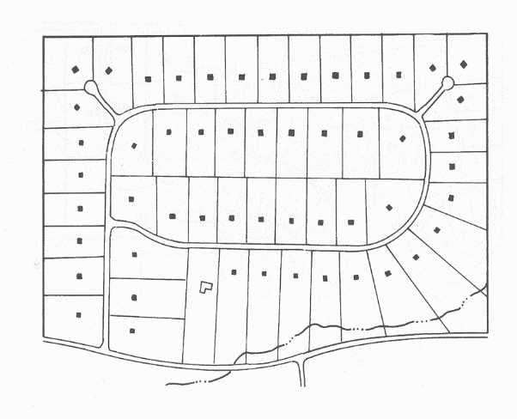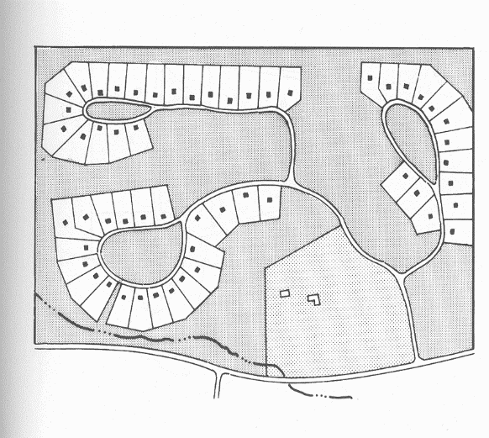

**Prepared by: Fred A. Jarman, AICP**

**May, 2007**

**CONSERVATION SUBDIVISION**

1. **PURPOSE**

The purpose of this regulation is to provide an applicant considering developing land into a residential subdivision in Garfield County with certain incentives which include density bonuses and zoning flexibility in exchange for the provision of certain amounts of land that is preserved as open space within a development plan. This regulation is intended to provide a regulatory mechanism which encourages residential lots to be reduced in size as well as be clustered on a property so that a greater amount of open space can be provided as an integral component in a development’s design and possible integration into adjoining property open space. More specifically, the purpose of this regulation is intended to accomplish the following:

1. To encourage the development of residential developments which are designed to preserve and protect environmental resources, scenic vistas, and natural and cultivated landscapes.
2. To enhance land, water, and natural vegetative resources by minimizing the area of land disturbance, reducing impervious surface, optimizing stream buffers, preserving tree cover and encouraging retention of undisturbed open space.
3. To reduce infrastructure maintenance costs as a result of efficient residential development design.
4. To provide open space and pedestrian linkages and wildlife corridors among residential communities and to encourage recreation opportunities.
5. To preserve and protect contiguous undeveloped areas within the development.
6. **APPLICABILITY / ELIGIBILITY**

This regulation shall apply to all privately owned ground in Garfield County for which a subdivision is sought pursuant to C.R.S. §30-28-133 et seq, as an alternative to a conventional subdivision as described in Division 3, Article 5. Development proposals submitted under these regulations as a Conservation Subdivision may be in the form of 1) a Density Neutral Development Plan or 2) an Increased Density Development Plan.

* 1. **Density Neutral Development Plan**

The Density Neutral Development Plan (DNDP) allows a development plan to propose the same maximum number of lots allowed in the underlying zone district for a parcel as defined in a yield plan except that the plan may reduce the lot size for individual lots below the minimum lot size contemplated in the underlying zone district. All setbacks for the underlying zone district shall be maintained for all proposed lots. This allows for the density established in the yield plan to be transferred in the form of smaller lots to a portion of the same parcel leaving the remainder of the parcel as open space. There are no bonus lots sought in this option.

Illustration 1.0 below provides an example of a DNDP where the lots achieved in the yield plan on the left have been reduced in size and clustered into pods in the plan on the right. There is no net increase in density.

**Illustration 1.0**

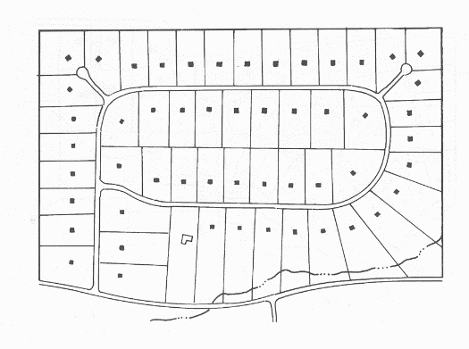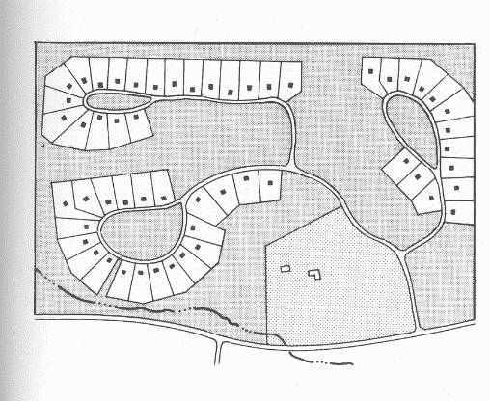

* 1. **Increased Density Development Plan**

The Increased Density Development Plan (IDDP) allows a development plan to propose an increase in the number of residential lots as contemplated in the underlying zoning district (determined in a yield plan) as well as reducing the minimum lot size from what is currently allowed in the underlying zone district. All setbacks for the underlying zone district shall be maintained for all proposed lots. Any increase in density (also referred to as bonus lots) is a function of the percentage of open space proposed in a development plan. More specifically, as the amount of proposed open space increases, so does the percentage of bonus lots awarded. The percentage of open space proposed in a development plan is multiplied 0.5 which results in the percentage increase in the number of lots configured in the yield plan. The calculation is figured in the following way:

**Table 1.0**

|  |  |  |  |  |  |  |  |  |  |  |
| --- | --- | --- | --- | --- | --- | --- | --- | --- | --- | --- |
| ***% of Open Space (.5)*** | ***=*** | ***% Increase*** | ***x*** | ***Lots in Yield Plan*** | ***=*** | ***# Bonus Lots*** | ***+*** | ***Lots in Yield Plan*** | ***=*** | ***Total Lots Available*** |

For example, if a yield plan indicates a total of 38 lots are possible on a parcel and a developer proposes to convert 40% of the parcel into open space, the conversion calculation will show that 25% of that percentage is 10% which represents a 10% increase in the number of lots (38) attainable in the yield plan for a total of 45.6 lots or 7.6 bonus lots. (See Table 2.0 below.) For bonus lots that result in a fraction, they are to be rounded such that if a number is 5.5, it will be rounded up to 6. If the number is 5.49, it will be rounded down to 5. A more detailed example of this sliding scale model can be found at the end of this section in Table 3.0.

**Table 2.0**

|  |  |  |  |  |  |  |  |  |  |  |
| --- | --- | --- | --- | --- | --- | --- | --- | --- | --- | --- |
| ***(40%).5*** | ***=*** | ***0.2*** | ***x*** | ***38*** | ***=*** | ***7.6*** | ***+*** | ***38*** | ***=*** | ***45.6*** |

1. **PROCESS**

Because a Conservation Subdivision results in a division of land, any proposal shall be required to follow the Major Subdivision Review Process as described in Section 5-302 which includes a pre-application conference, sketch plan (optional), preliminary plan, and final plat which are also consistent with C.R.S. §30-28-133 et seq. However, a Conservation Subdivision shall follow a modified preliminary plan process so that the number of bonus lots (if so sought in an Increased Density Development Plan) to be incorporated into a site design can be determined. This process is more fully defined below.

* 1. **Sketch Plan (Optional)**

An applicant considering a Conservation Subdivision shall have the option of submitting a sketch plan (as defined in Section 5-302) to be reviewed by the Planning Department and the Planning Commission. The sketch plan application shall include two conceptual site designs or plans where 1) the first plan illustrates the maximum number of lots that could realistically be achieved on the property under present zoning also called a Yield Plan, and 2) a second plan illustrates a site design that incorporates an open space component with residential lots being clustered on the property using either the Increased Density Development Plan option or the Density Neutral Development Plan option. The purpose of the sketch plan exercise is to discuss the validity of both plans and provide regulatory direction so that a more precise Preliminary Plan can be sought.

* 1. **Preliminary Plan**

Once an applicant has attended a pre-application conference (and a sketch plan if so desired), an applicant shall submit a preliminary plan to be reviewed by Staff, the Planning Commission, and the Board of County Commissioners. All Conservation Subdivisions shall be considered Major Subdivision pursuant to Section 5-303. In addition to the submittal information already required for a Major Subdivision, the preliminary plan review by the Planning Commission shall include the following two steps specific to a Conservation Subdivision.

1. **Step 1**

The first step shall include an analysis of a Yield Plan so that the Planning Commission can determine an accurate number of the maximum number of residential lots that could realistically be developed on the property within the context of the underlying zoning and also addressing any development constraints identified as a result of a land suitability analysis.

1. **Step 2**

Once the Yield Plan has been approved by the Planning Commission, the second step shall include an analysis of the proposed Conservation Subdivision design which shall be designed as either a Density Neutral Development Plan or an Increased Density Development Plan. If an Increased Density Development Plan is sought, the analysis shall specifically include a demonstration of the calculation that determines any bonus lots sought and open space proposed in the plan. If a Density Neutral Development Plan is sought, the plan shall effectively show that the plan only transfers existing density as allowed under current zoning and reduces the minimum lot size required in the underlying zoning district. The analysis conducted in3Step 2 shall also require the same submittal information required in Section 5-305.

* 1. **Final Plan/Final Plat**

An applicant shall have 1-year to submit a Final Plat application for the Conservation Subdivision following approval of the Preliminary Plan by the Board of County Commissioners. The applicant shall follow the Final Plat process for traditional subdivisions as provided in Section 5-303.E.

1. **Submittal Materials**

In addition to the submittal information already required for a Major Subdivision the following additional items shall be submitted with any application for a Conservation Subdivision:

* 1. **Yield Plan**

The yield plan is a specific site design or lot layout for a particular parcel of land that could be practically developed under the required (underlying) zone district which addresses any site constraints identified in the Land Suitability Analysis. The sole purpose of a yield plan is to illustrate a development design which shows the number and size of lots that could be realistically developed on a parcel within the parameters of the required zone district. This plan, while not necessarily requiring detailed engineering plans for roads, utilities, and drainage, needs to adequately demonstrate that it could be realistically developed.

* 1. **Land Suitability Analysis**

A Land Suitability Analysis is an exercise used to identify certain physical constraints on a parcel that are un-buildable. More specifically, this area consists of certain site characteristics and constraints which have been identified to be un-buildable under any subdivision scenario. All residential lots proposed in a Conservation Subdivision shall not contain any site constraints identified in the land suitability analysis. Specific site constraints which are considered un-buildable include but are not limited to:

1. Land within the “flood way” of the mapped 100-year flood plain and which is 30 feet from the “high water mark” of a live stream;
2. Land under “high water mark” of a water body such as lakes, creeks, and rivers;
3. Land on slopes steeper than 30%;
4. Land which has unsuitable soils as defined by the USDA National Resource Conservation Service (NRCS);
5. Land located in a jurisdictional wetland as defined by the US Army Corps of Engineers (USACE); and
6. Land encumbered by any private or public road or ditch right-of-way / easement.
   1. **Open Space Plan**

The Open Space Plan consists of a map, drawn to a scale of at least 1” = 200 feet which delineates the proposed open space areas designated for either the Density Neutral Development Plan or the Increased Density Development Plan. This Plan shall show the location of any proposed structures including trails to be located within the open space. This plan shall also show the proposed residential lots and roadways within the development.

* 1. **Open Space Management Plan**

The Open Space Management Plan shall describe what entity (such as a Homeowners Association) owns and manages the open space in the development. The owner may place a perpetual conservation easement on the open space and deed that easement to a qualified conservation organization. In all cases, ownership shall be deeded to the finally controlling entity at the time of final plat. The Open Space Management Plan shall also contain specific management provisions for how the open space is to be maintained including noxious weed control, what uses are allowed, and what entity shall pay for maintenance of the open space. Lastly, this plan shall also provide stipulations for any future amendments to the use and maintenance of the open space. All open space shall be platted as part of the first final plat.

* 1. **Review Standards & Requirements**

All proposals for a Conservation Subdivision shall demonstrate how the proposed plan meets the following review standards and requirements:

1. **Site Plan Design**

In addition to the review standards and requirements required as part of a Major Subdivision review, all Conservation Subdivision proposals shall address the following additional site design requirements.

* 1. **Residential Lot Design**

The proposed lot layout shall locate the proposed residential lots such that they are clustered together in specific areas of the parcel. There may be more than one separate pod of clustered lots located throughout the parcel. A design which provides that a majority of lots are directly adjacent to open space is encouraged. All residential lots cannot contain any site constraints identified in the land suitability analysis such as steep slopes, wetlands, etc. While there is no minimum lot size requirement, all lots shall show the proposed lot area and setbacks on each lot.

* 1. **Density**

For the purposes of this regulation, densities proposed in either the Density Neutral Development Plan or the Increased Density Development Plan shall be determined by the maximum of lots which can practically be created within the confines of the minimum lot size defined in the underlying zone district for a particular parcel of land. However, as with all Major Subdivisions, the proposal shall also be required to demonstrate general compliance with the densities and land use policies contained in the County’s Comprehensive Plan. Development Plans which propose a density higher than what is designated may wish to amend the Comprehensive Plan in order to achieve general conformity with the Comprehensive Plan.

* 1. **Increased Density Calculation**

For all Conservation Subdivisions which propose the Increase Density Development Plan, the application shall include the calculation as provided in Table 1.0 which shows the percentage of open space proposed and the number of bonus lots requested.

* 1. **Infrastructure & Project Location**

All Conservation Subdivision designs which propose lots less than 2 acres but greater than 1 acre in size and utilize Individual Sewage Disposal Systems (ISDS) shall be required to provide a central water system. ISDS leach fields and well systems may be located in land designated as open space. Such proposals may be located anywhere in unincorporated Garfield County.

Plans that propose lots that are 1 acre or smaller in size shall only be allowed within the urban growth areas of the municipalities in unincorporated Garfield County or in special district service areas where the development can be served by their central water and sewage facilities.

All Conservation Subdivision proposals, regardless of lot size, containing 15 or more dwelling units shall be required to provide central water and sewer regardless of their location within unincorporated Garfield County.

1. **Open Space**

Open space shall be defined as a parcel of land, an area of water, or a combination of land and water within a development designed and intended primarily for the use or enjoyment of residents, occupants, and owners within that development. For purposes of this regulation, open space may include areas of land and water which exist in a natural undeveloped state and are intended to preserve natural areas, environmentally sensitive resources, and existing wildlife habitat. Land identified in the land suitability analysis shall only be included in open space and not within individual residential lots. In designing a Conservation Subdivision, the Open Space Plan shall address the following criteria:

* 1. **Internal Contiguity**

All proposed open space within a development is intended to be designed as large contiguous tracts where small “islands” of open space are discouraged.

* 1. **Connection with external adjacent open space**

All proposed open space within the development is intended to be designed such that it connects to available existing open space on neighboring properties or tracts of public lands in order to create larger regional tracts of contiguous open space.

* 1. **Wildlife / Environmental Value**

All proposed open space areas within a development, unless otherwise designated, shall be designed to protect and not detract from existing wildlife habitat and natural features of the land such as steep slopes, riparian areas, jurisdictional wetlands, regulated floodplains, steam courses, lakes.

* 1. **Aesthetic Value**

All proposed open space areas within a development should, to the extent practical, preserve the historic rural character of the parcel which includes preserving existing natural land features which buffer the property from adjacent developments and external roads, ridgelines, and any designated view sheds.

* 1. **Recreation Value**

Portions of proposed open space may be improved to support passive and active recreation uses such as summer / winter use trail systems, tot lots, community greens, ball fields, etc where no more than 25% of the open space is designated for these uses.

* 1. **Agricultural Value**

Regarding agricultural land, 100% of designated open space may be used for certain agricultural uses including grazing, irrigated pasture land, and cultivated dry land crop farming in tracts of land which are intended to perform as viable agricultural units.

* 1. **Uses Prohibited in Open Space**

The following areas shall not be considered or credited as open space for the purposes of this regulation:

1. Residential yards within the boundaries of a lot;
2. Proposed permanent lakes. No more than 50% of the area of a permanent lake may be credited; and
3. Impervious surfaces in recreation areas shall not be credited.

**Table 3.0**

|  |  |  |  |  |  |  |  |  |  |  |  |  |  |  |  |
| --- | --- | --- | --- | --- | --- | --- | --- | --- | --- | --- | --- | --- | --- | --- | --- |
| **Proposed Model using a "sliding scale" for determining ratio of bonus lots awarded to open space provided using the Increased Density Development Plan (This example assumes a flat 80-acre property having no constraints identified through a "Land Suitability Analysis"** | | | | | | | | | | | | | | | |
|
|  | **Shall be located in Urban Growth Areas or Special Districts Service Areas** | | | | | | | | **May be located anywhere in the County** | | | | | | |
| ***Yield Plan Assumptions*** | *acres* | *acres* | *acres* | *acres* | *acres* | *acres* | *acres* | *acres* | *acres* | *acres* | *acres* | *acres* | *acres* | *acres* | *acres* |
| Gross Parcel Acreage | **80** | **80** | **80** | **80** | **80** | **80** | **80** | **80** | **80** | **80** | **80** | **80** | **80** | **80** | **80** |
| Proposed Amount of Open Space | **80%** | **75%** | **70%** | **65%** | **60%** | **55%** | **50%** | **45%** | **40%** | **35%** | **30%** | **25%** | **20%** | **15%** | **10%** |
| Land Placed in Open Space | **64** | **60** | **56** | **52** | **48** | **44** | **40** | **36** | **32** | **28** | **24** | **20** | **16** | **12** | **8** |
| Land after Open Space Removed | **16** | **20** | **24** | **28** | **32** | **36** | **40** | **44** | **48** | **52** | **56** | **60** | **64** | **68** | **72** |
| 5% from Gross Acreage for Roads | **4** | **4** | **4** | **4** | **4** | **4** | **4** | **4** | **4** | **4** | **4** | **4** | **4** | **4** | **4** |
| Balance for Development | **12** | **16** | **20** | **24** | **28** | **32** | **36** | **40** | **44** | **48** | **52** | **56** | **60** | **64** | **68** |
|  |  |  |  |  |  |  |  |  |  |  |  |  |  |  |  |
| ***Potential Bonus Lots*** |  |  |  |  |  |  |  |  |  |  |  |  |  |  |  |
| Lots Possible in "Yield Plan" | **38** | **38** | **38** | **38** | **38** | **38** | **38** | **38** | **38** | **38** | **38** | **38** | **38** | **38** | **38** |
| Lots Lost to Open Space | **30.4** | **28.5** | **26.6** | **24.7** | **22.8** | **20.9** | **19** | **17.1** | **15.2** | **13.3** | **11.4** | **9.5** | **7.6** | **5.7** | **3.8** |
| Bonus Lots at 25% | **7.60** | **7.13** | **6.65** | **6.18** | **5.70** | **5.23** | **4.75** | **4.28** | **3.80** | **3.33** | **2.85** | **2.38** | **1.90** | **1.43** | **0.95** |
| Total Available Lots for Project | **45.60** | **45.13** | **44.65** | **44.18** | **43.70** | **43.23** | **42.75** | **42.28** | **41.80** | **41.33** | **40.85** | **40.38** | **39.90** | **39.43** | **38.95** |
|  |  |  |  |  |  |  |  |  |  |  |  |  |  |  |  |
| ***Minimum Lot Size in Cluster Plan*** |  |  |  |  |  |  |  |  |  |  |  |  |  |  |  |
| Minimum Lots Size (acres) | **0.26** | **0.35** | **0.45** | **0.54** | **0.64** | **0.74** | **0.84** | **0.95** | **1.05** | **1.16** | **1.27** | **1.39** | **1.50** | **1.62** | **1.75** |
| (square footage) | **11,463** | **15,445** | **19,512** | **23,666** | **27,910** | **32,248** | **36,682** | **41,216** | **45,853** | **50,596** | **55,450** | **60,418** | **65,504** | **70,712** | **76,048** |
| Urban Services Required | Central Water and Sewer Required | | | | | | | | Central Water / ISDS | | | | | | |

1. Flow Charts

The following flow charts indicate the steps in a review process as well the approximate time to review an application upon the submittal of a complete application. These flow charts are not adopted. Please ensure that you have reviewed the processes as set out in the adopted LUDC before submitting an application.

* + - 1. Section 4-103 Administrative

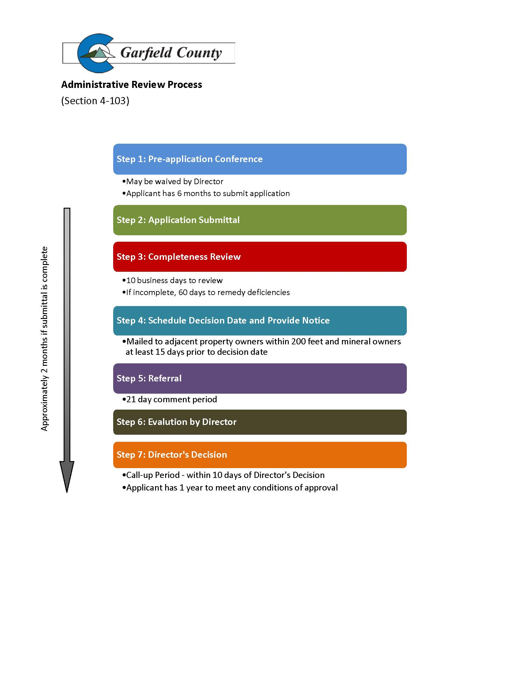

* + - 1. Section 4-104 Limited Impact

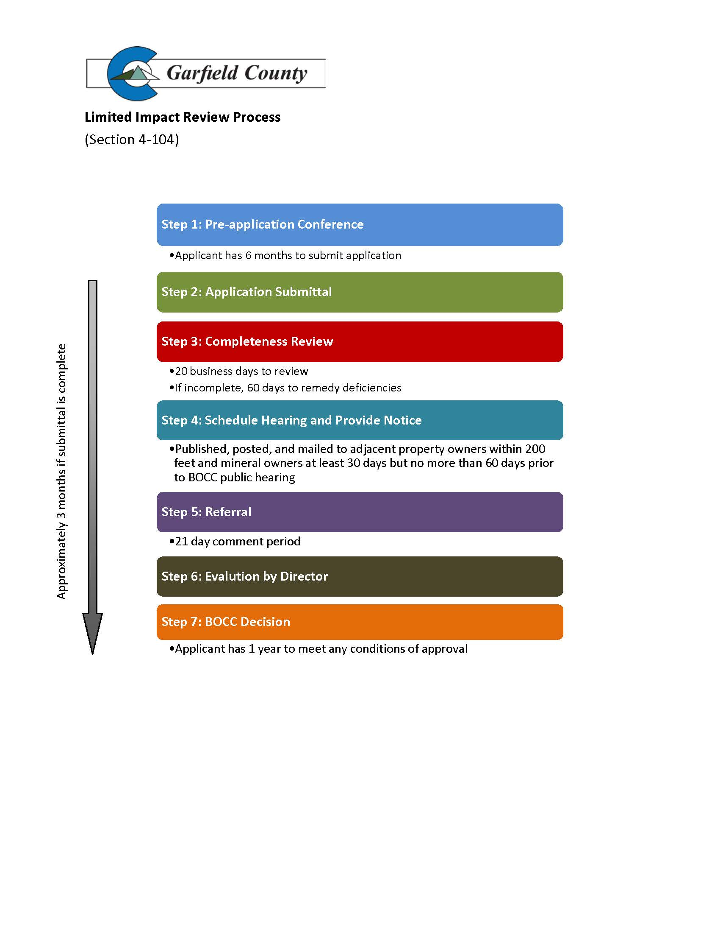

* + - 1. Section 4-105 Major Impact

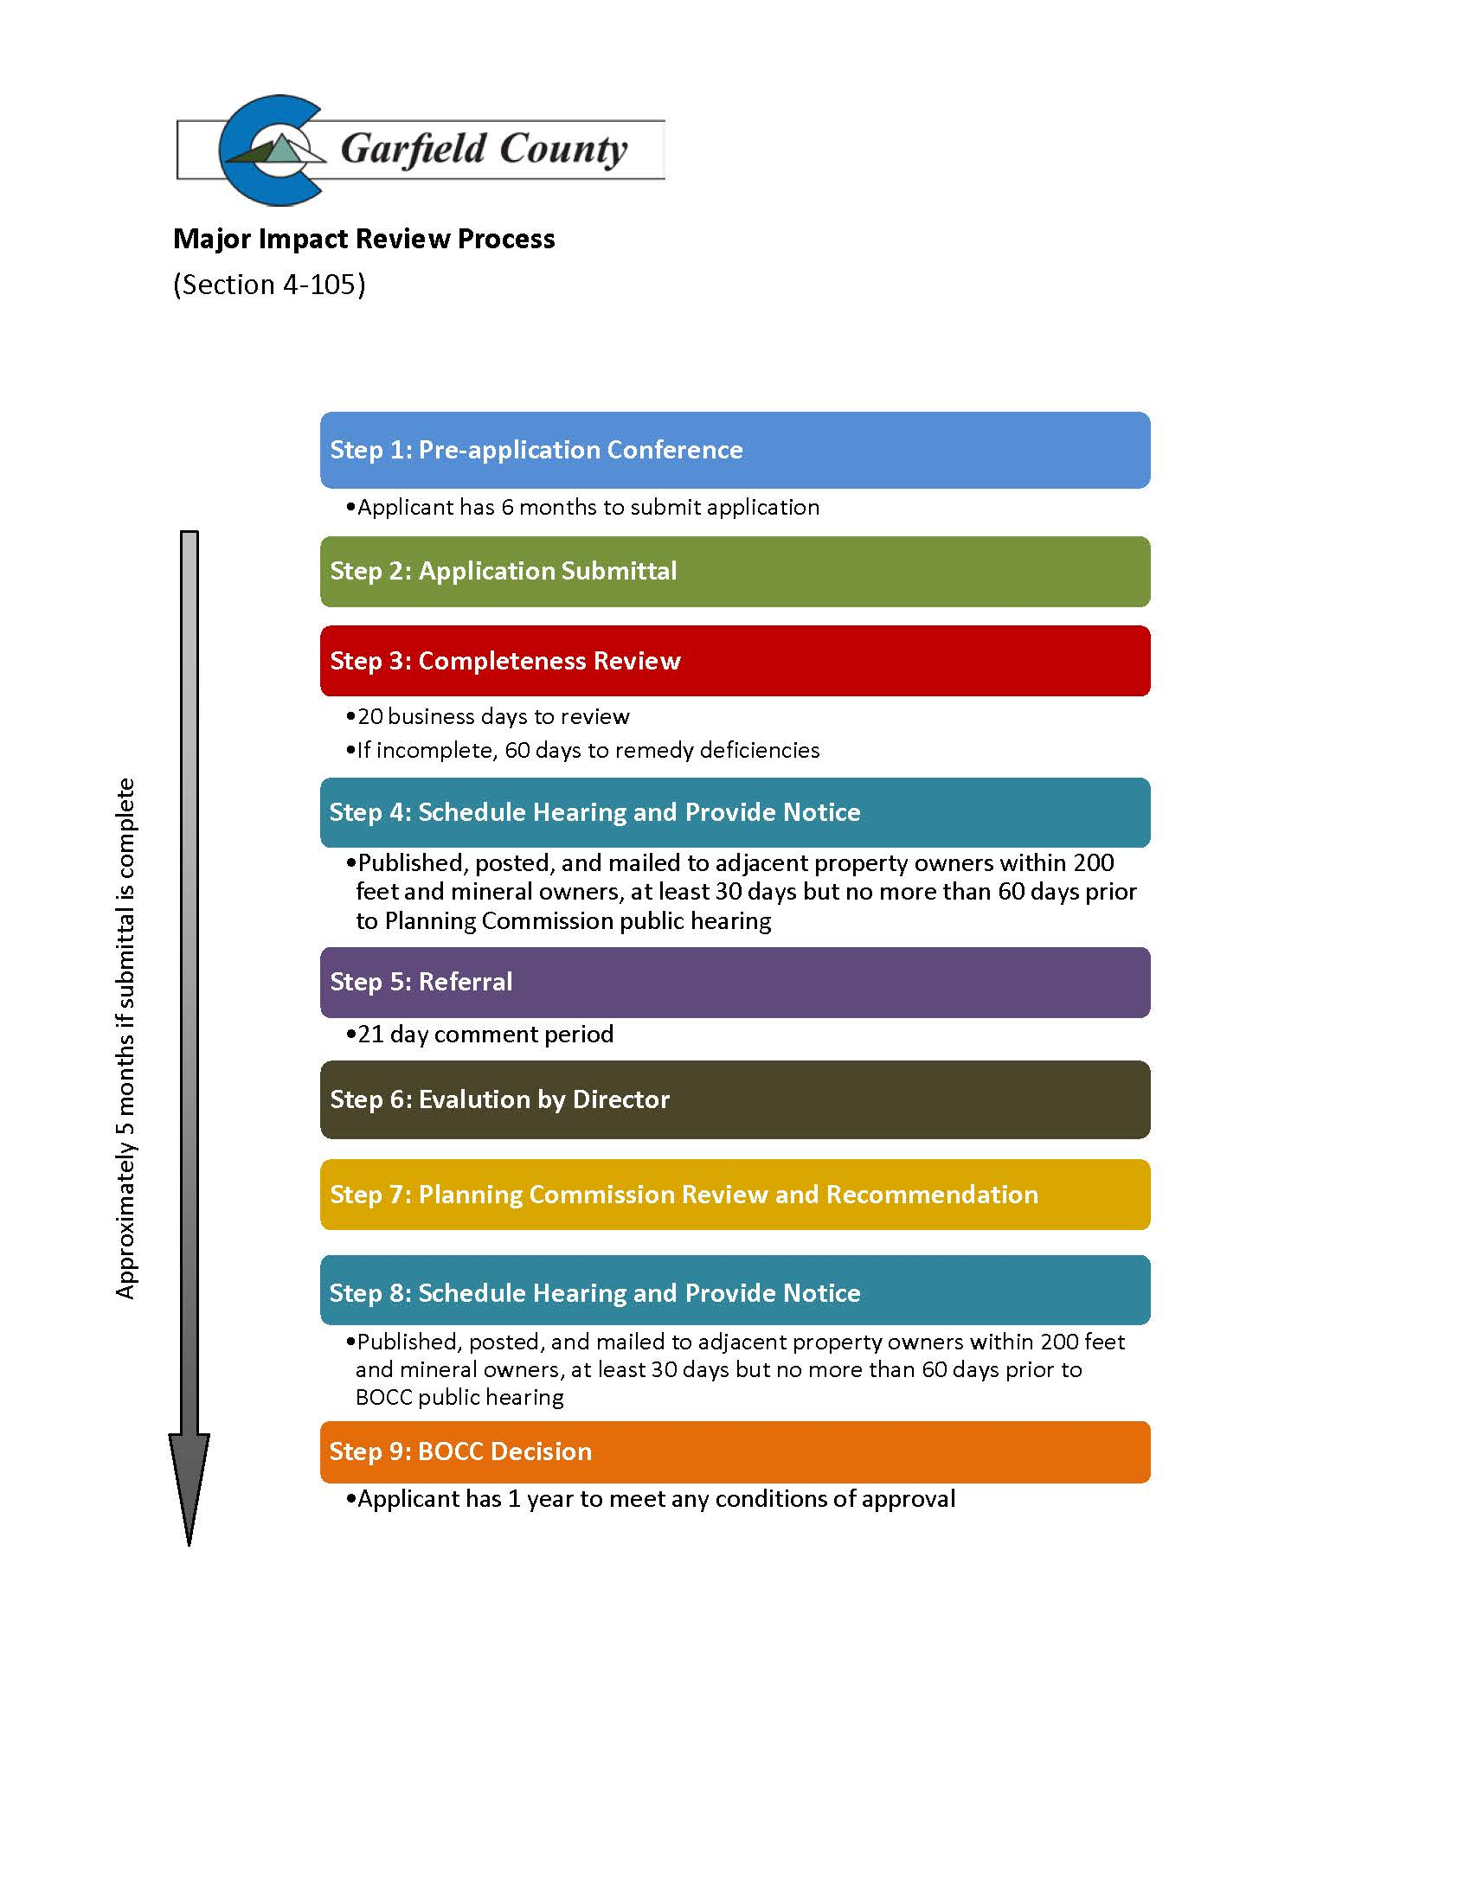

* + - 1. Section 4-106 Amendment to an Approved Land Use Change Permit

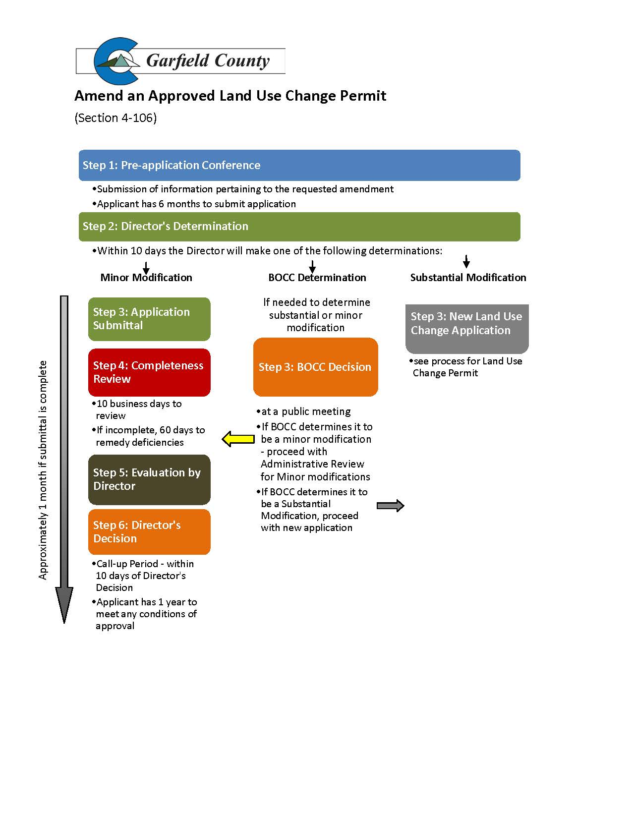

* + - 1. Section 4-107 Minor Temporary Employee Housing Facility

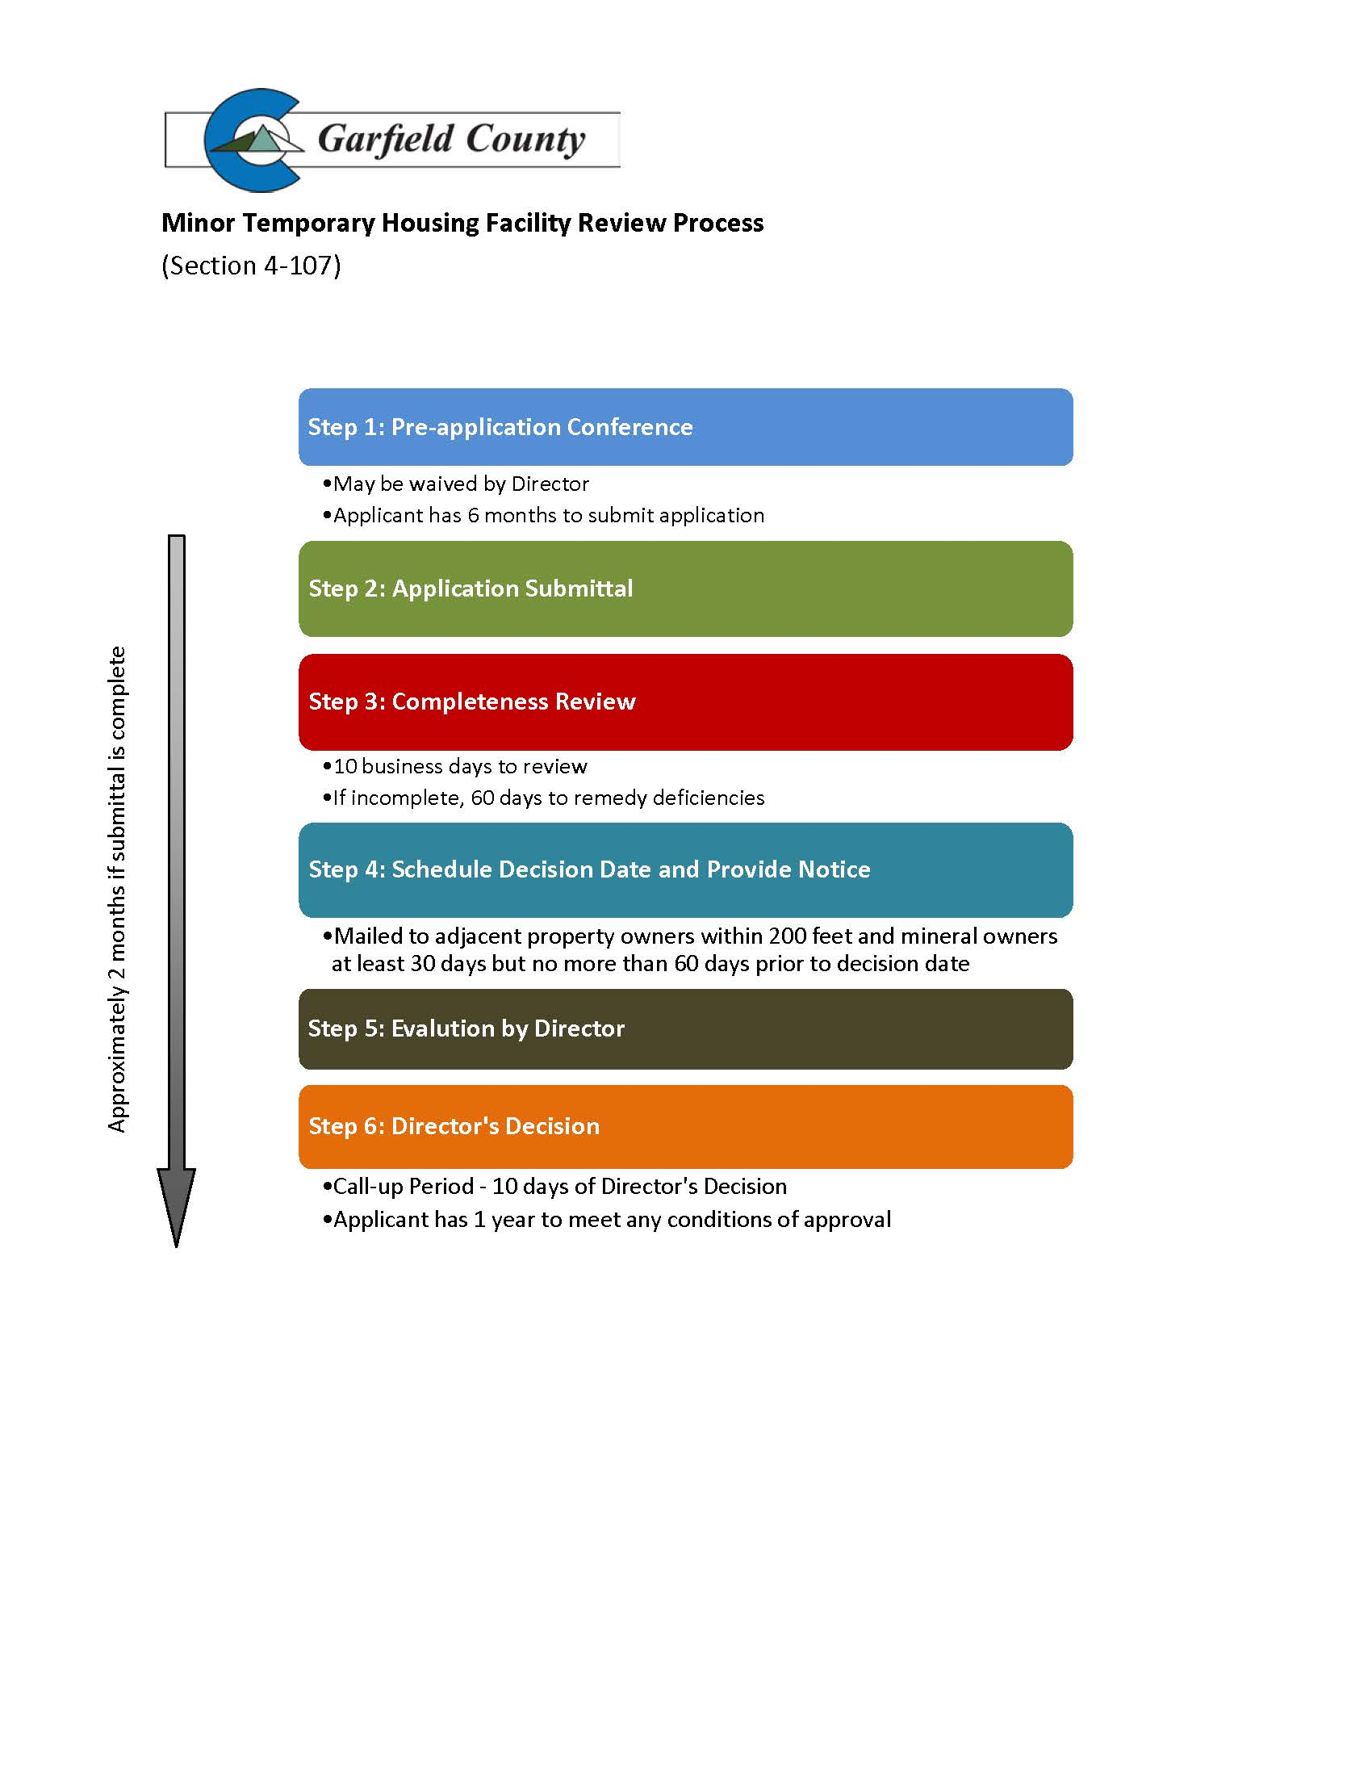

* + - 1. Section 4-108 Vacation of a County Road or Public Right-of-Way

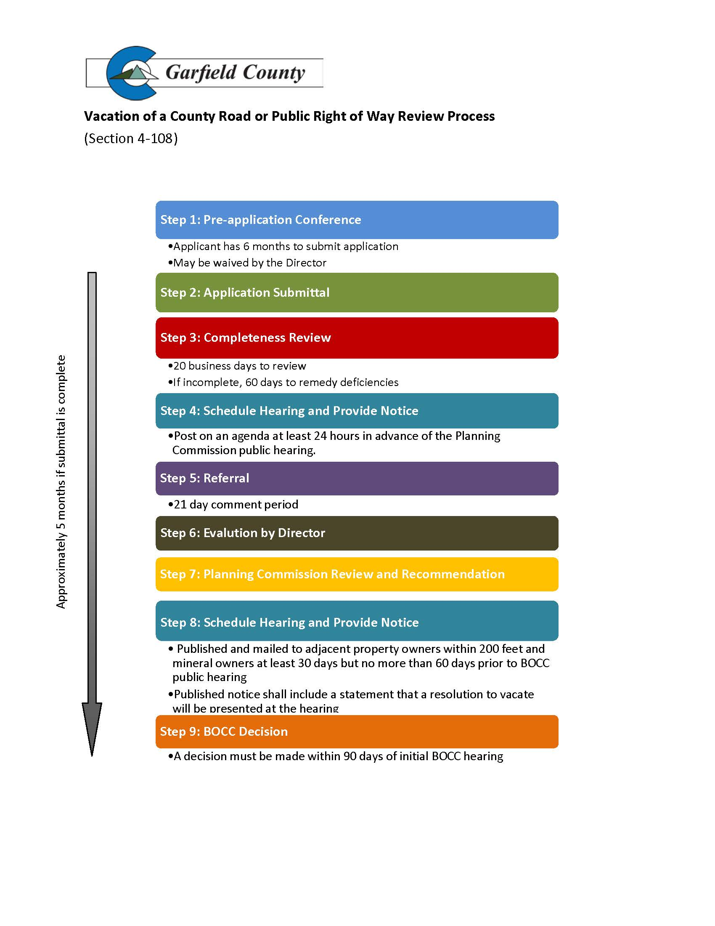

* + - 1. Section 4-109 Development in 100-year Floodplain

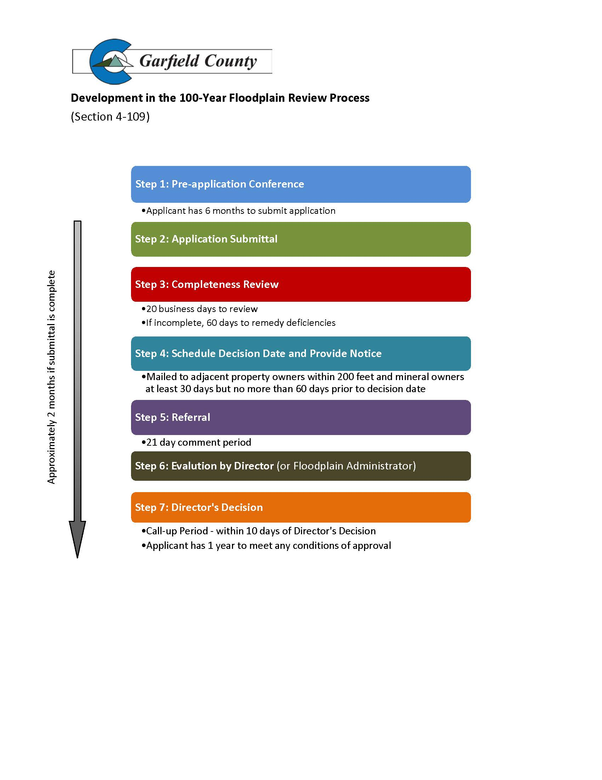

* + - 1. Section 4-110 Development in 100-year Floodplain Variance

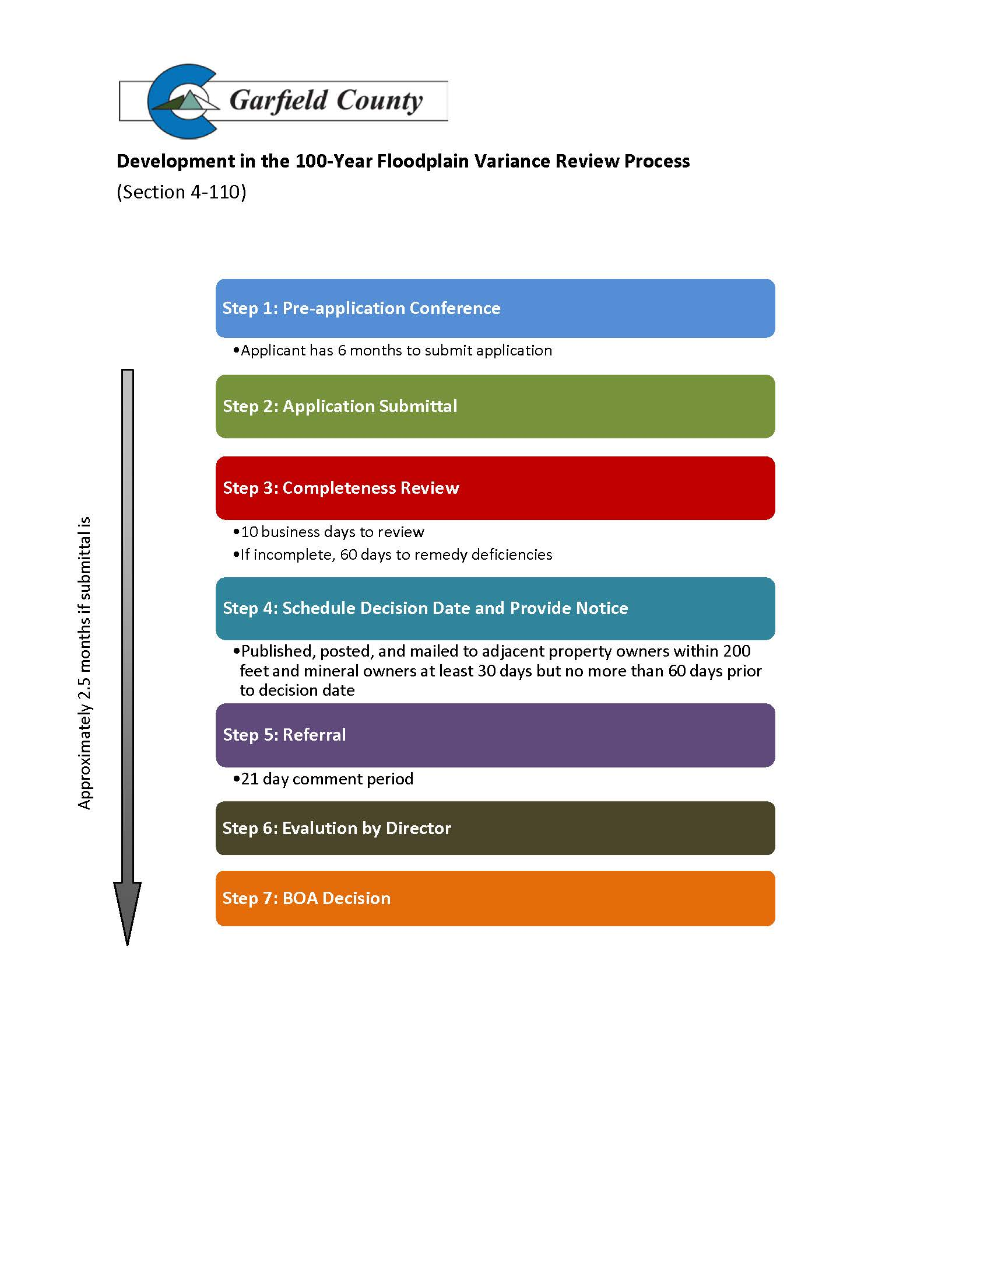

* + - 1. Section 4-111 Location and Extent

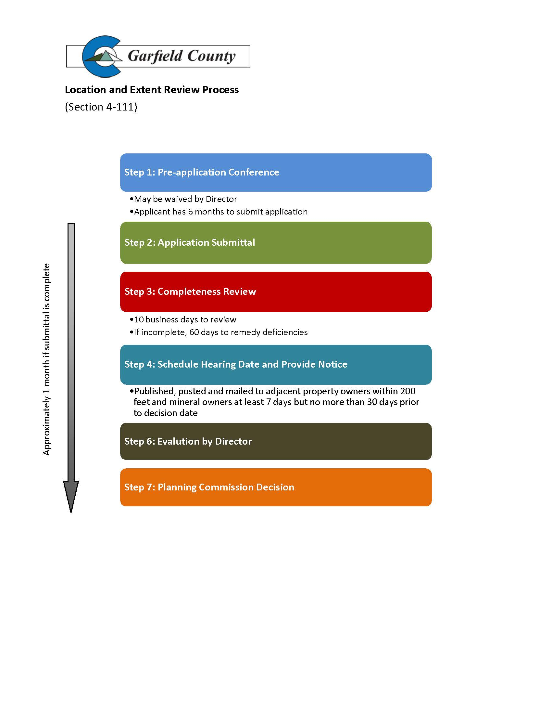

* + - 1. Section 4-112 Call-Up to the BOCC

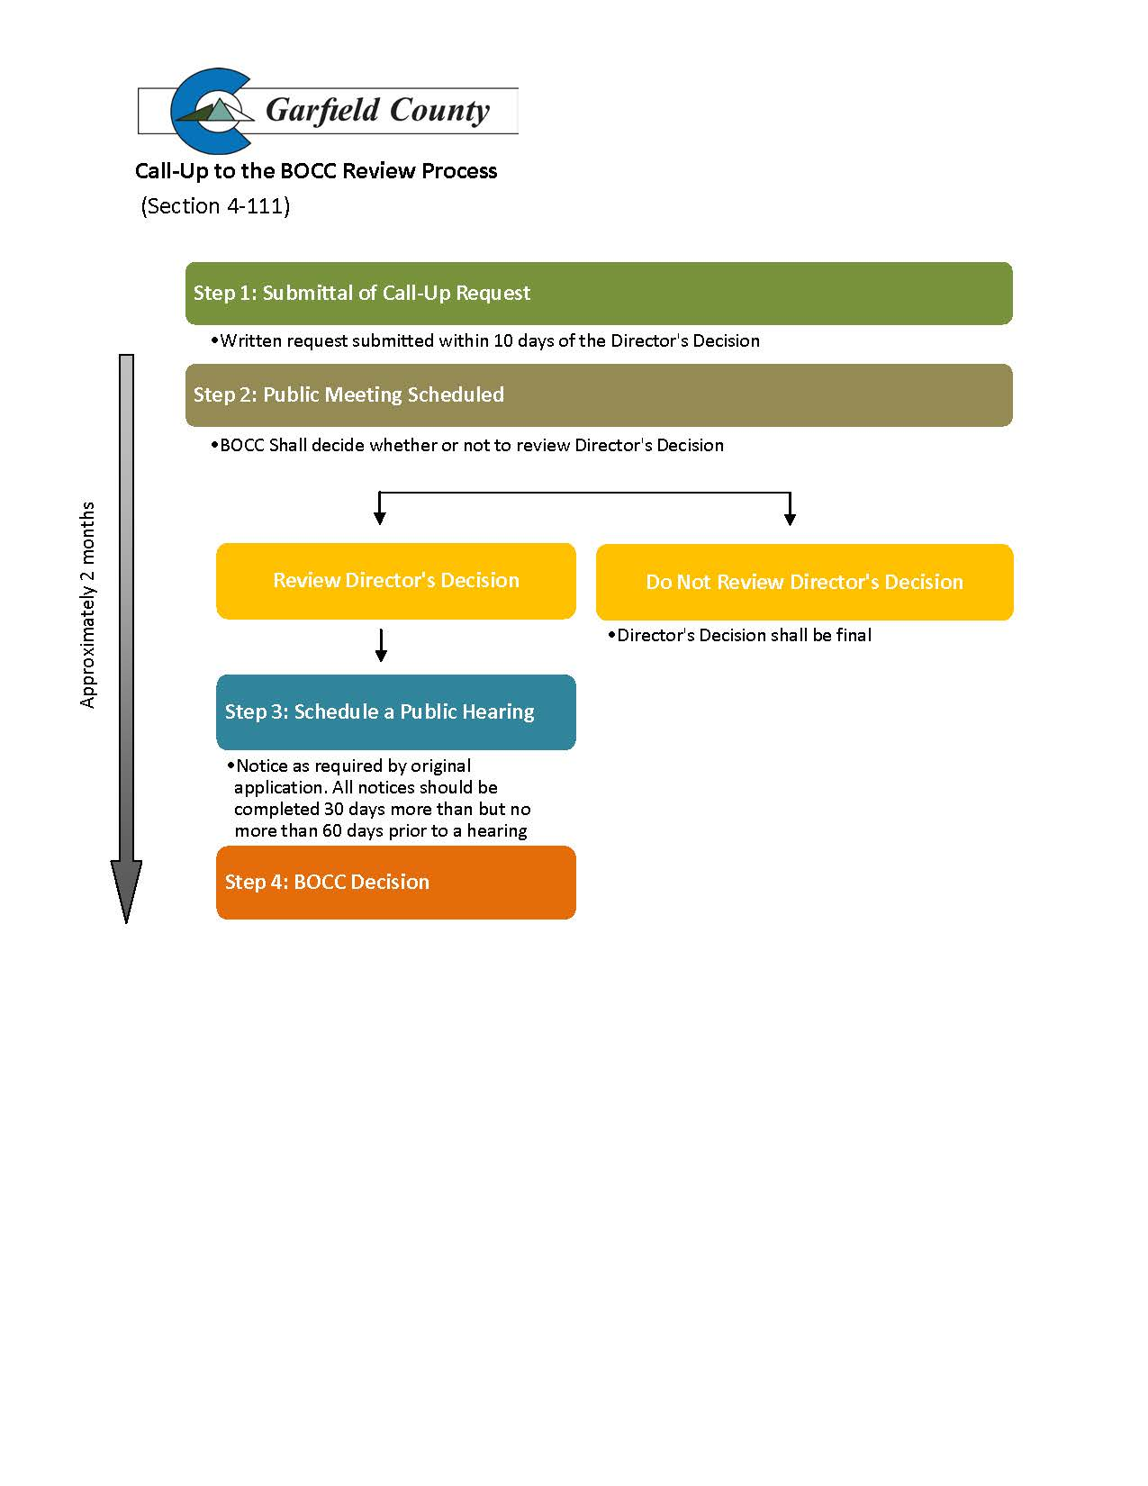

* + - 1. Section 4-113 Rezoning

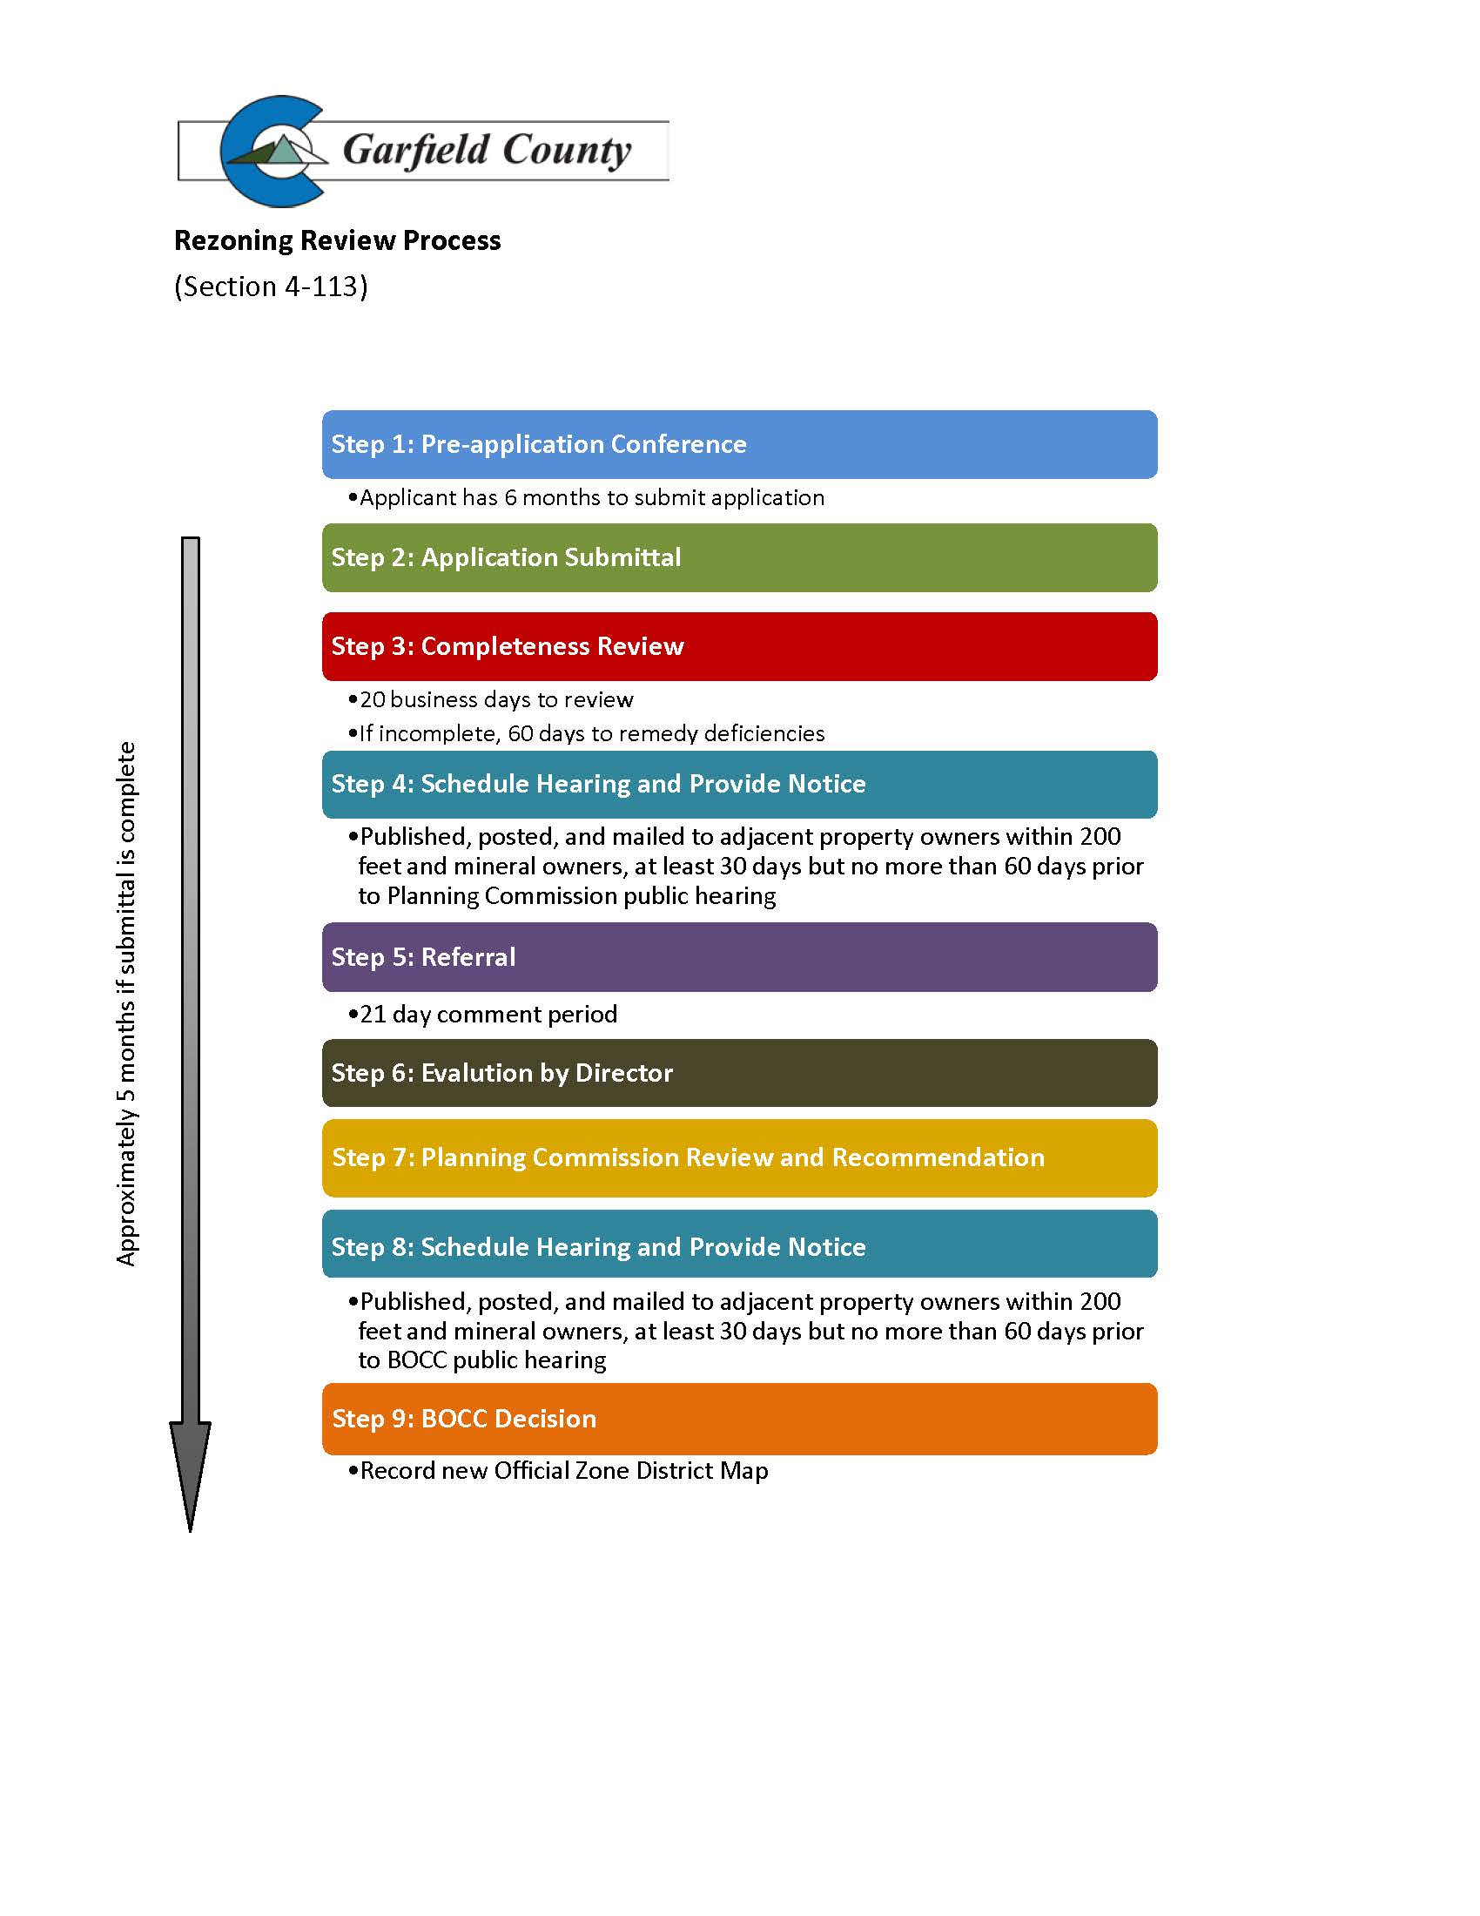

* + - 1. Section 4-114 Code Text Amendment

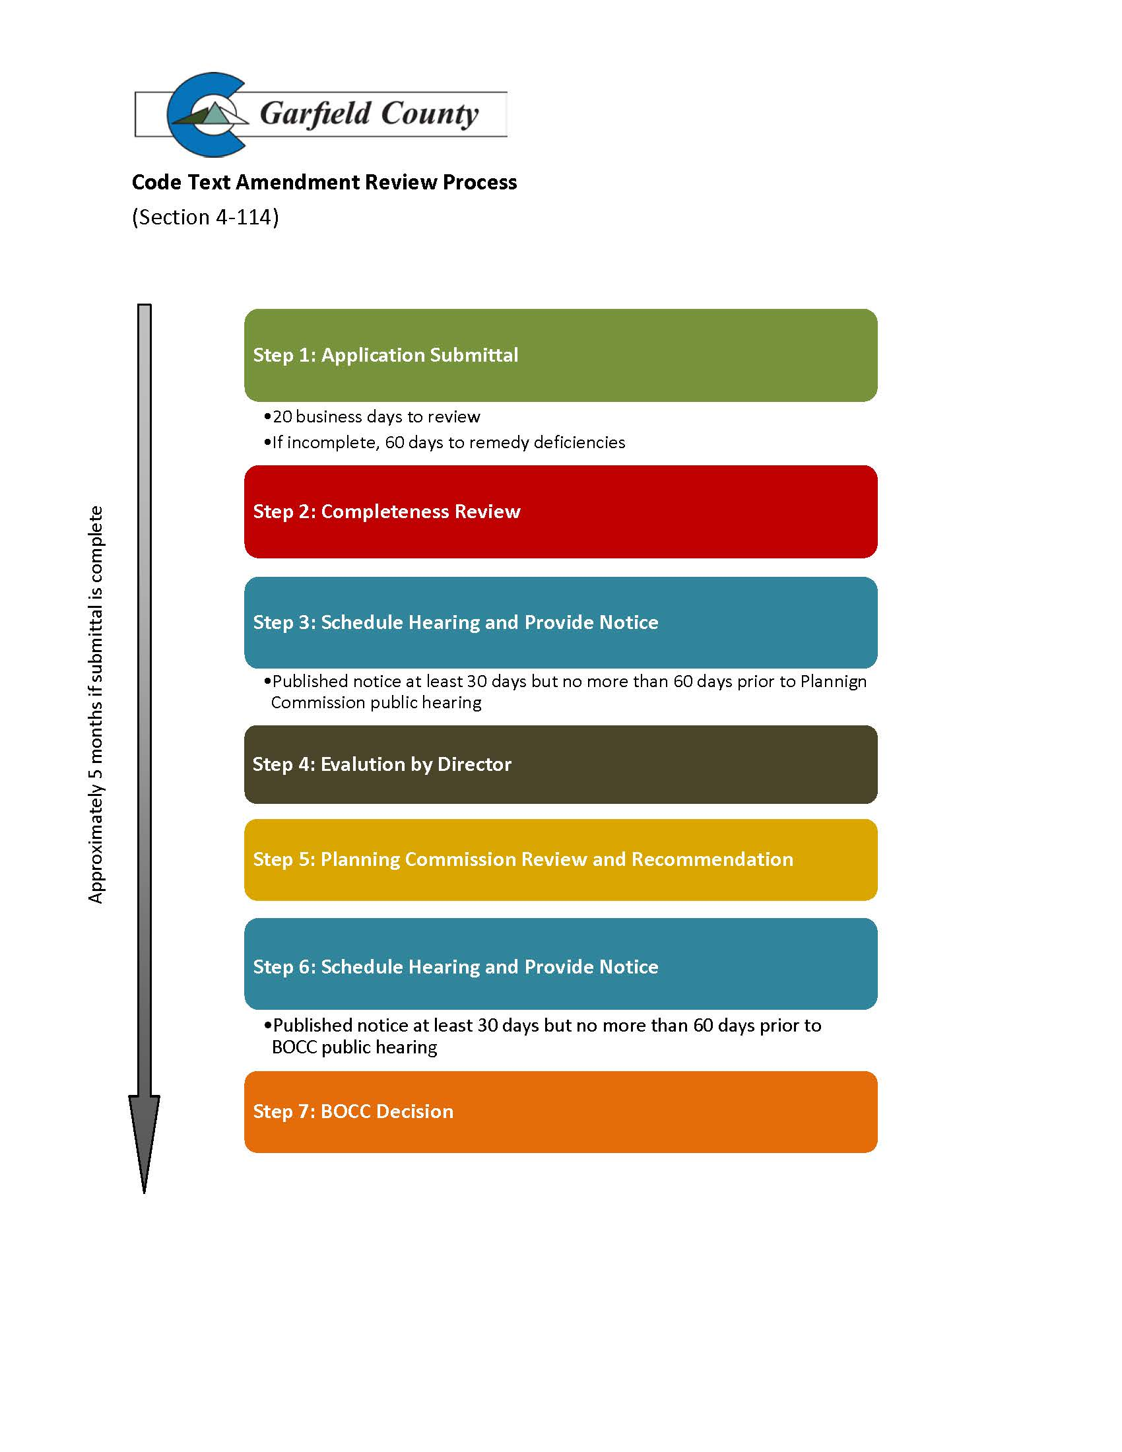

* + - 1. Section 4-115 Variance

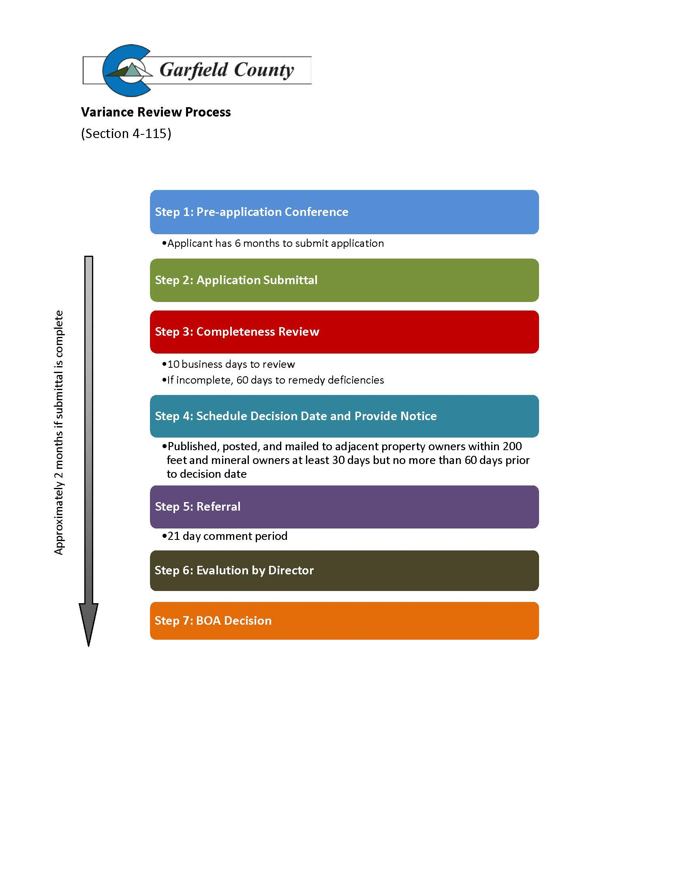

* + - 1. Section 4-116 Administrative Interpretation

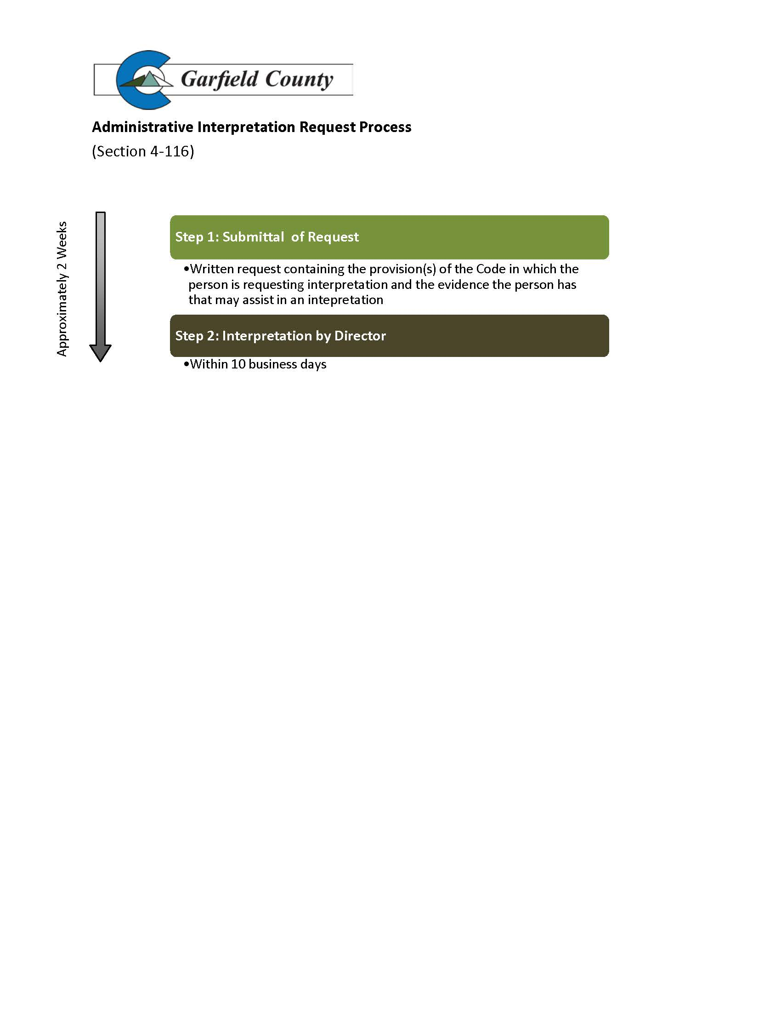

* + - 1. Section 4-117 Administrative Interpretation Appeal

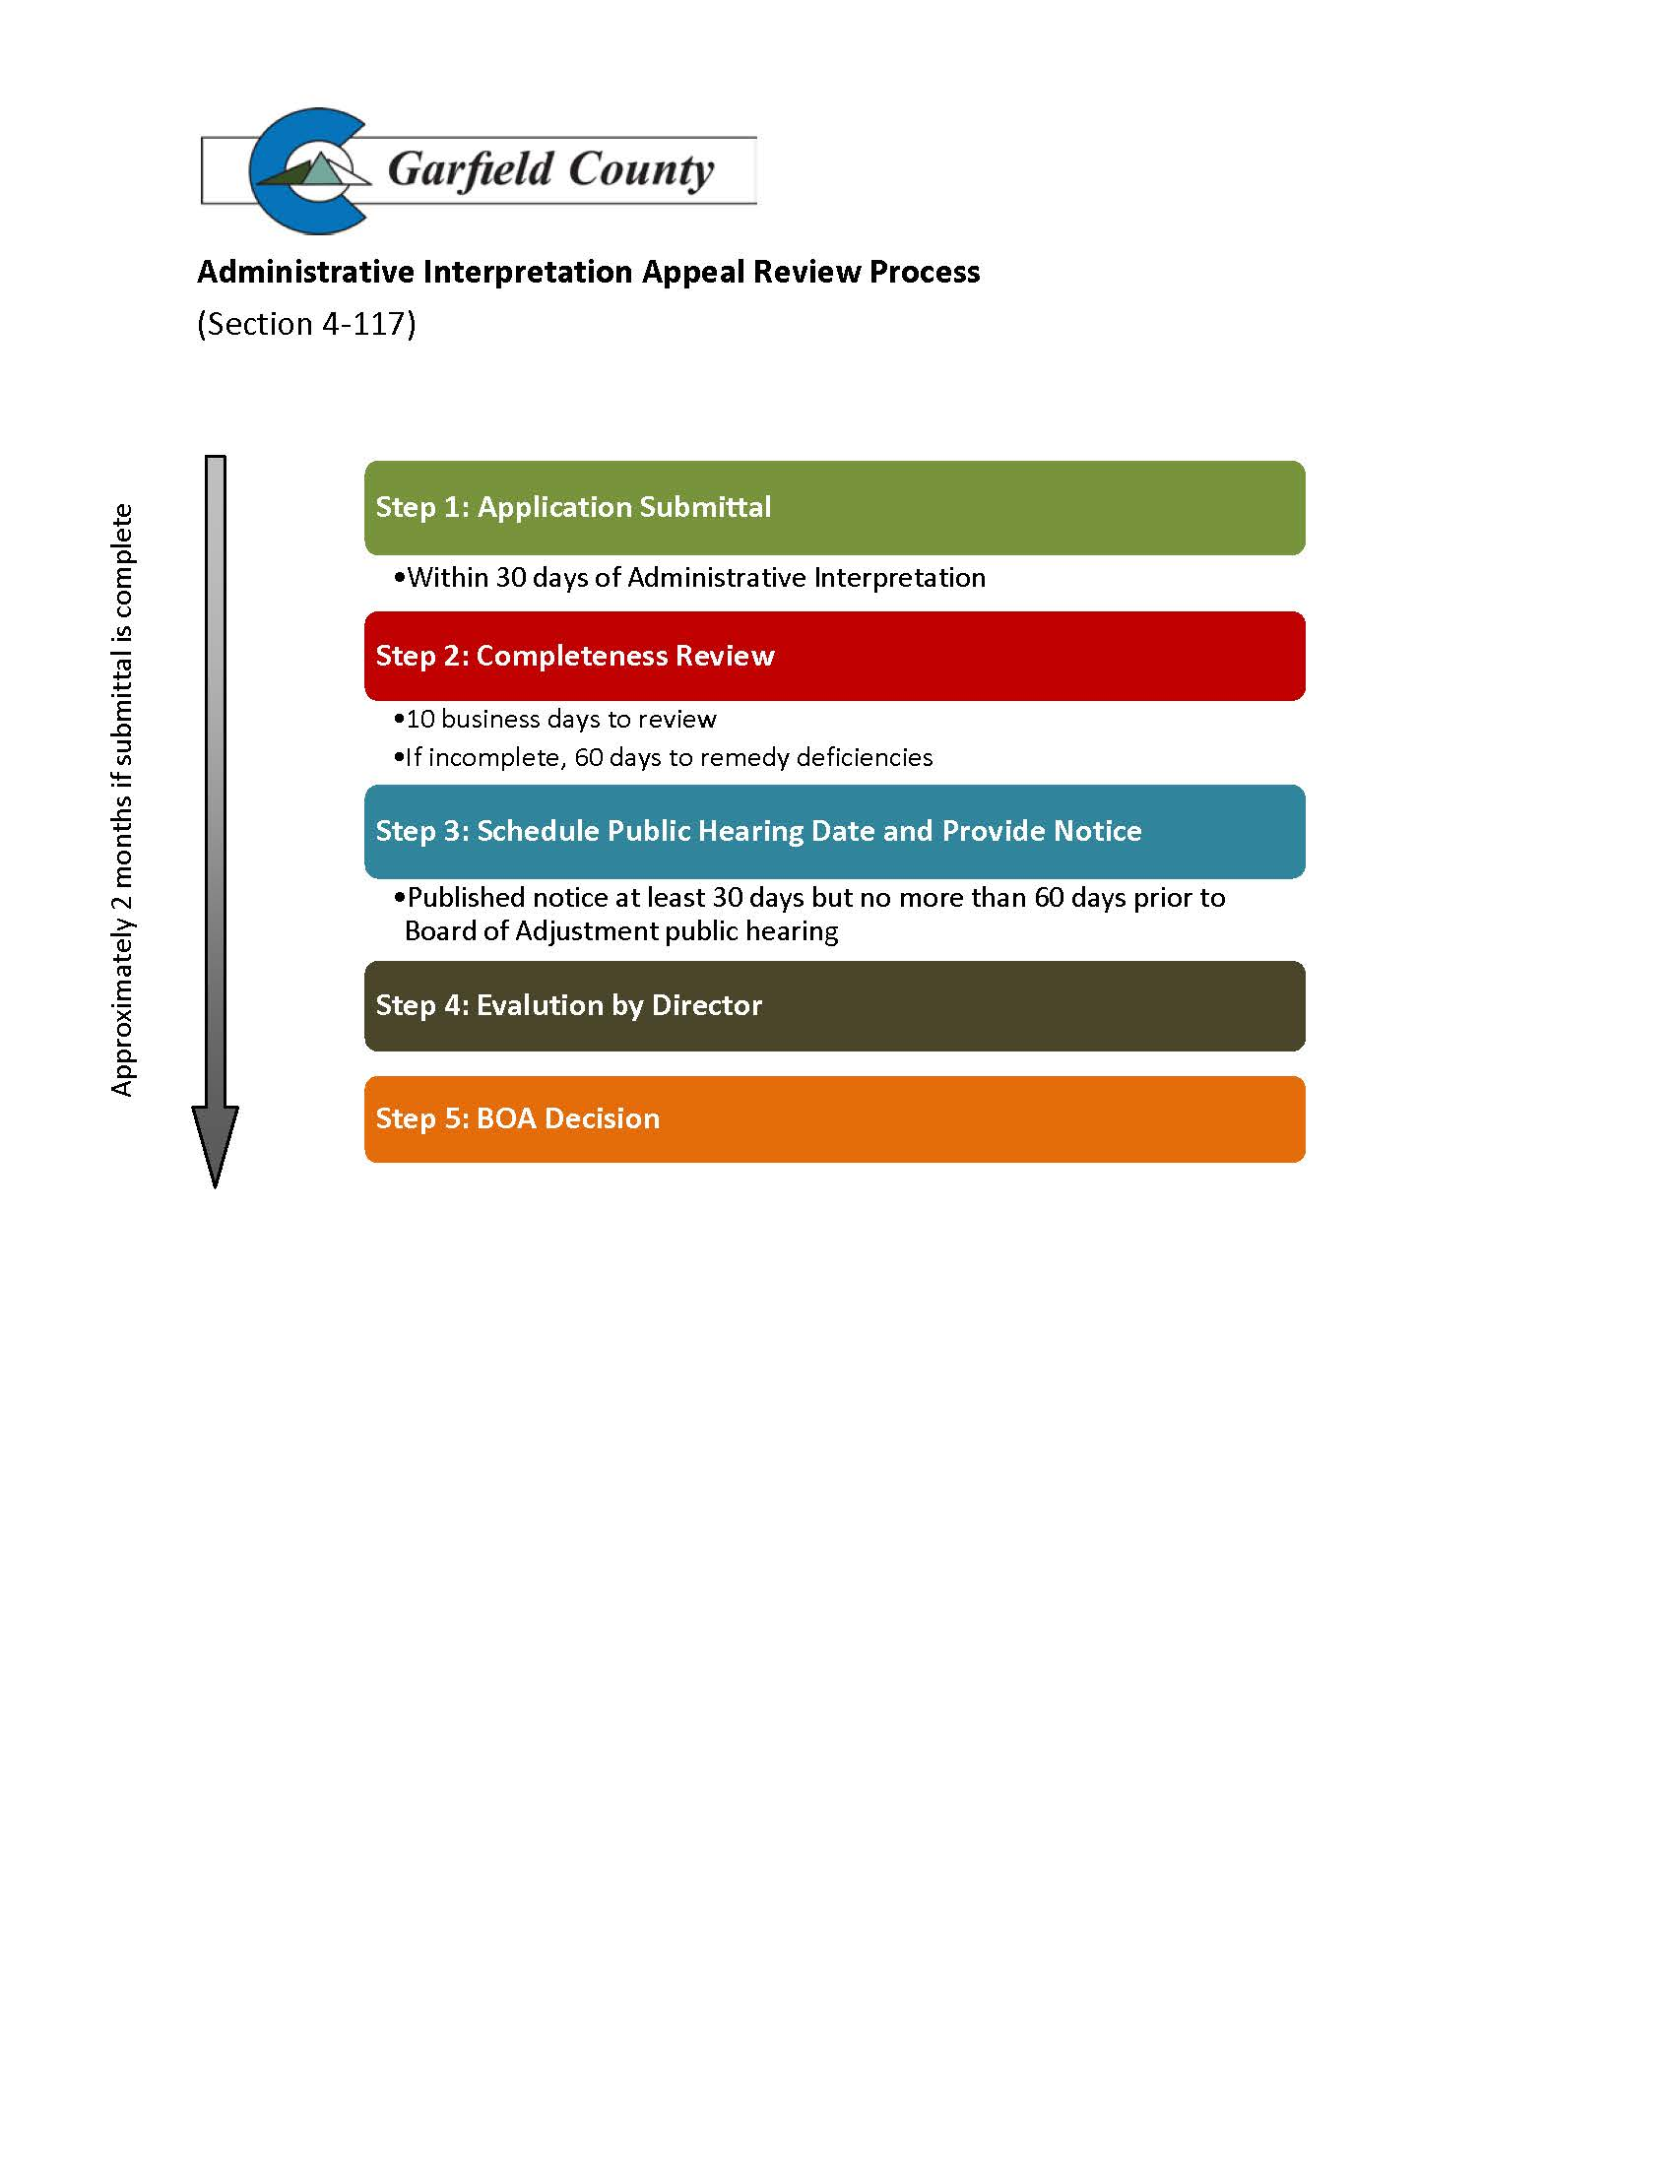

* + - 1. Section 4-119 Accommodation Pursuant to Federal Fair Housing Act

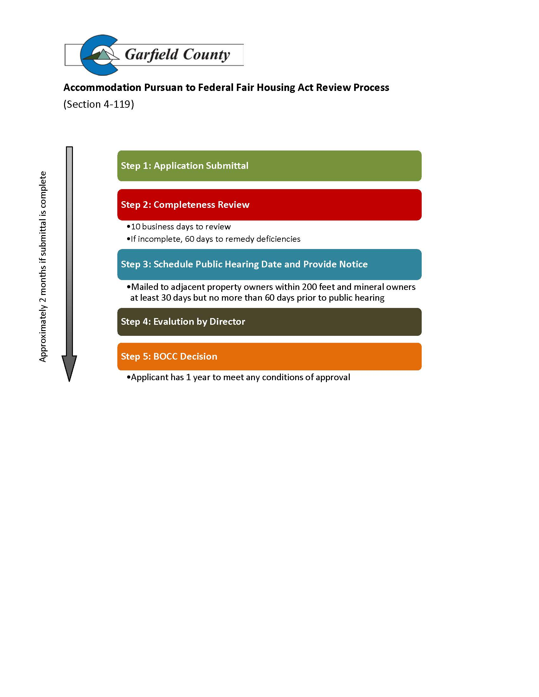

* + - 1. Section 5-202 Public or County Road Split Exemption

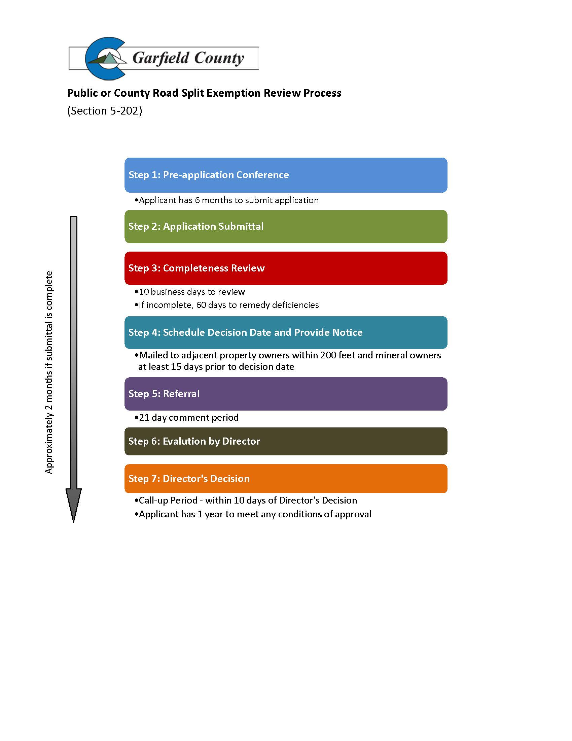

* + - 1. Section 5-203 Rural Land Development Exemption

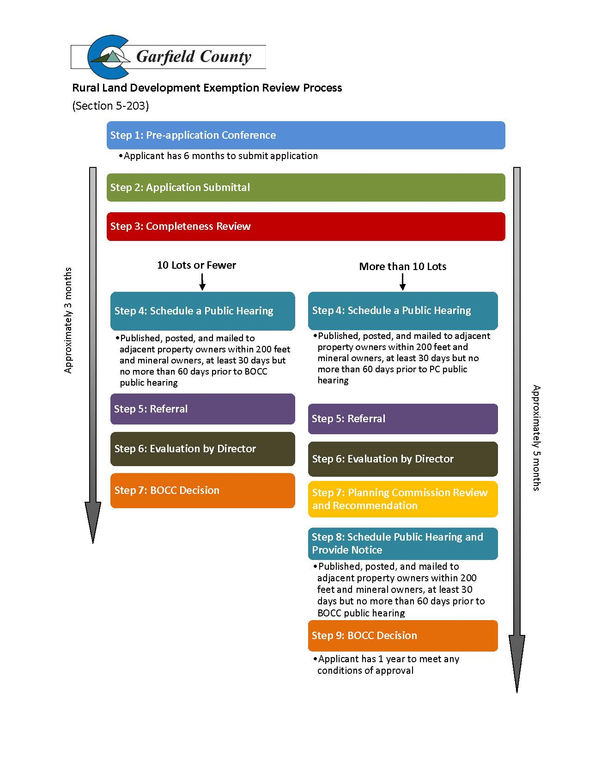

* + - 1. Section 5-204 Basic Correction Exemption

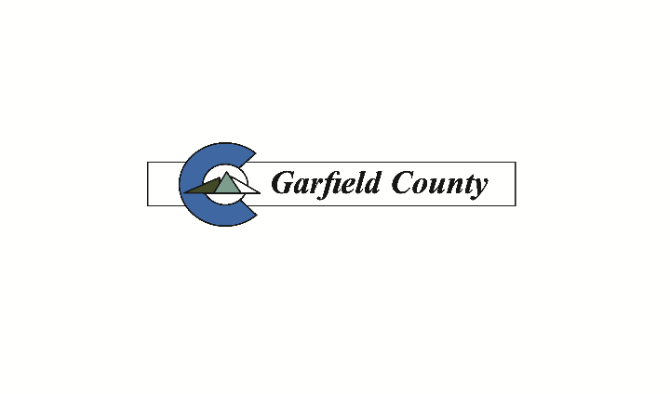

**Basic Correction Exemption Review Process**

(Section 5-204)

**Step 1: Pre-application Conference**



.

* Mailed to adjacent property owners within 200 feet and minerals owners at least 15 days but no more than 30 calendar days prior to BOCC public hearing.

**Step 4: Schedule Hearing and Provide Notice**

* 10 business days to review.
* If incomplete, 60 days to remedy deficiencies.dy deficiencies

**Step 3: Completeness Review**

**Step 2: Application Submittal**

* Prior to submitting, the Director must make the determination that the request is in general conformance with Review Criteria. Applicant may call up Director determination to the BOCC.
* Applicant has 6 months to submit application.

Approximately 3 months if submittal is complete

**Step 5: Referral**

* 21 day comment period

**Step 6: Evaluation by Director**

**Step 7: BOCC Decision**

* Applicant has 1 year to meet any conditions of approval.

* + - 1. Section 5-301 Minor Subdivision

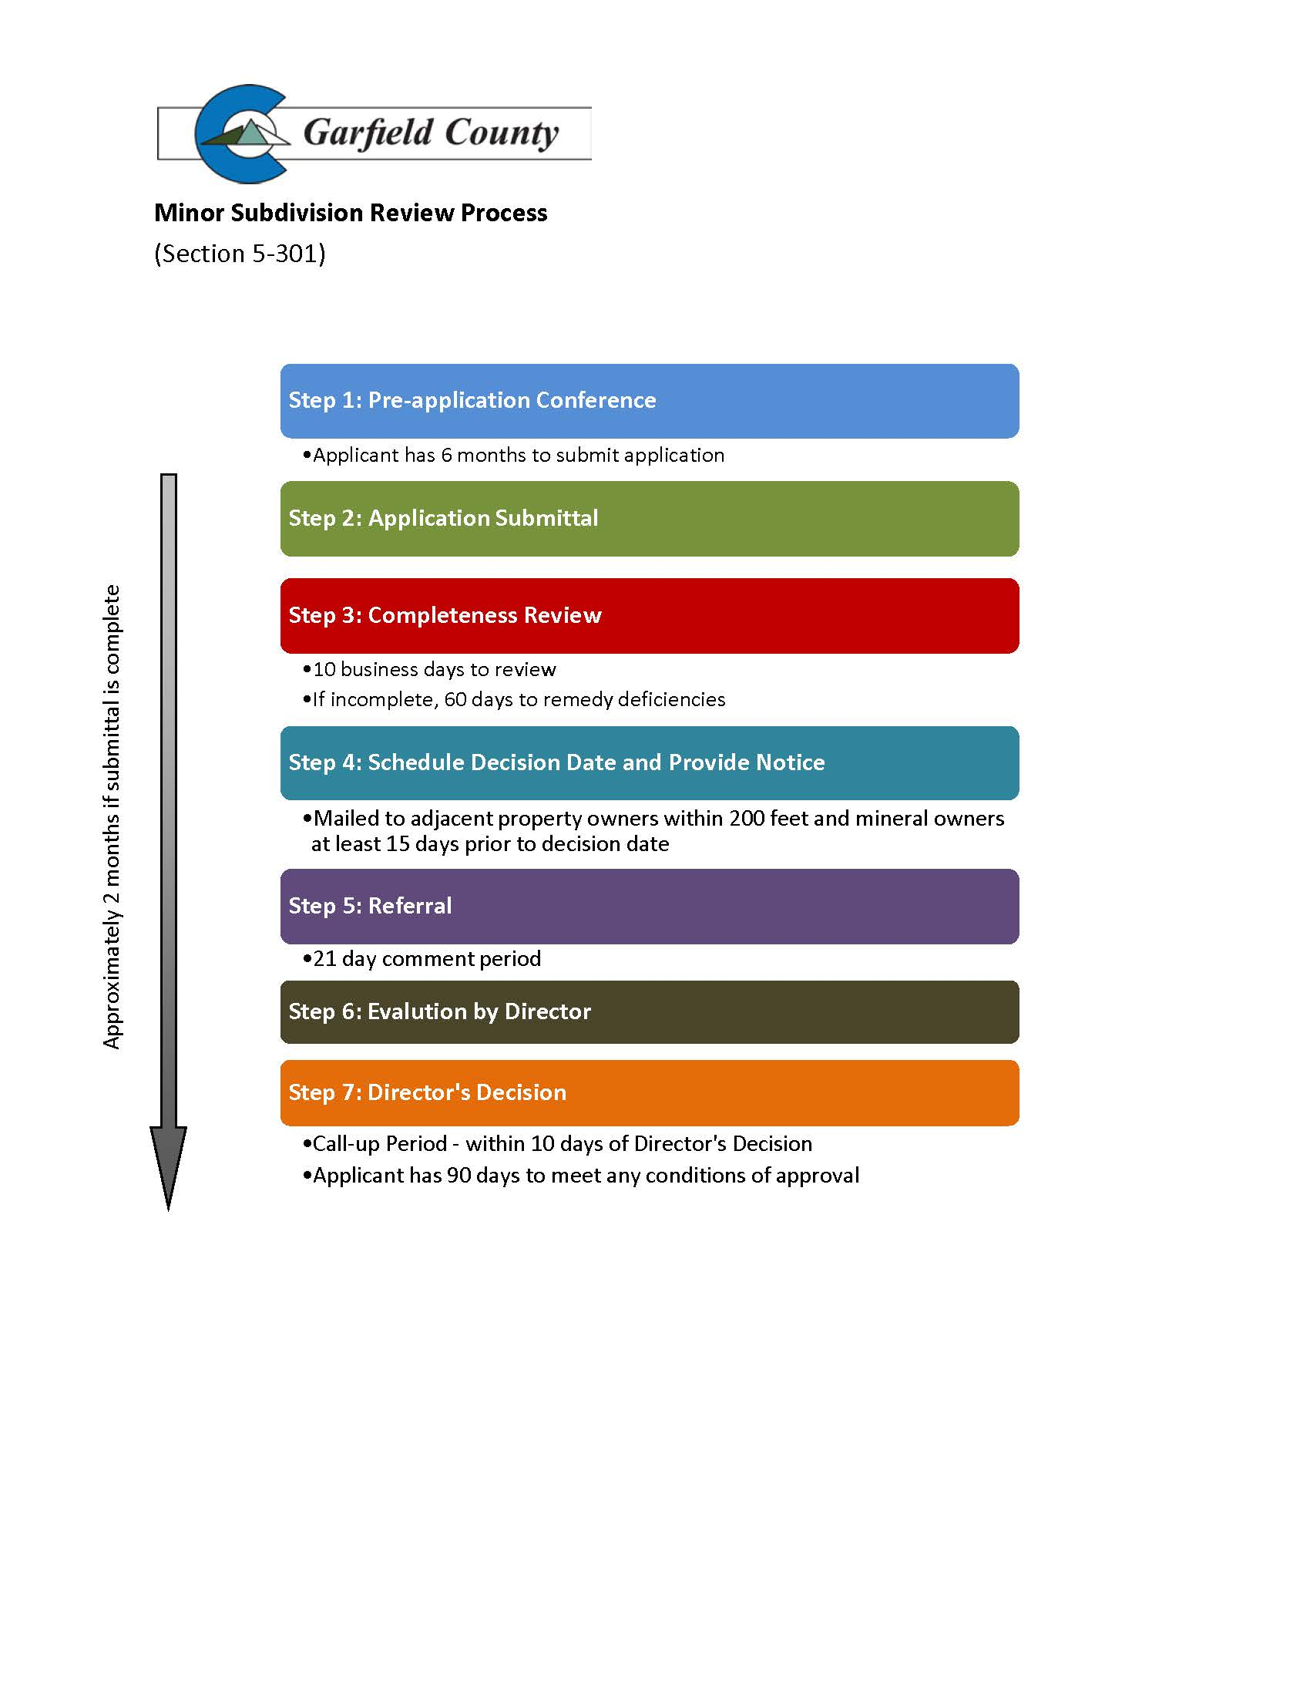

* + - 1. Section 5-302 Major Subdivision

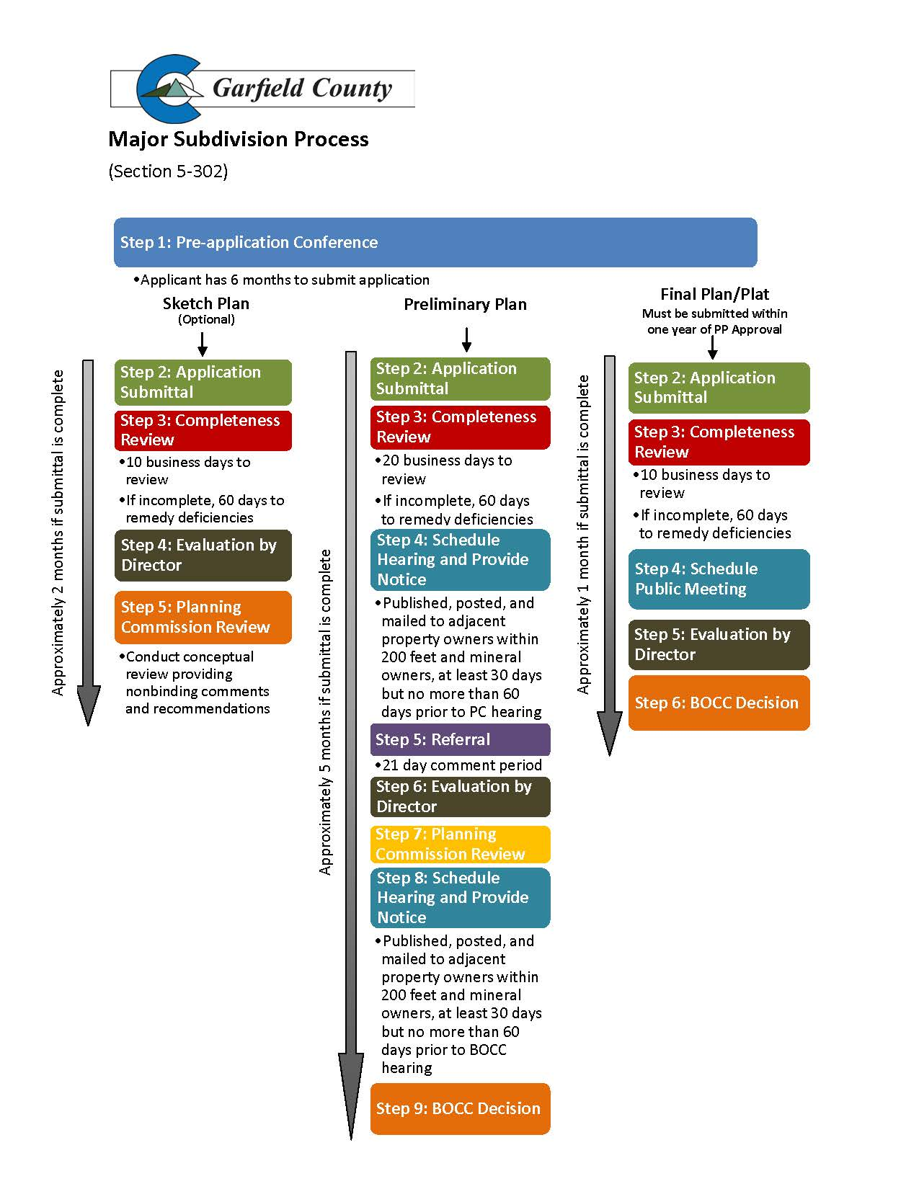

* + - 1. Section 5-303 Conservation Subdivision

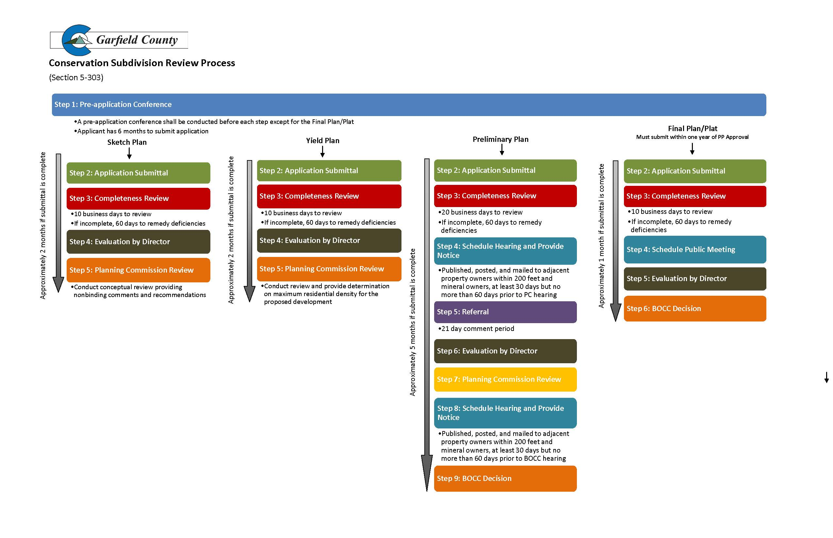

* + - 1. Section 5-304 Amendment to an Approved Preliminary Plan

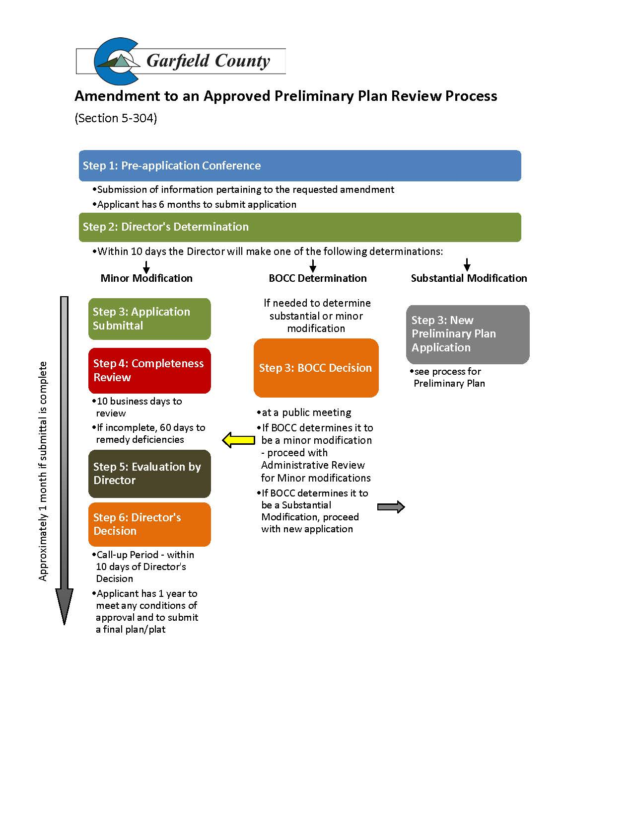

* + - 1. Section 5-305 Amended Final Plat

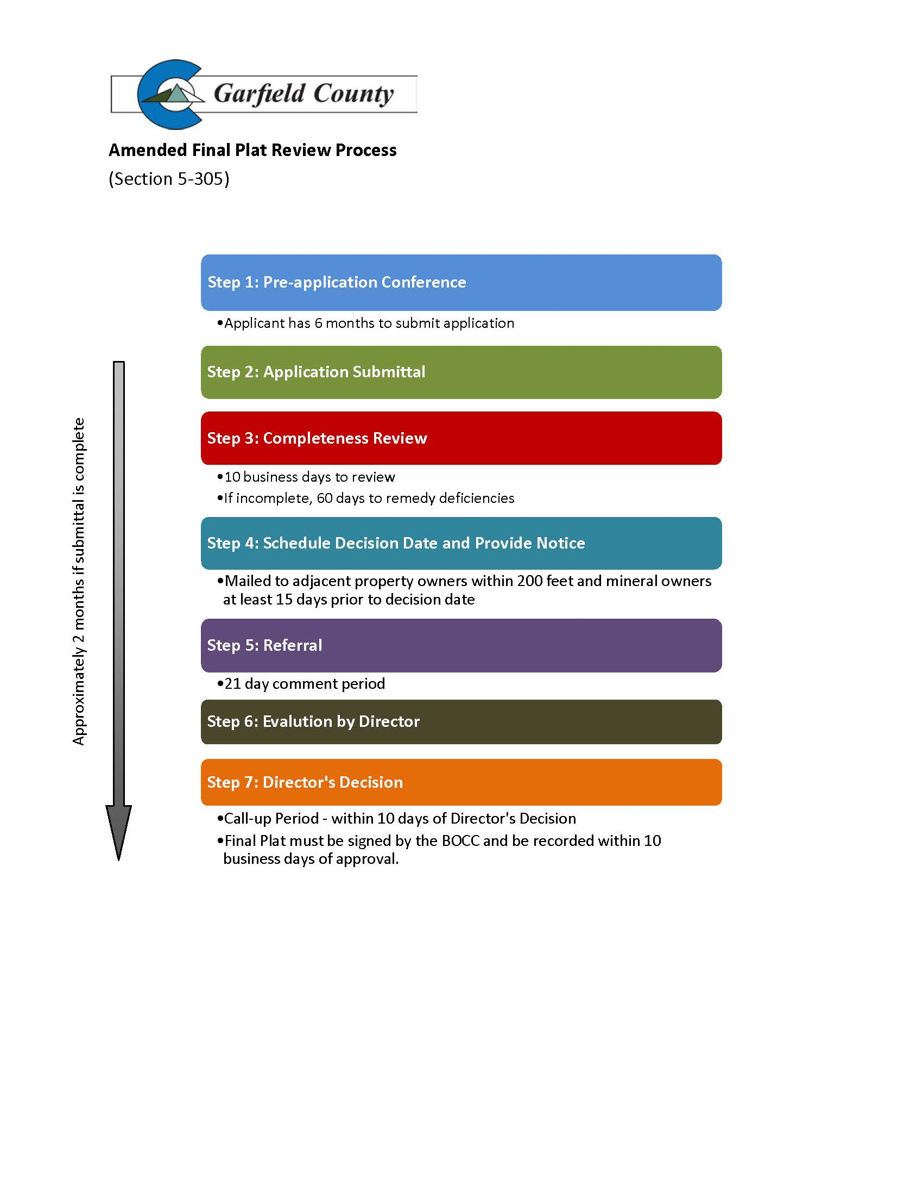

* + - 1. Section 5-306 Common Interest Community Subdivision

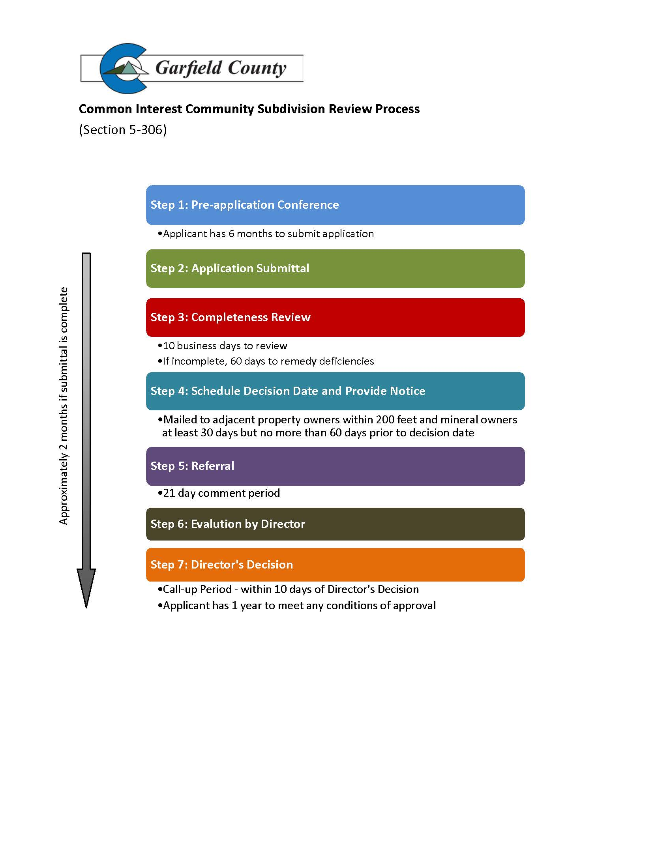

* + - 1. Section 6-202 Planned Unit Development

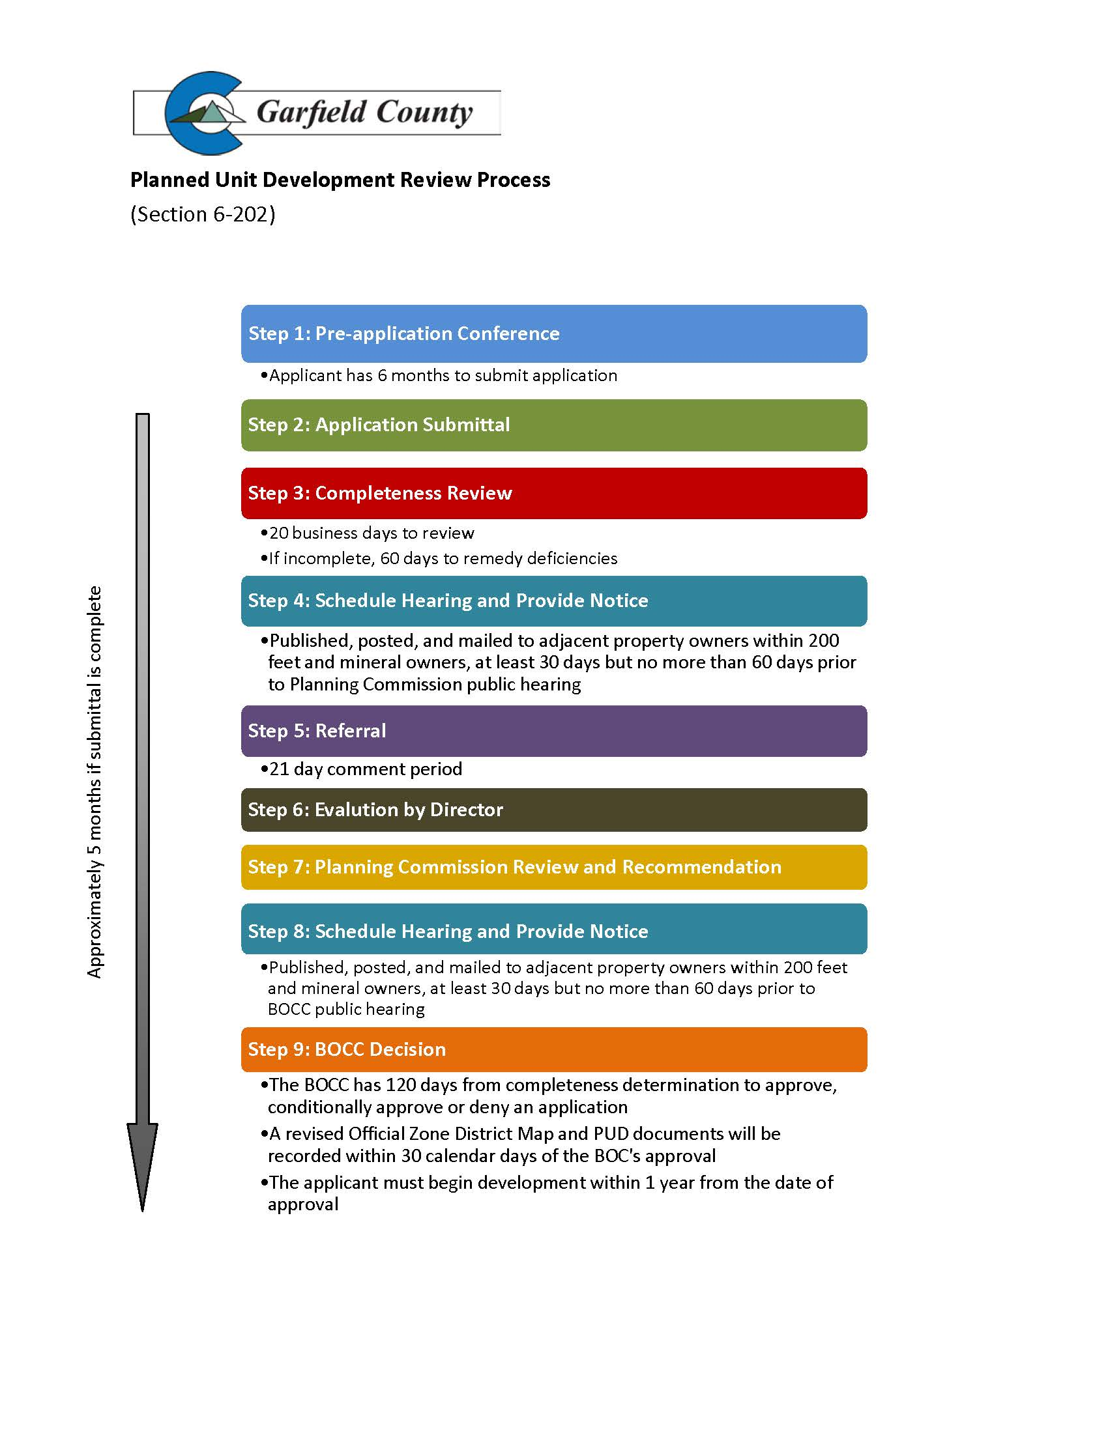

* + - 1. Section 6-203 Amendment to an Approved PUD

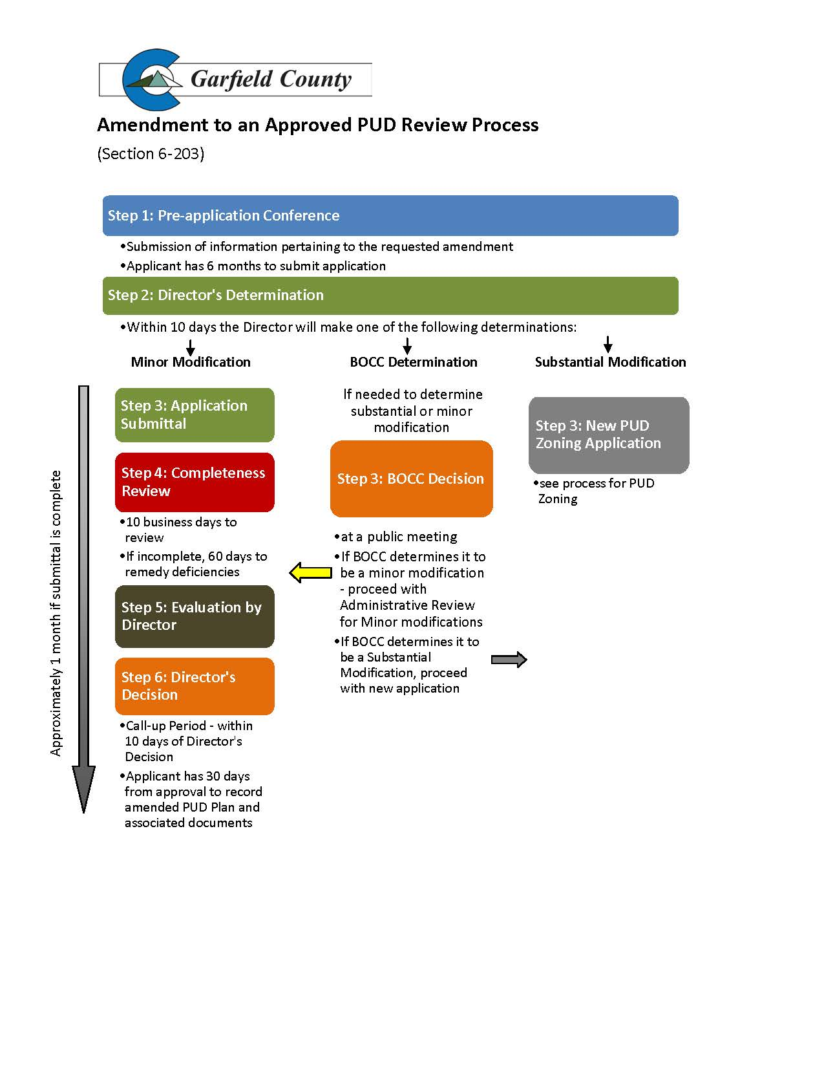

* + - 1. Section 9-103 Pipeline

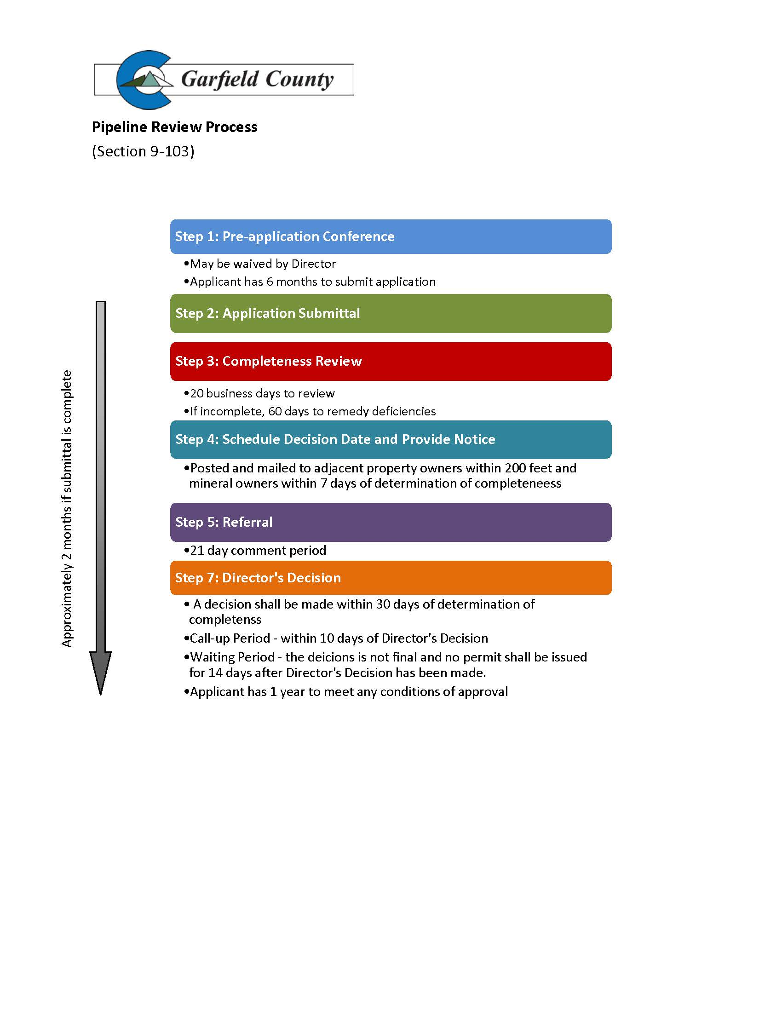

* + - 1. Section 11-201 Sign Permit

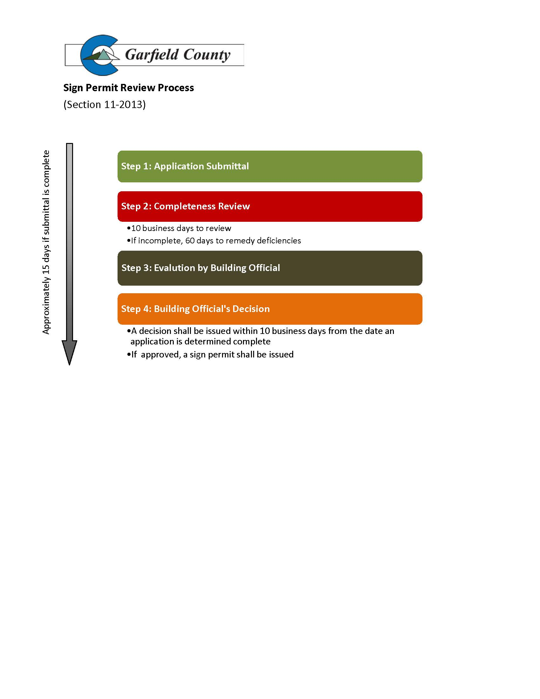

1. Alternative language depending upon desired coverage of easement
2. Local recordation and subordination practices must also be met. If subordination is necessary, in which case the mortgagee must join in the agreement, the above language is suggested.