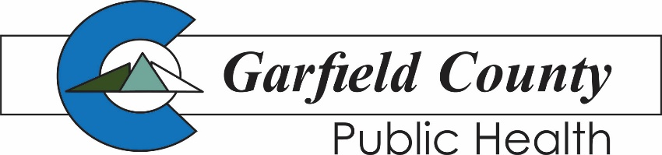
2014 Blake Avenue
Glenwood Springs, CO 81601
(970) 945-6614
195 W. 14th Street
Rifle, CO 81650
(970) 625-5200

Public Health COVID-19 vaccine mini-grant application

PURPOSE: Getting a COVID-19 vaccination protects you, your family, the community, and will help end the pandemic. To promote vaccination, Garfield County Public Health (GCPH) is accepting applications for COVID-19 vaccine mini-grants.

ELIGIBLE PROJECTS: Mini-grants will be awarded to projects that conduct activities or events that encourage youth, ages 12 to 17, and their caregivers to receive the COVID-19 vaccine. The mini-grant program is being offered based on grant funding from the Caring for Colorado Foundation.

In addition to focusing on increasing vaccination rates, mini-grants offer a secondary benefit. Only part of the awarded funding needs to be used on COVID-19 vaccination efforts. The other portion can be used on unrelated expenses.

Example: A cooking club wants to host a vaccine information night, but also needs baking supplies for their club. Funds can be used to host the vaccine event and to buy supplies for the club’s future use.

Garfield County Public Health is committed to ensuring equitable access for children and youth to receive COVID-19 vaccines. Equity in information and vaccine access is a cornerstone for reduced transmission of the COVID-19 virus. Projects with a focus on equity will be given priority consideration.

WHO MAY APPLY: The COVID-19 vaccination mini-grant program is open to applicants serving youth ages 12 to 17 and their families. Middle or high schools, youth-serving non-profit agencies, religious organizations, festival or event coordinators, or other community groups of youth are welcome to apply.

DETAILS: A total of ten mini-grants, ranging from $500 to $2,500 will be awarded in a selection process held by Garfield County Public Health.

The application process opens on September 20 and closes on October 11. Submit applications as an email attachment to publichealthinfo@garfield-county.com. Applications are due no later than 5 pm on October 11. Please include “COVID Vaccine Mini-Grant Application” in the subject line of the email.

Grantees will be notified of selection on Monday, October 18. All projects must be completed by December 13, 2021. Awardees may be asked to complete a brief grant report at the end of the project.

Questions may be emailed to publichealthinfo@garfield-county.com. Please include “COVID Vaccine Mini-Grant Application” in the subject line.

To be completed by Applicant:

Applicant name (name of group/organization applying): Click or tap here to enter text.

In 1-2 sentences, please describe the group you represent: Click or tap here to enter text.

Grantee contact information (individual who may be contacted):

Name: Click or tap here to enter text. Title: Click or tap here to enter text.

Phone: Click or tap here to enter text. Email: Click or tap here to enter text.

Requested Amount (between $500 - $2,500): Click or tap here to enter text.

Does the project accomplish the following? Project will conduct activities or events that encourage youth, ages 12 to 17, and their caregivers to receive the COVID-19 vaccine and assure equitable access to vaccines and/or information.
(Mark one) Yes: Click or tap here to enter text. No: Click or tap here to enter text.

Briefly address the following questions:

- How will this project encourage youth, ages 12 to 17, and their caregivers to receive the COVID-19 vaccine? Please include any activities or events included in the plan.
Click or tap here to enter text.
Amount requested for vaccine-related activities: Click or tap here to enter text.

- How will this project use the additional non-vaccine outreach-related funds?
Click or tap here to enter text.
Amount requested for non-vaccine-related activities: Click or tap here to enter text.

- Who will the project serve? (Please list any available demographics and projected numbers)
Click or tap here to enter text.

- Project timeframe (List start date and any applicable milestones. All projects must be complete by December 13, 2021)
Click or tap here to enter text.

- How will this project measure success in terms of increasing COVID-19 vaccination rates among youth 12 – 17 and their caregivers?
Click or tap here to enter text.

Save responses and submit applications as an email attachment to publichealthinfo@garfield-county.com. Applications are due no later than 5 pm on October 11, 2021. Please include “COVID Vaccine Mini-Grant Application” in the subject line of the email. Award notifications will occur on October 18. Applicants not selected will also be notified.

Questions may be emailed to publichealthinfo@garfield-county.com. Please include “COVID Vaccine Mini-Grant Application” in the subject line.

